**CURRENT TOPIC HUMAN COMPUTER INTERACTION**

**CS-630-740**

**SMART HEALTH TRACKING SYSTEM**

**(TRACKING EMOTIONS)**

**PROJECT PHASE 2**

**By,**

**NEERAJA KARETI**

**(S01995530)**

***OVERVIEW OF THE PROJECT:***

1. Project Requirement
2. Pictures of the Project Interface
3. Code of the Project
4. Conclusion
5. Instructions for the running zip and unzip the project.

The idea of this project is to develop a system that provides member to add an activity for their stress relief, must capture the emotions of the activity with automatic date and time when the emotion was captured. Member must be registered to use the system. The activity which is no longer available can be selected by the member to delete those value in database.

***PROJECT REQUIREMENT:***

In today’s world, everyone will be busy in their work schedule due to that they have more stress in their life. **S**tress is a major risk for chronic diseases such as cardiovascular disease, metabolic diseases, kidney diseases, cancer and neurodegenerative diseases. The project aim is to develop a system that provides stress relief activity to the member and will track the emotions for each activity.

*Project Idea*

The idea of this project is to develop a system that provides member to add an activity for their stress relief, must capture the emotions of the activity with automatic date and time when the emotion was captured. Member must be registered to use the system. The activity which is no longer available can be selected by the member to delete those value in database.

***PROGRAMMING LANGUAGE AND SOFTWARE:***

* FrontEnd: Java
* BackEnd: MySQL
* Software used: MYSQL Workbench (Local Instance MYSQL 80) and Netbeans IDE 8.2

***INTERFACE PICTURES:***

*Homepage*

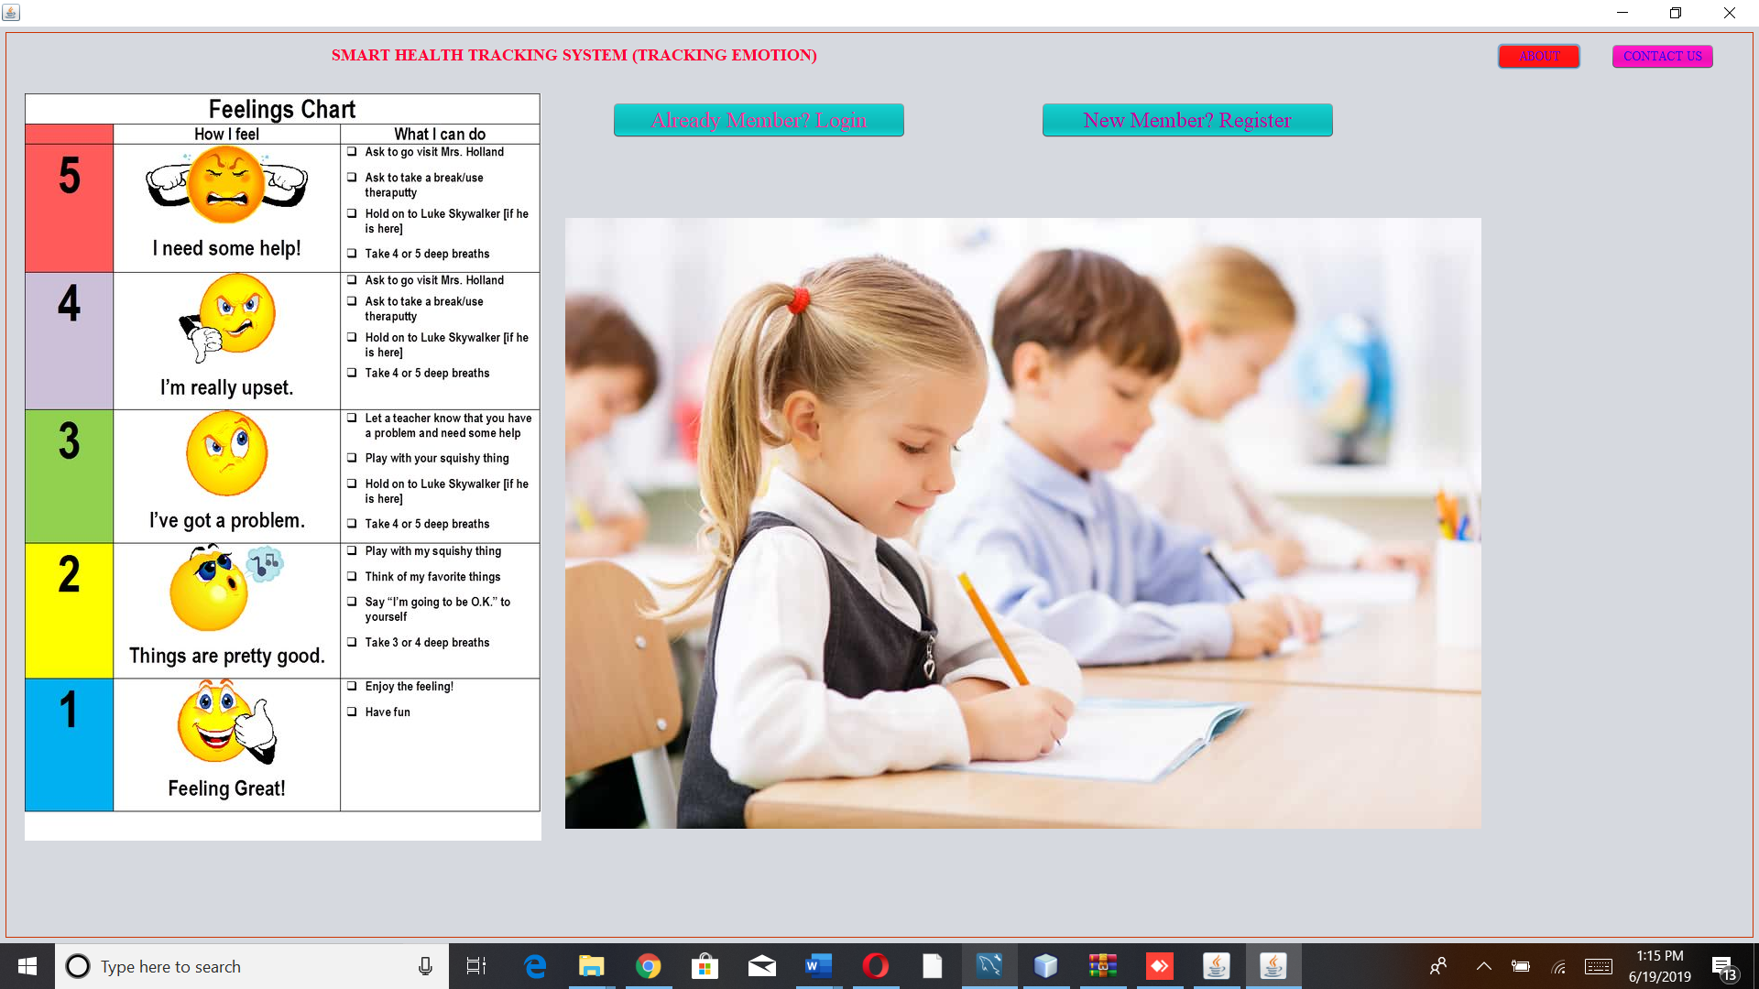

*Register*

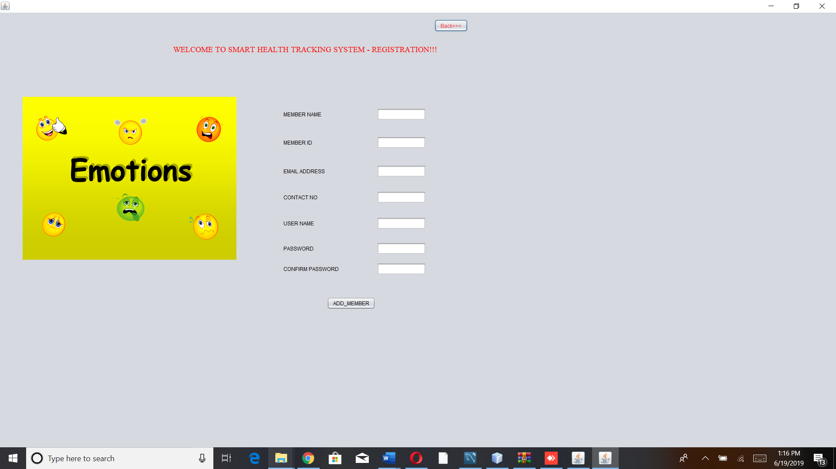

*LoginPage*

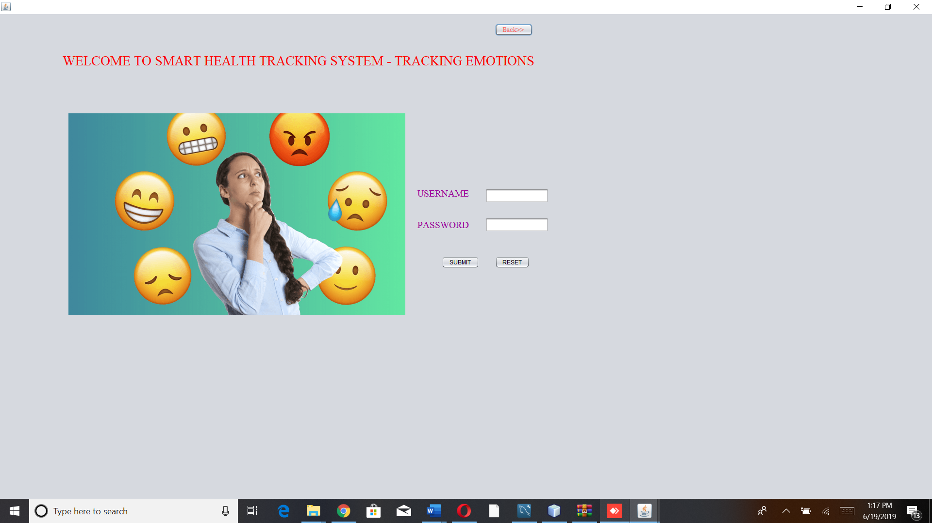

*MainPage*

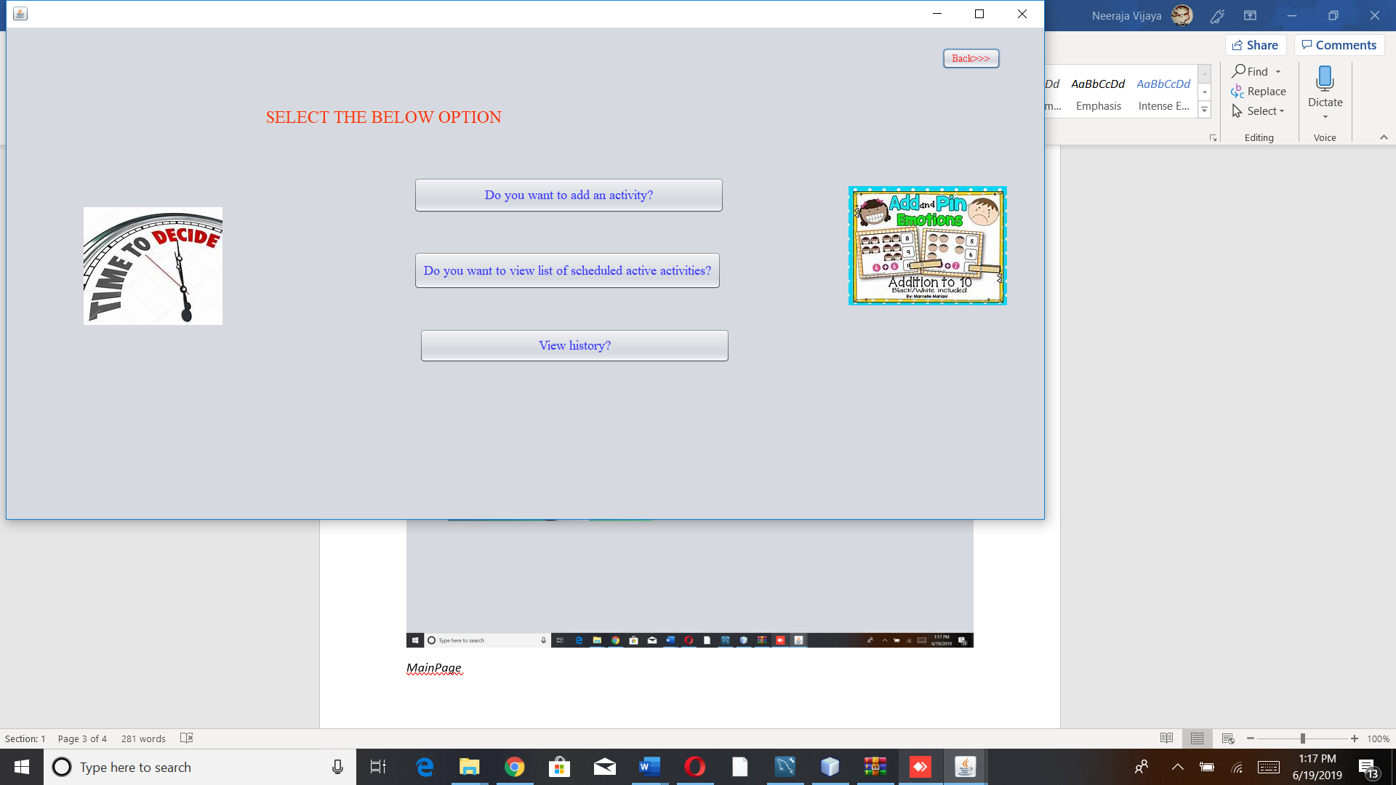

*AddActivity*

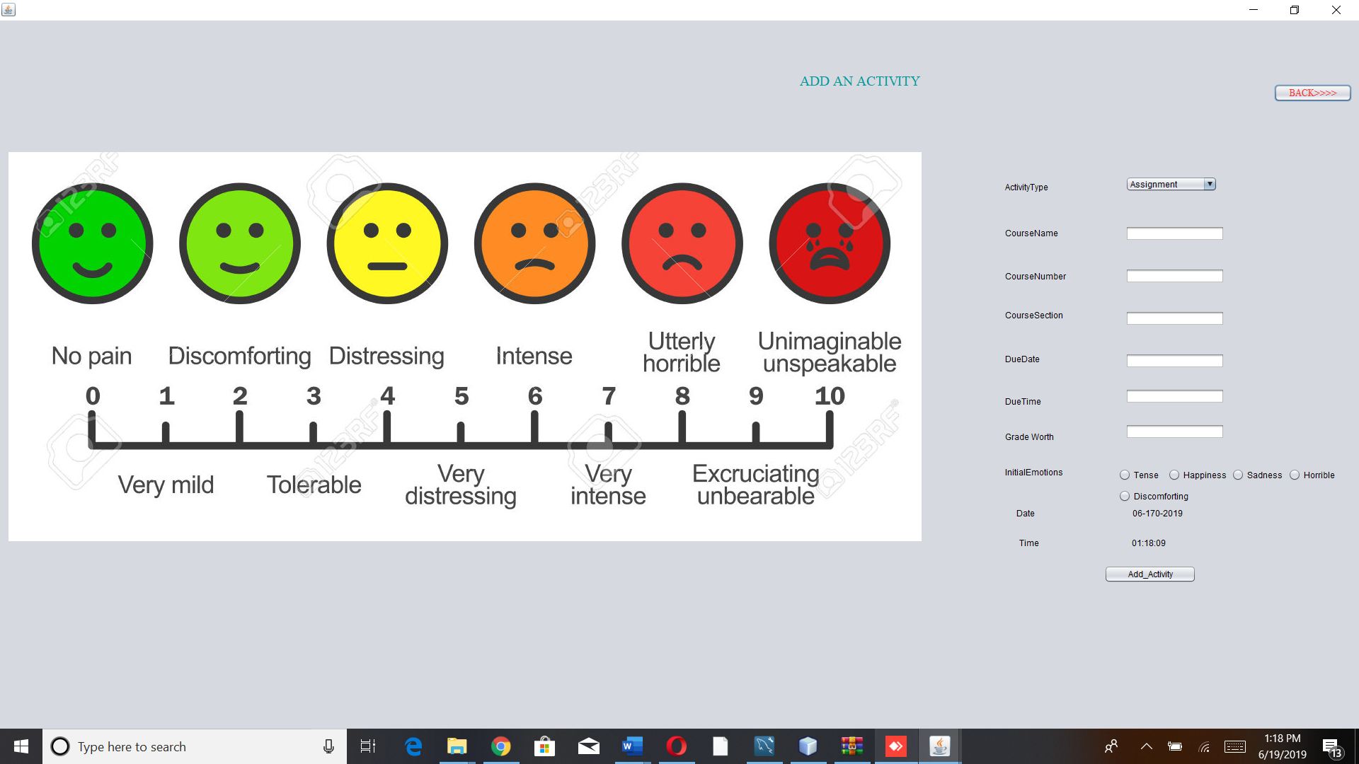

*ViewScheduledActivity*

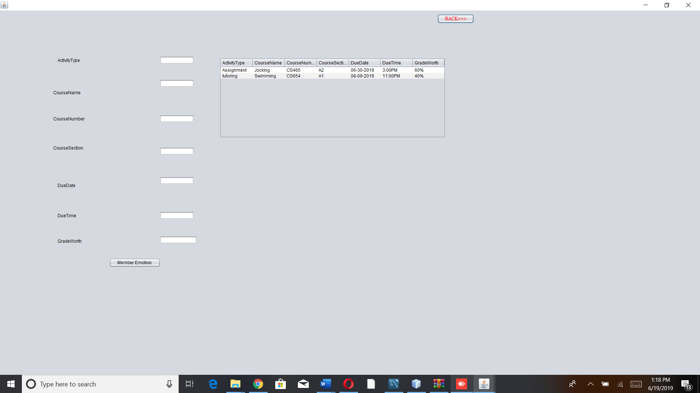

*UserEmotion*

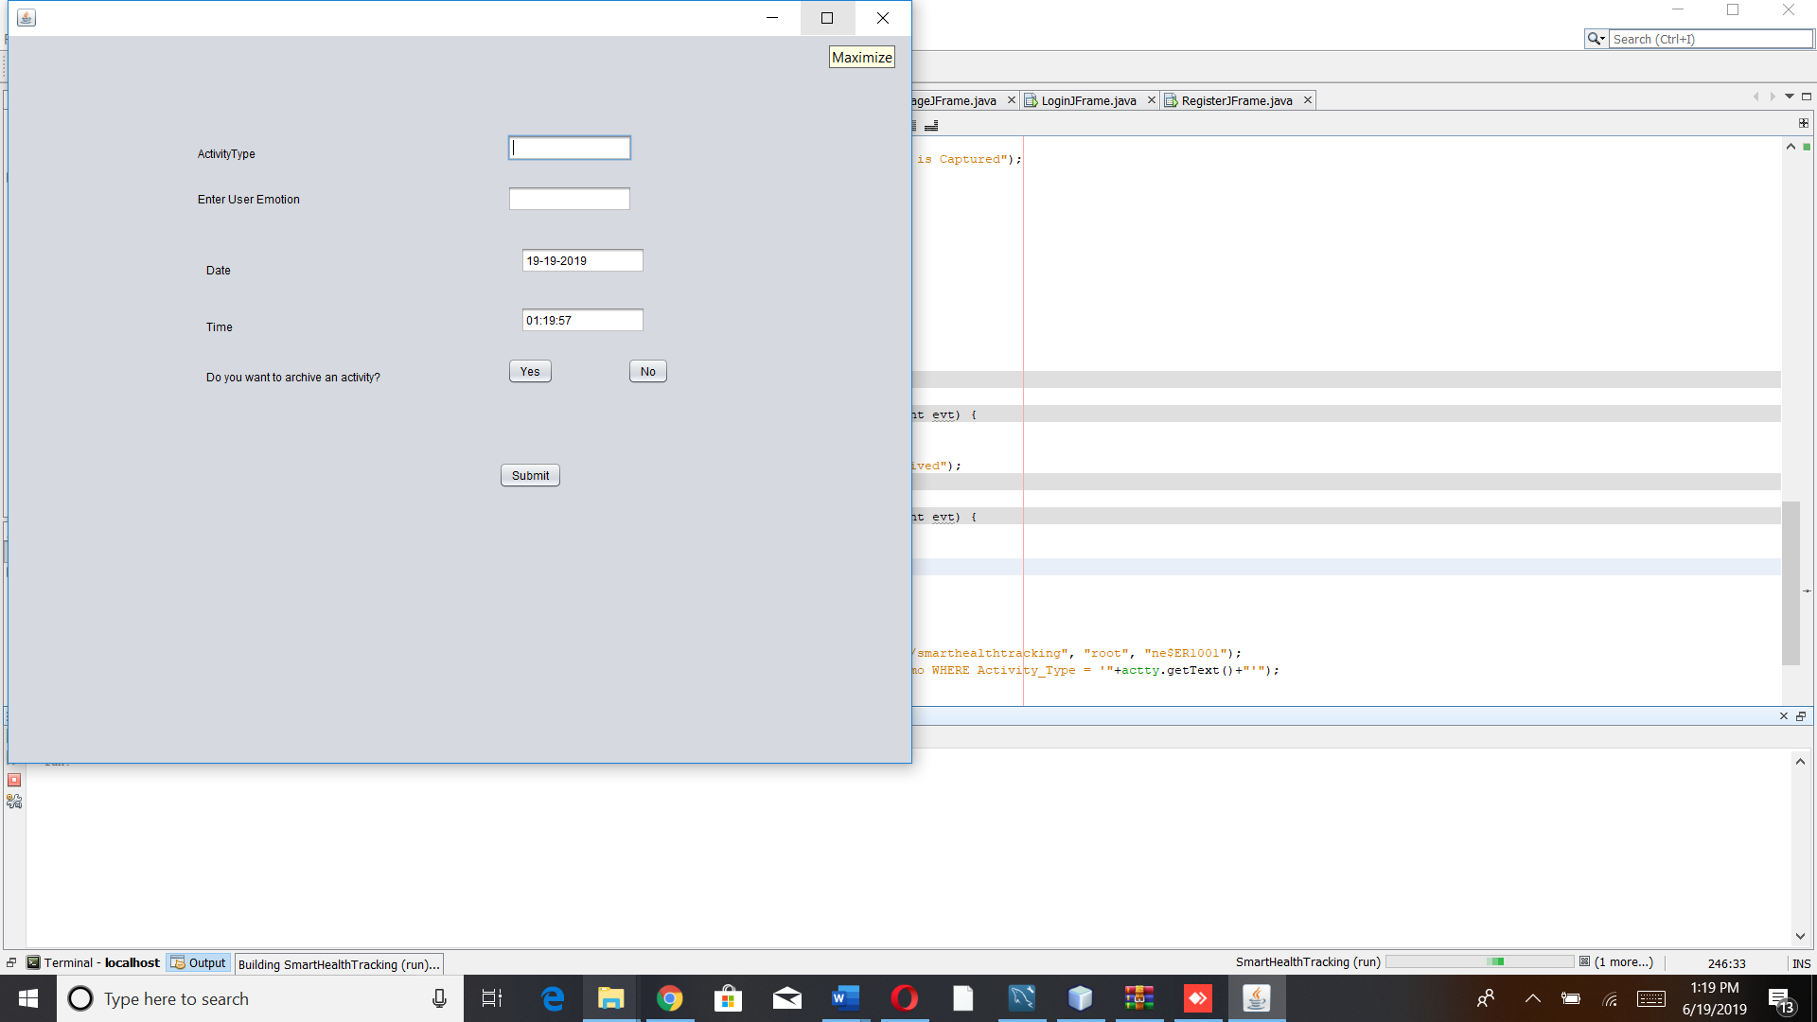

*ViewHistory*

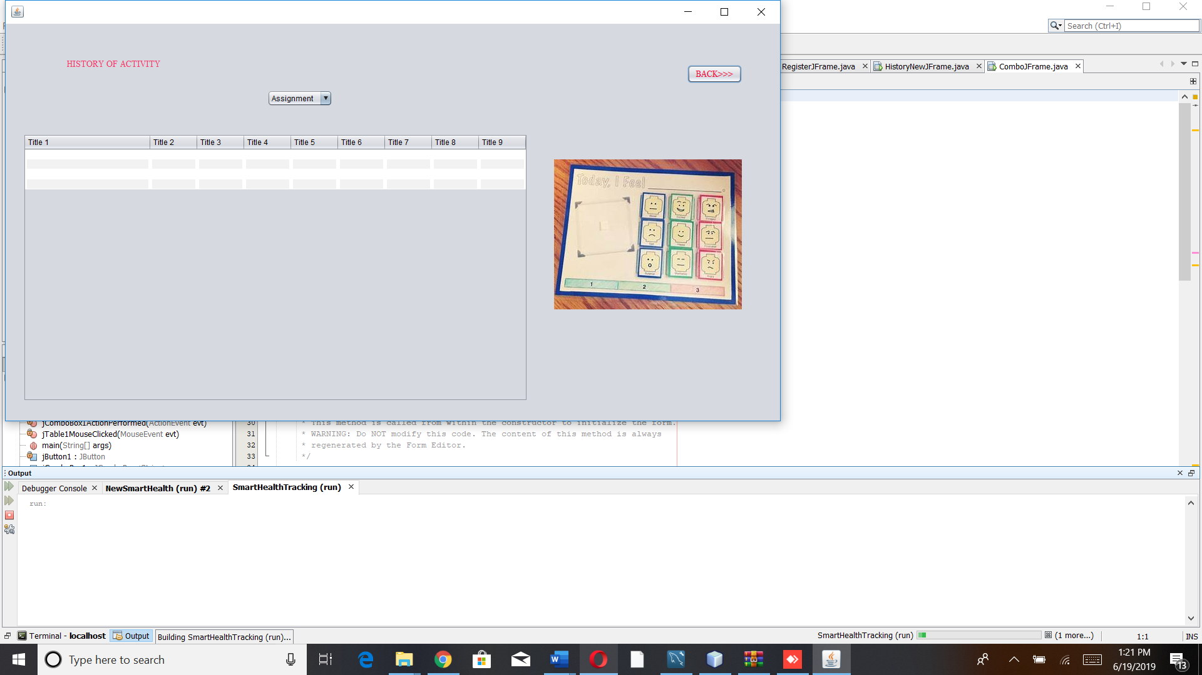

***Output Screenshot***

***Scenario 1:***

***Member will register in to the smart health tracking system, then will add the activity, then view the list of scheduled activity and will view the history***

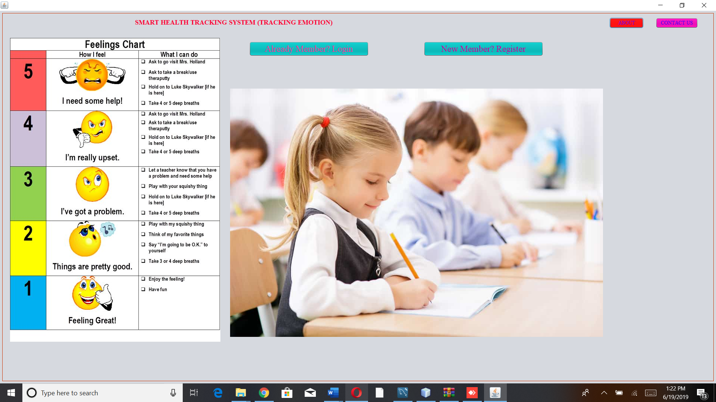

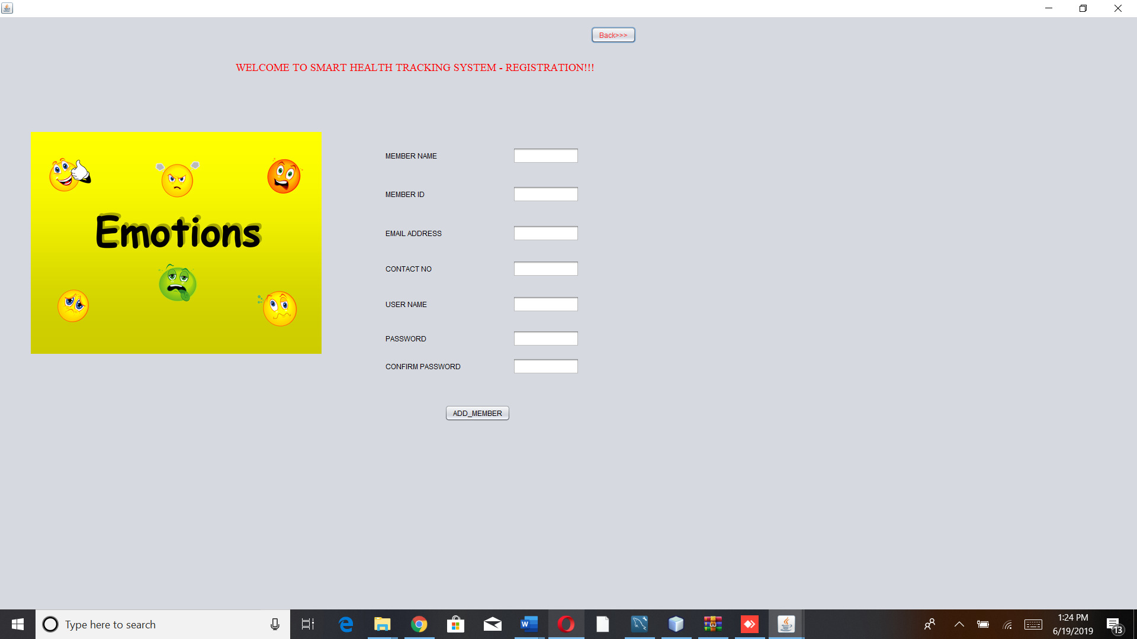

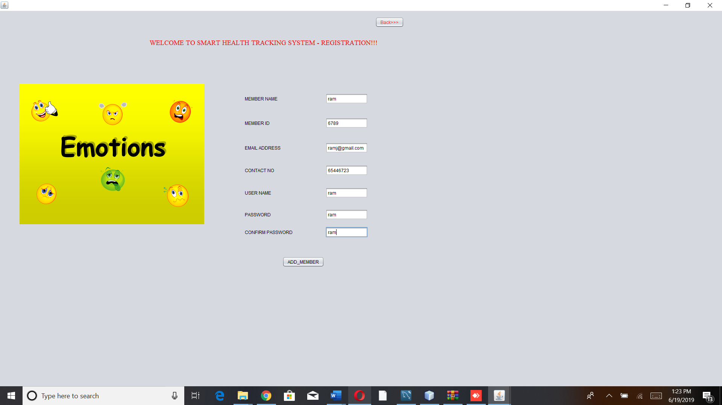

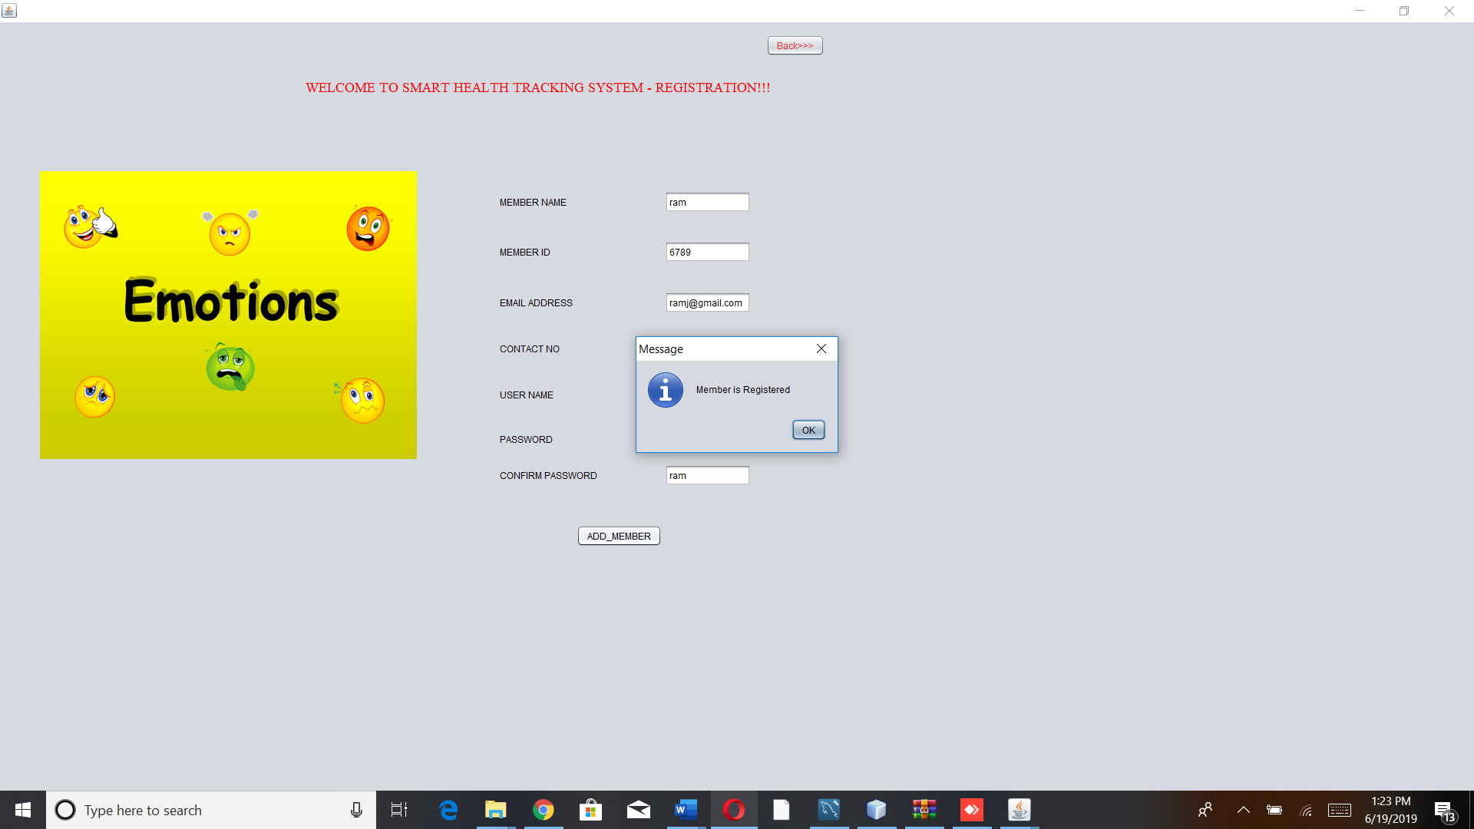

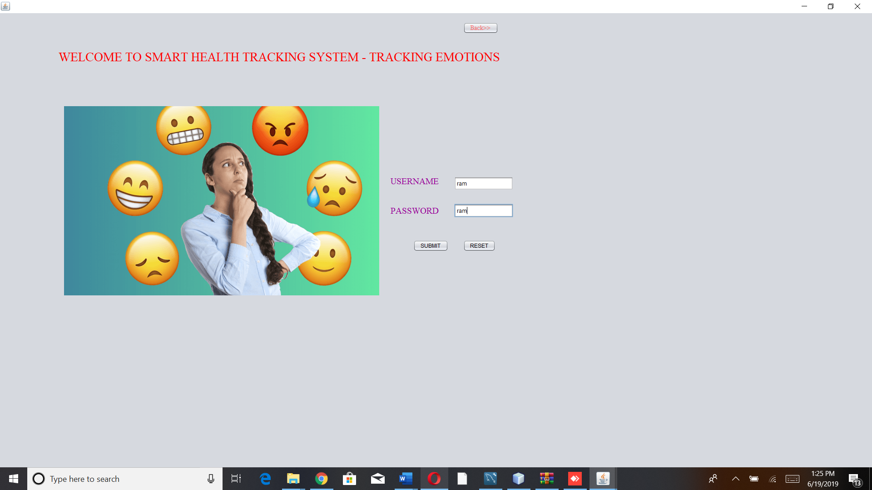

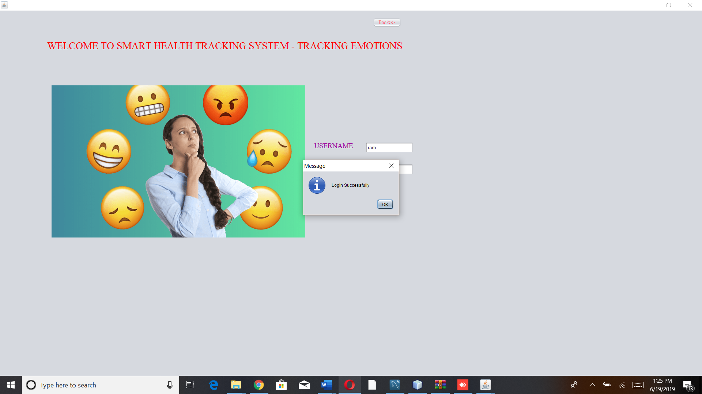

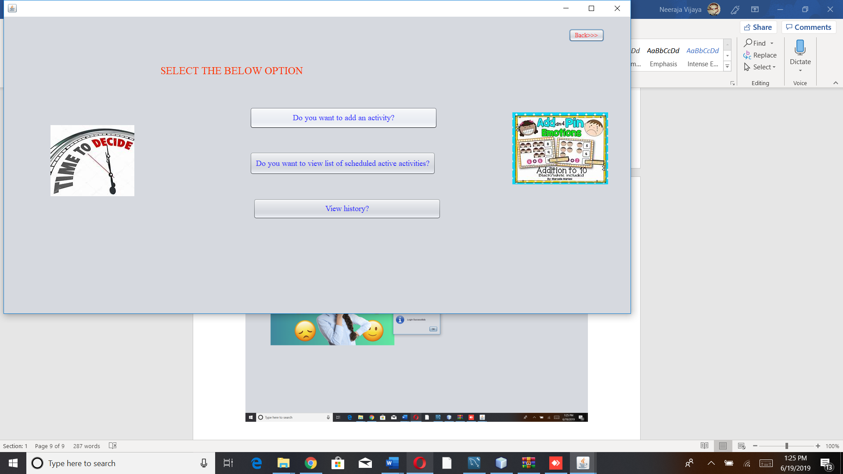

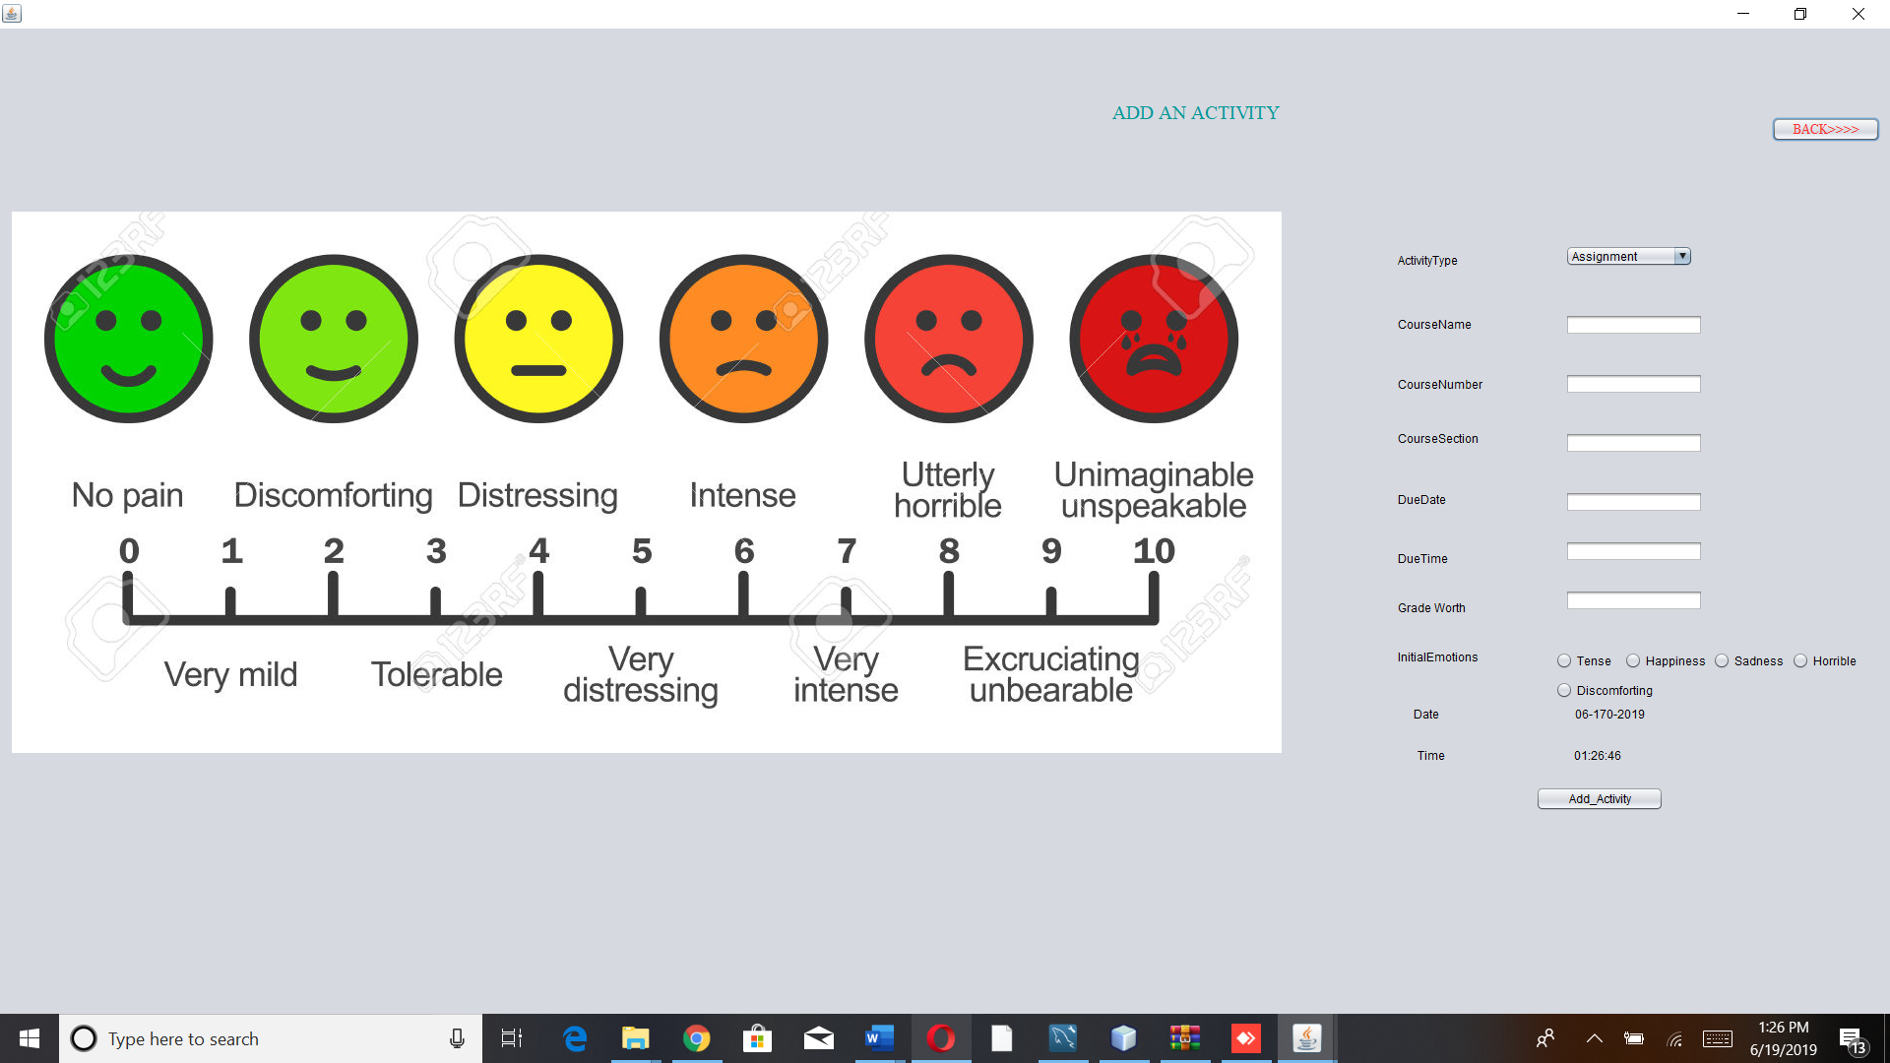

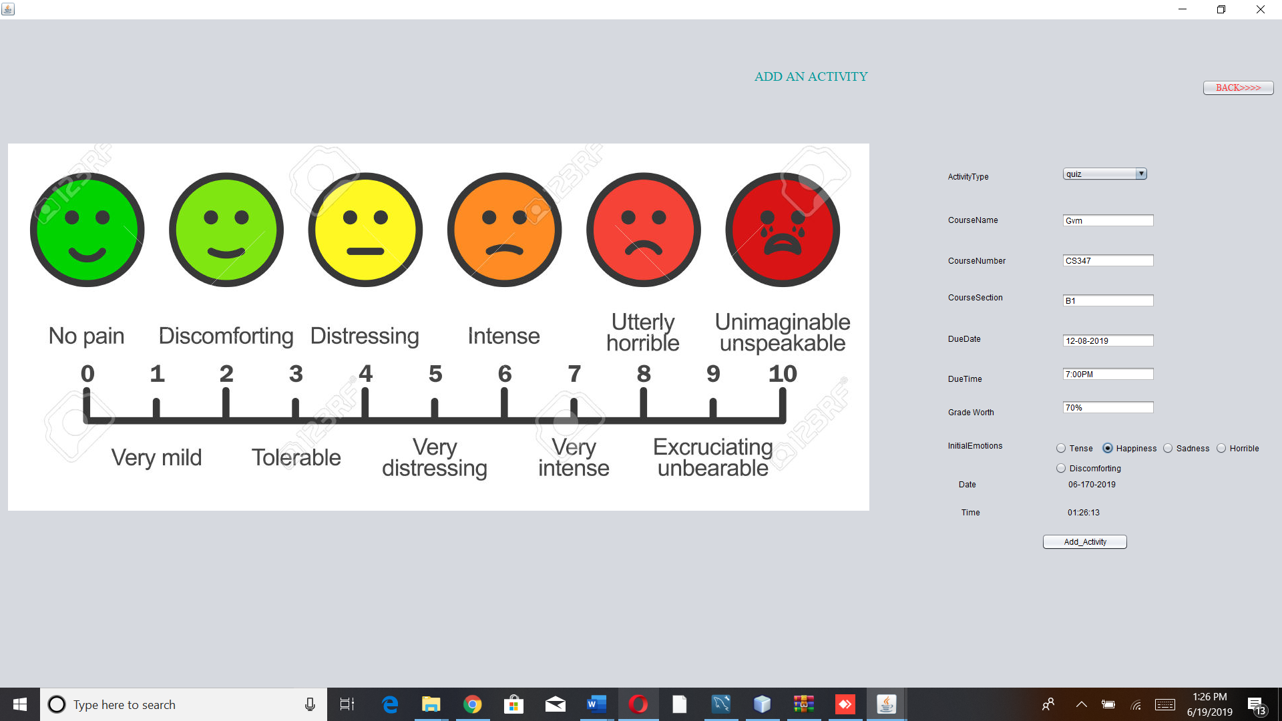

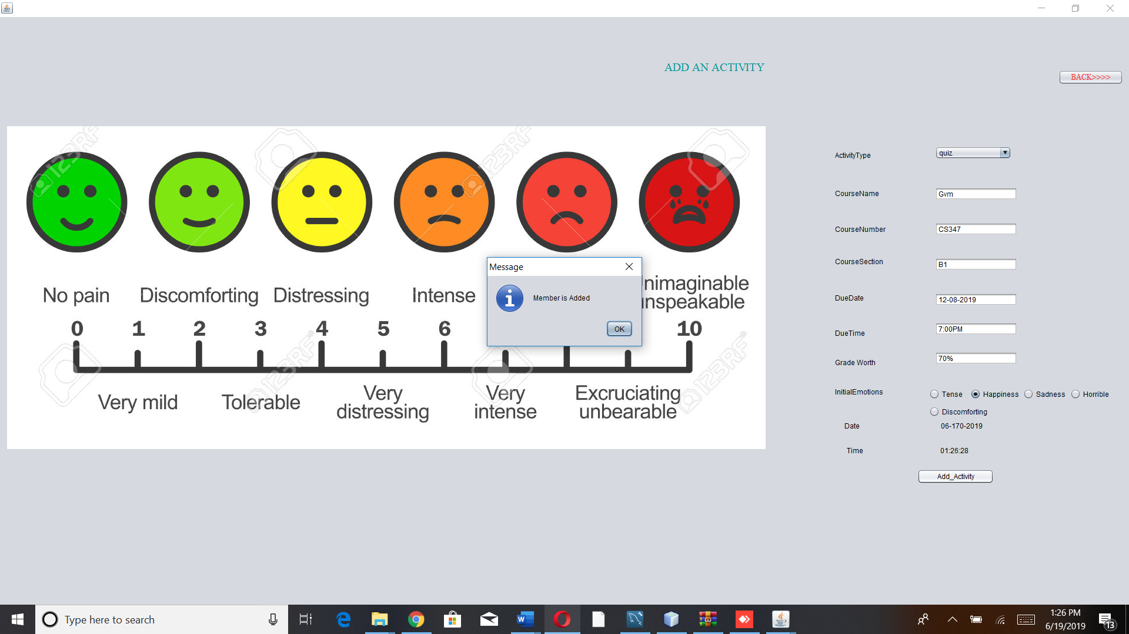

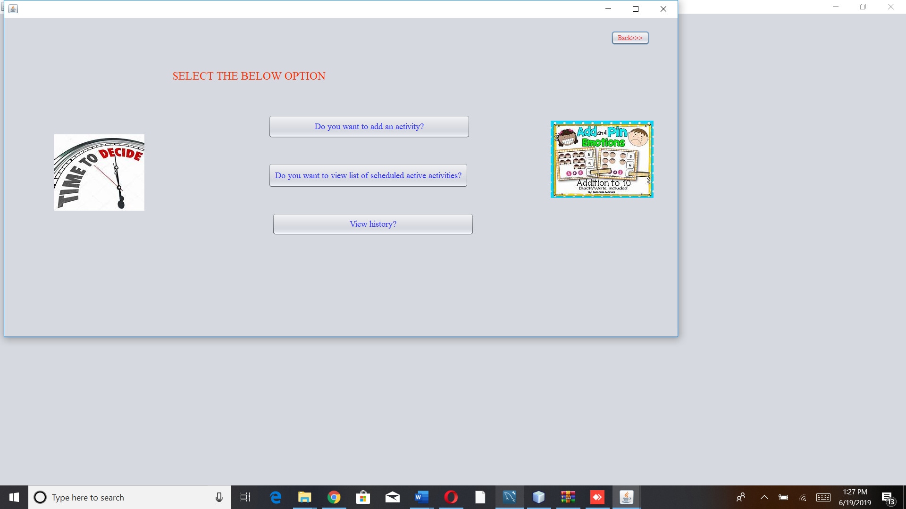

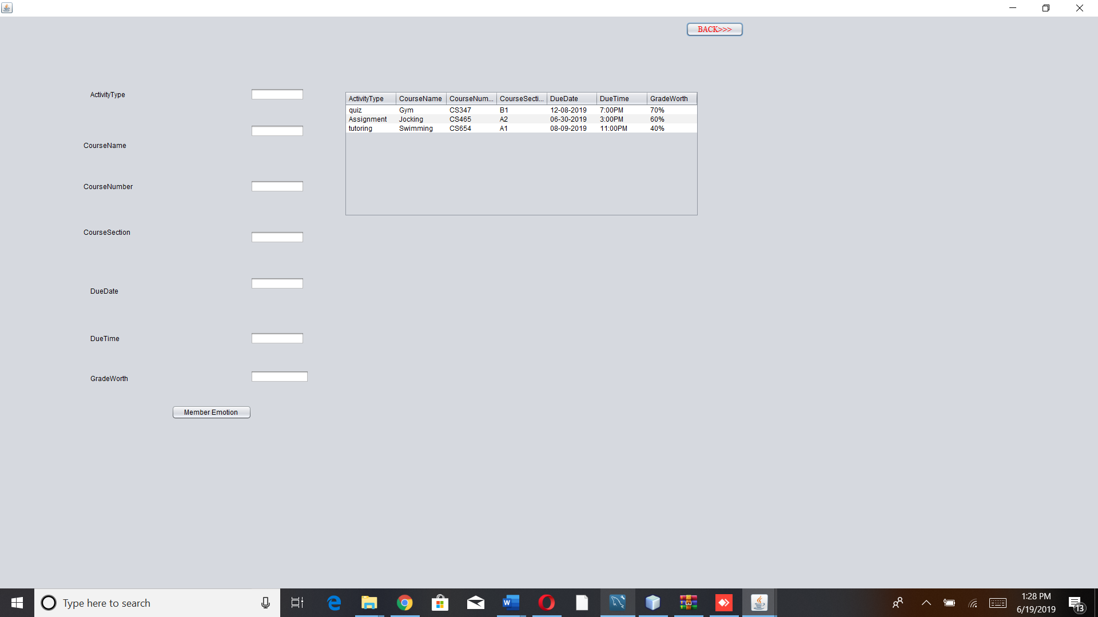

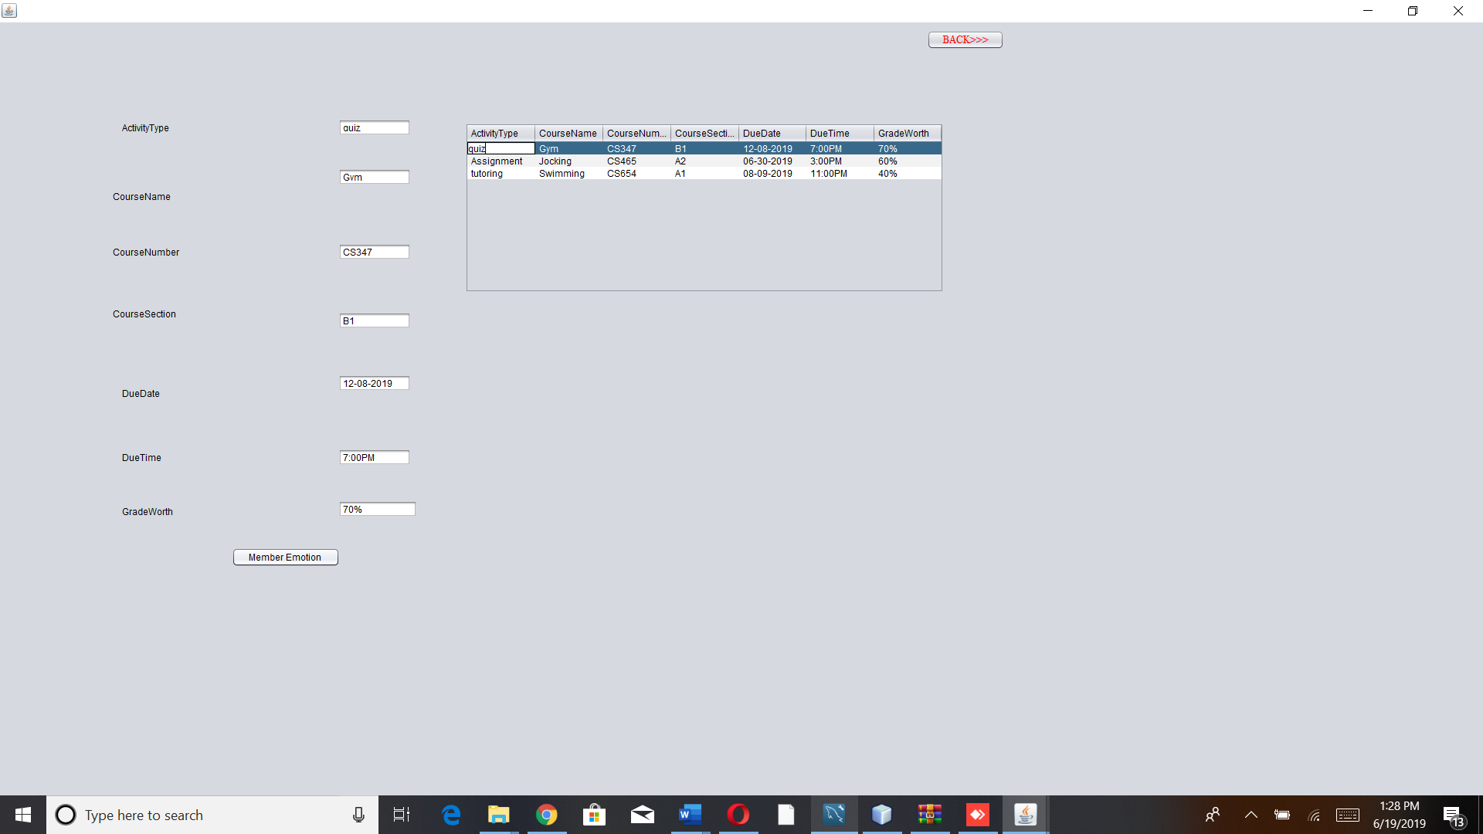

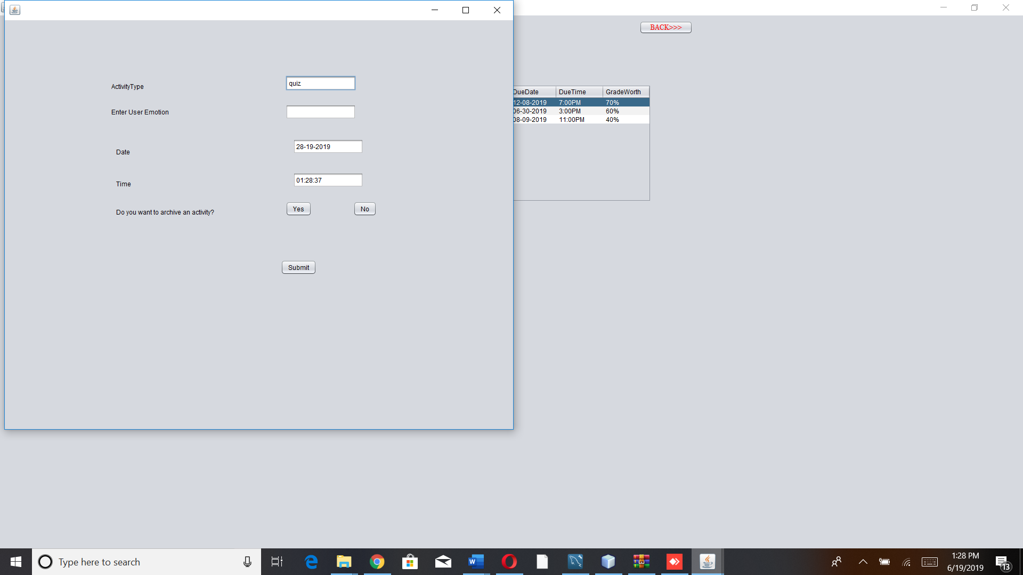

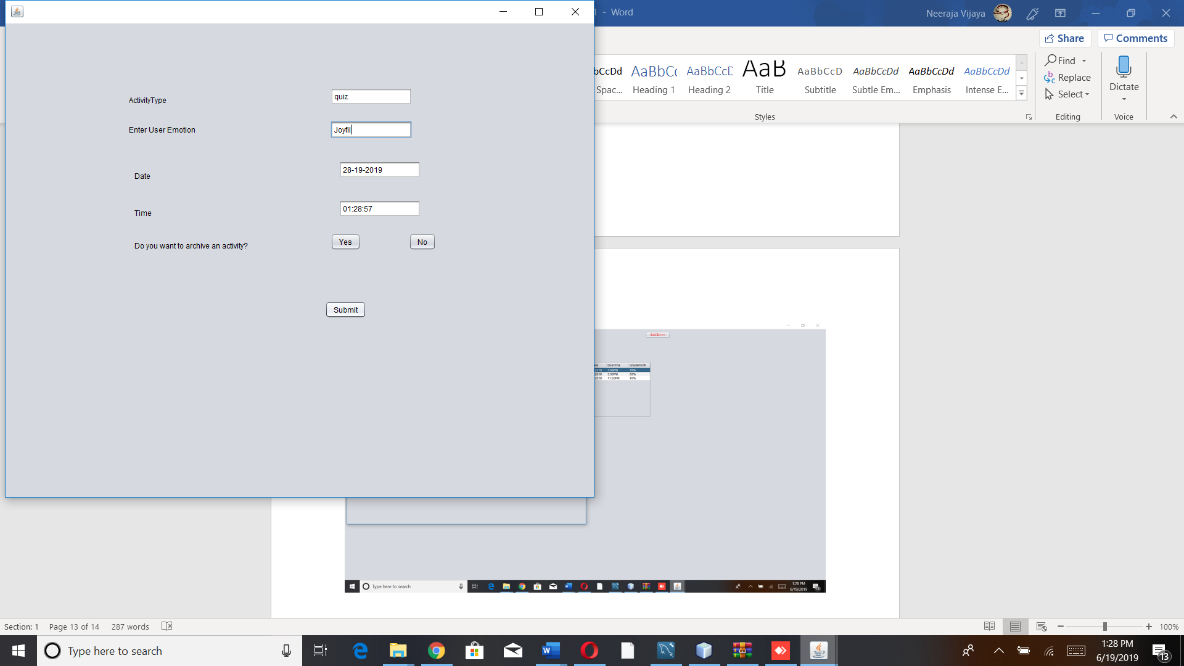

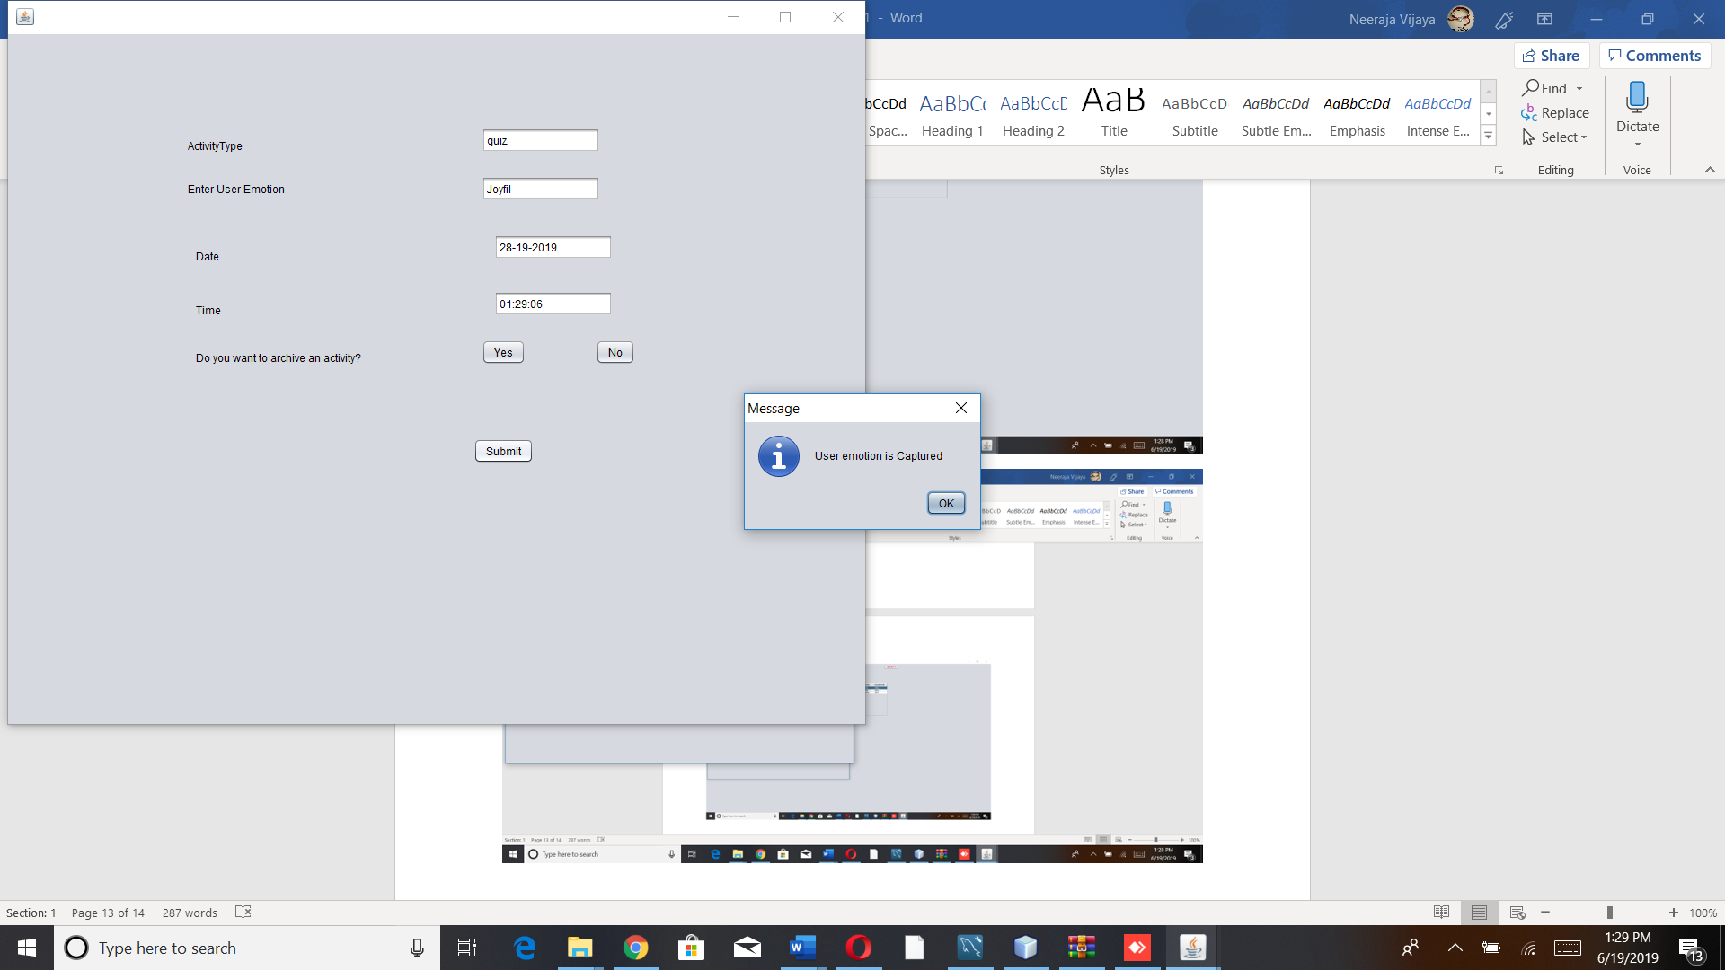

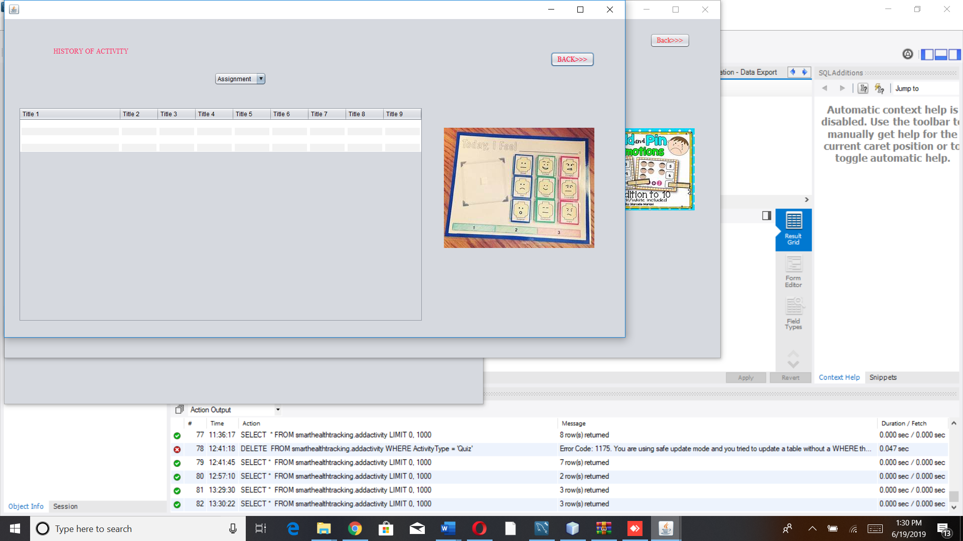

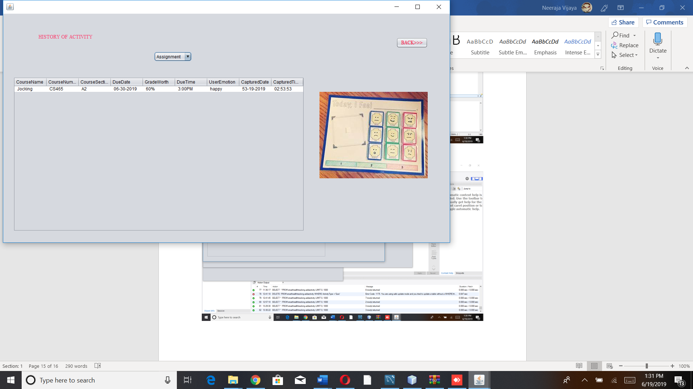

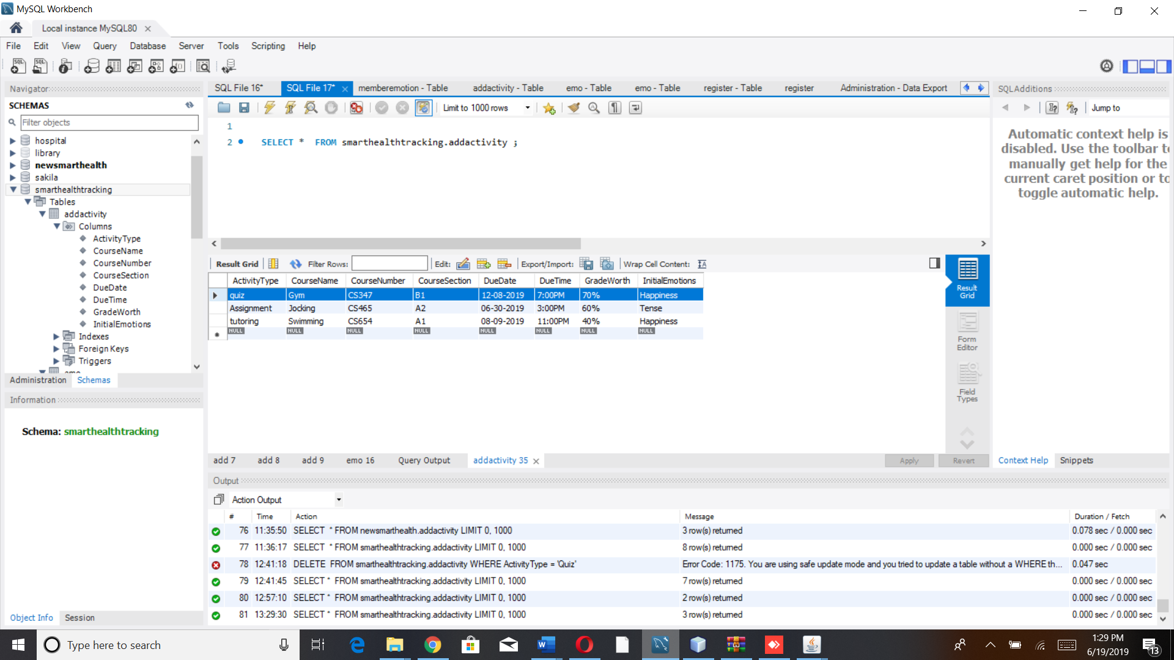

*Scenario 2:*

*Member will login to the system and will select the activity that need to be Archived that activity will be no longer available.*

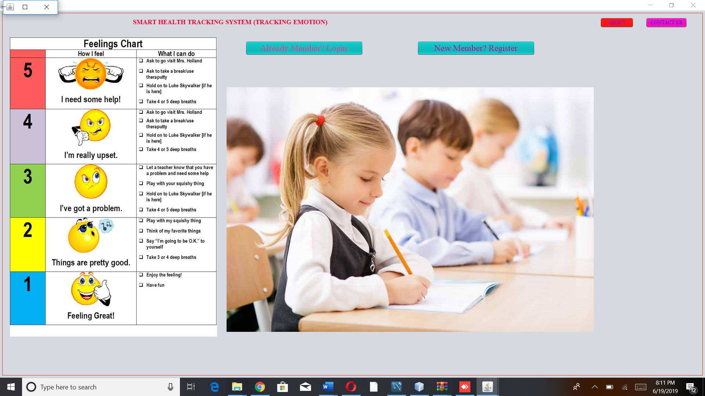

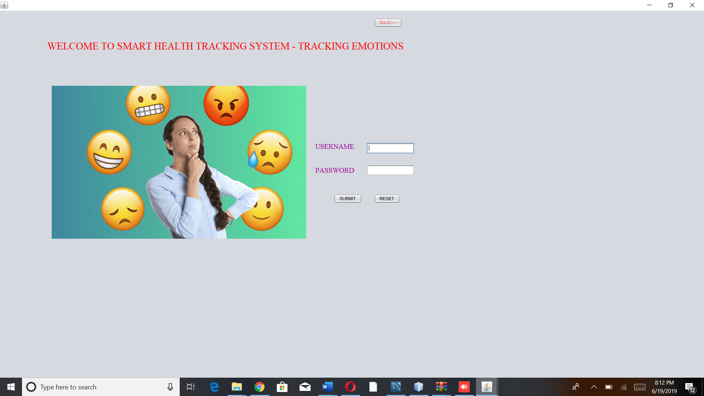

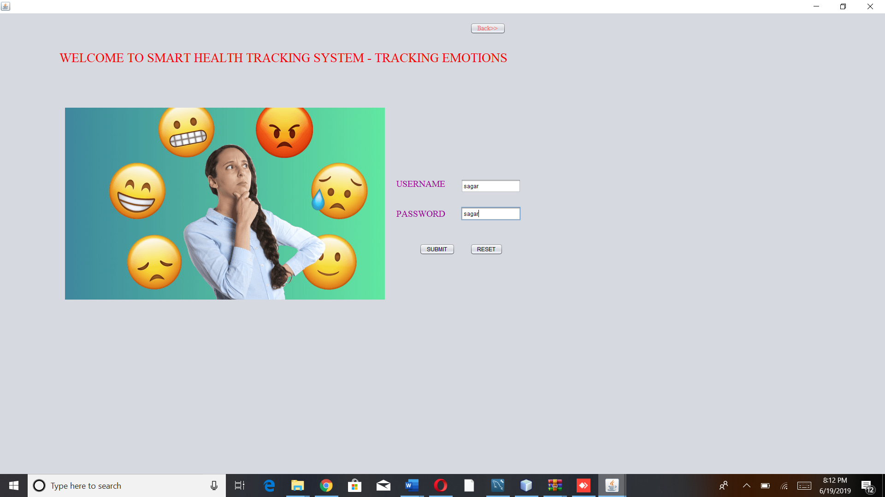

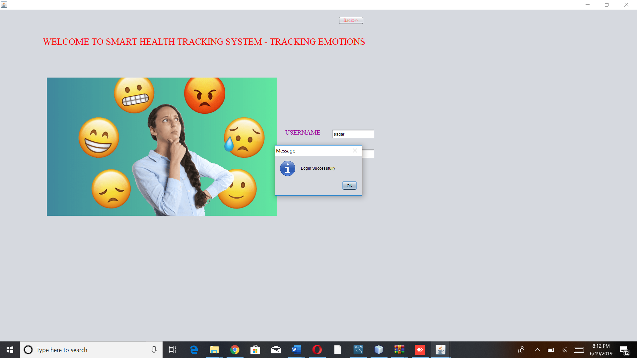

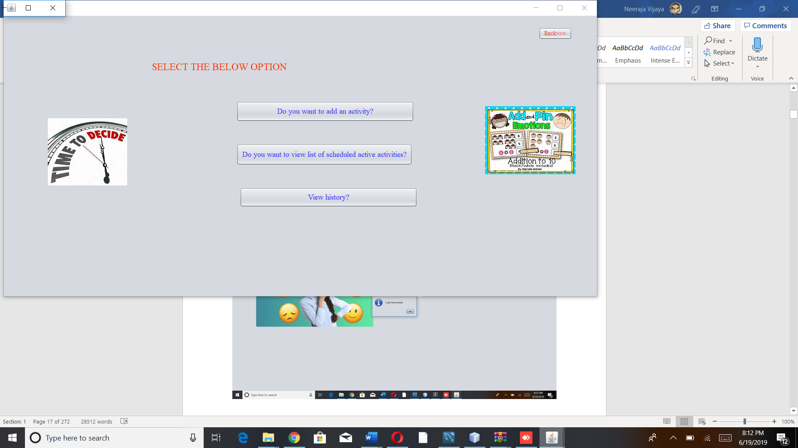

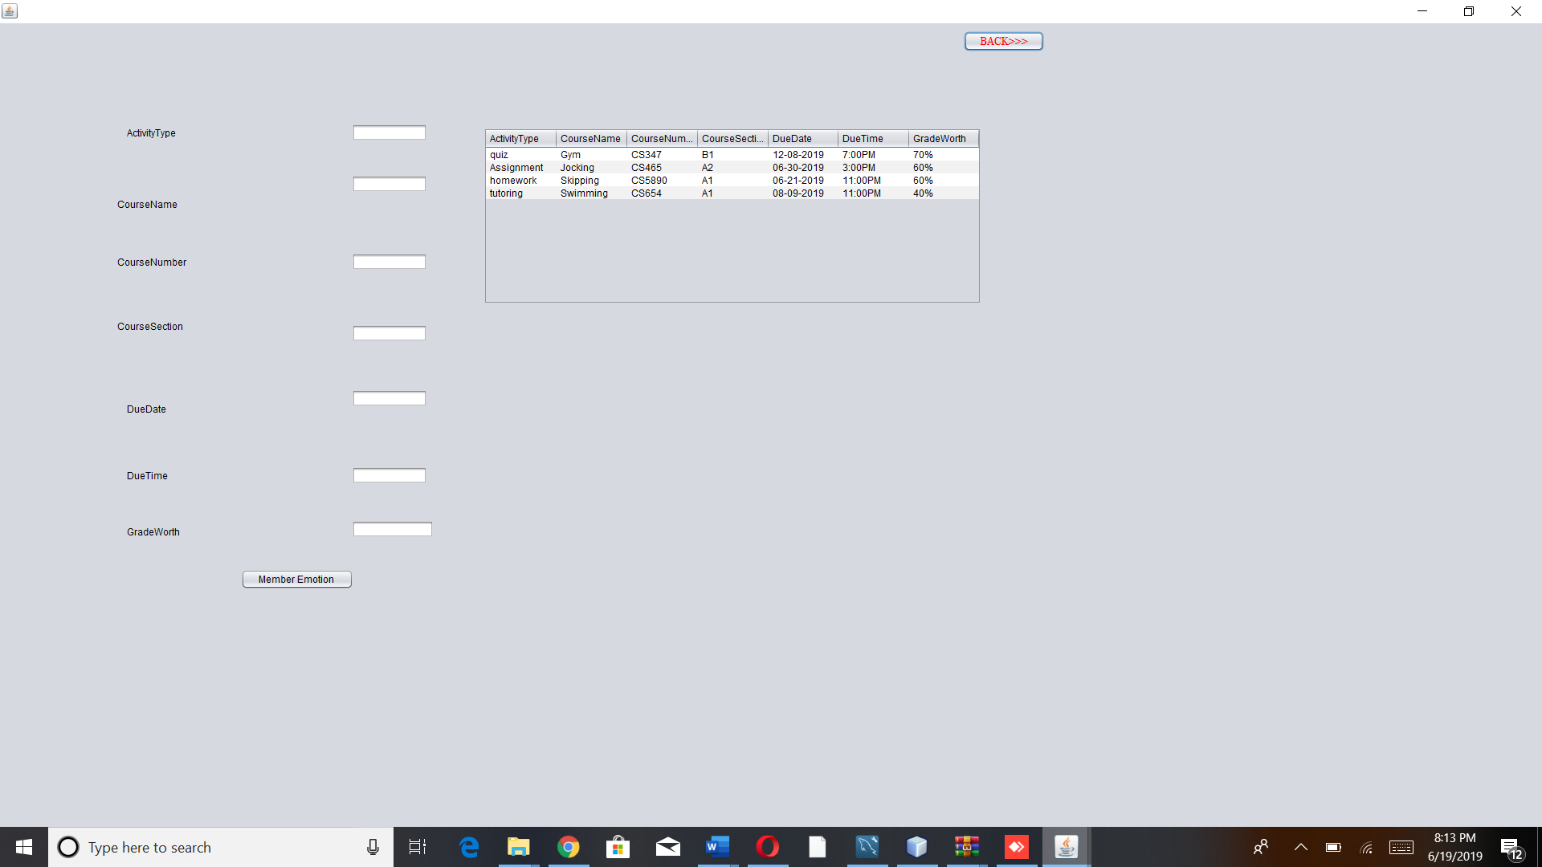

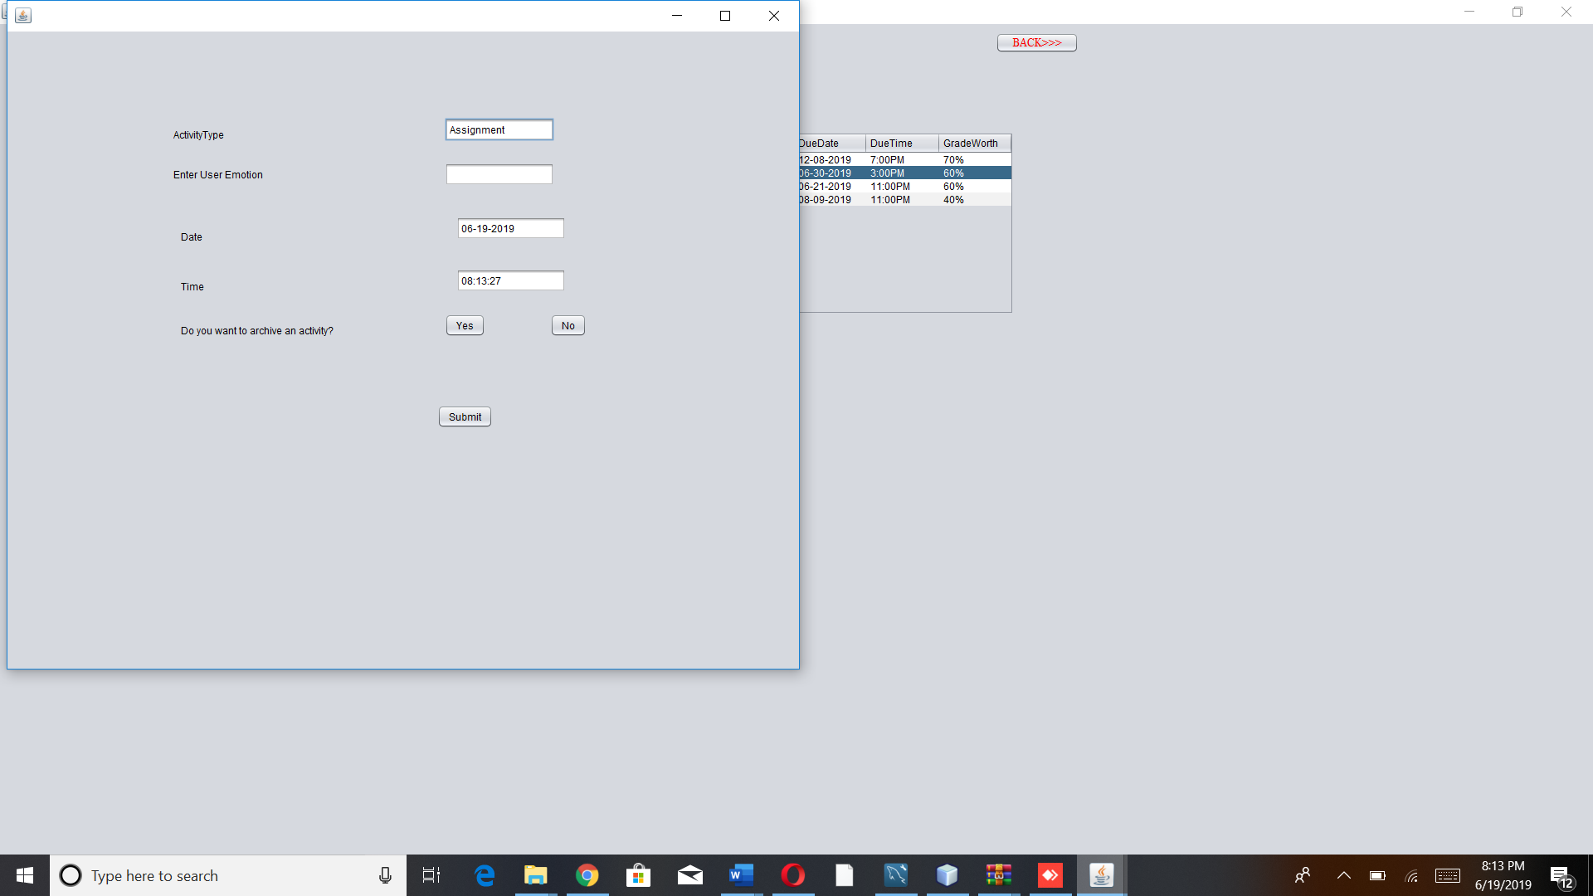

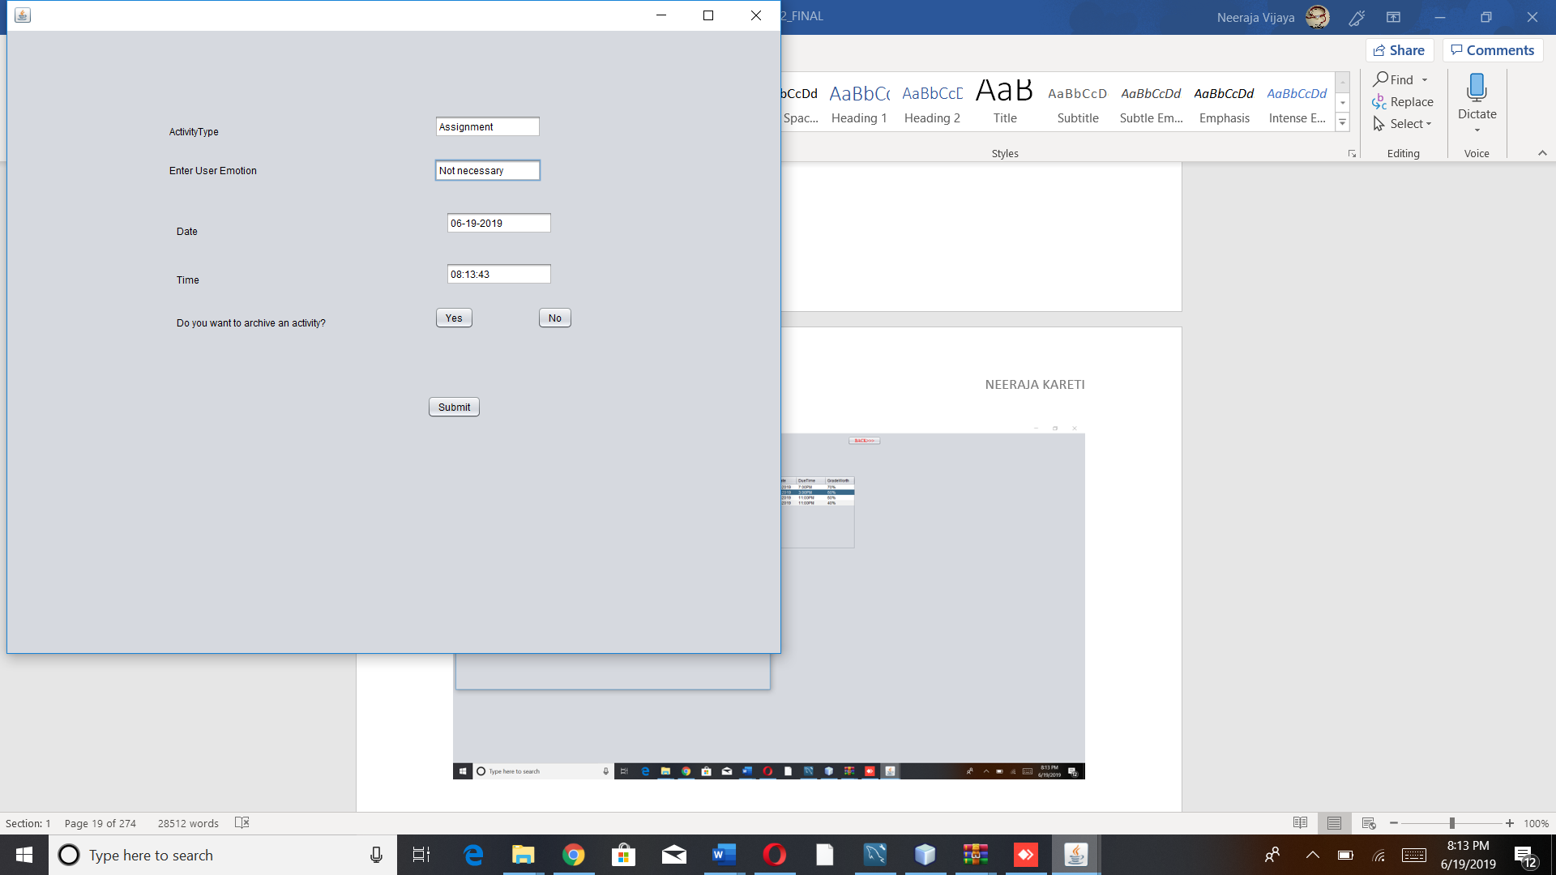

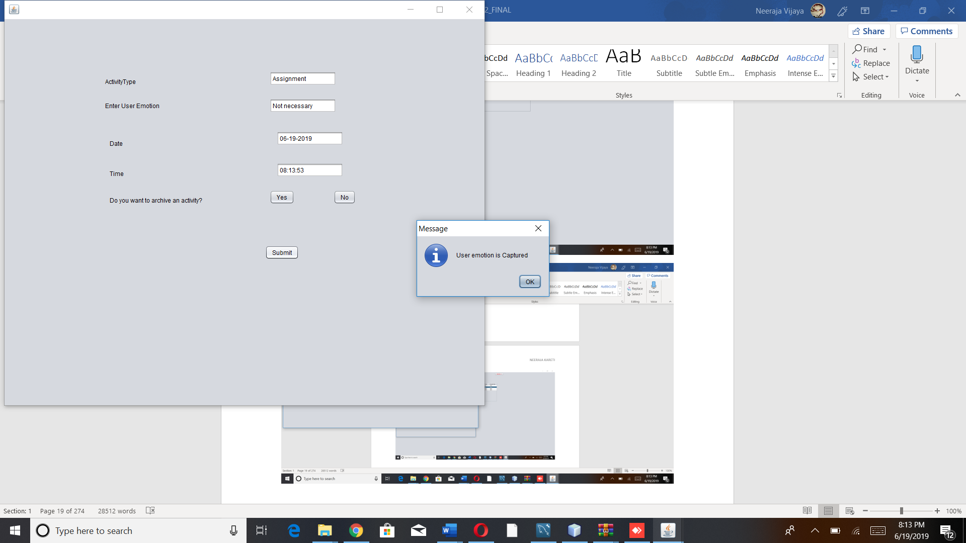

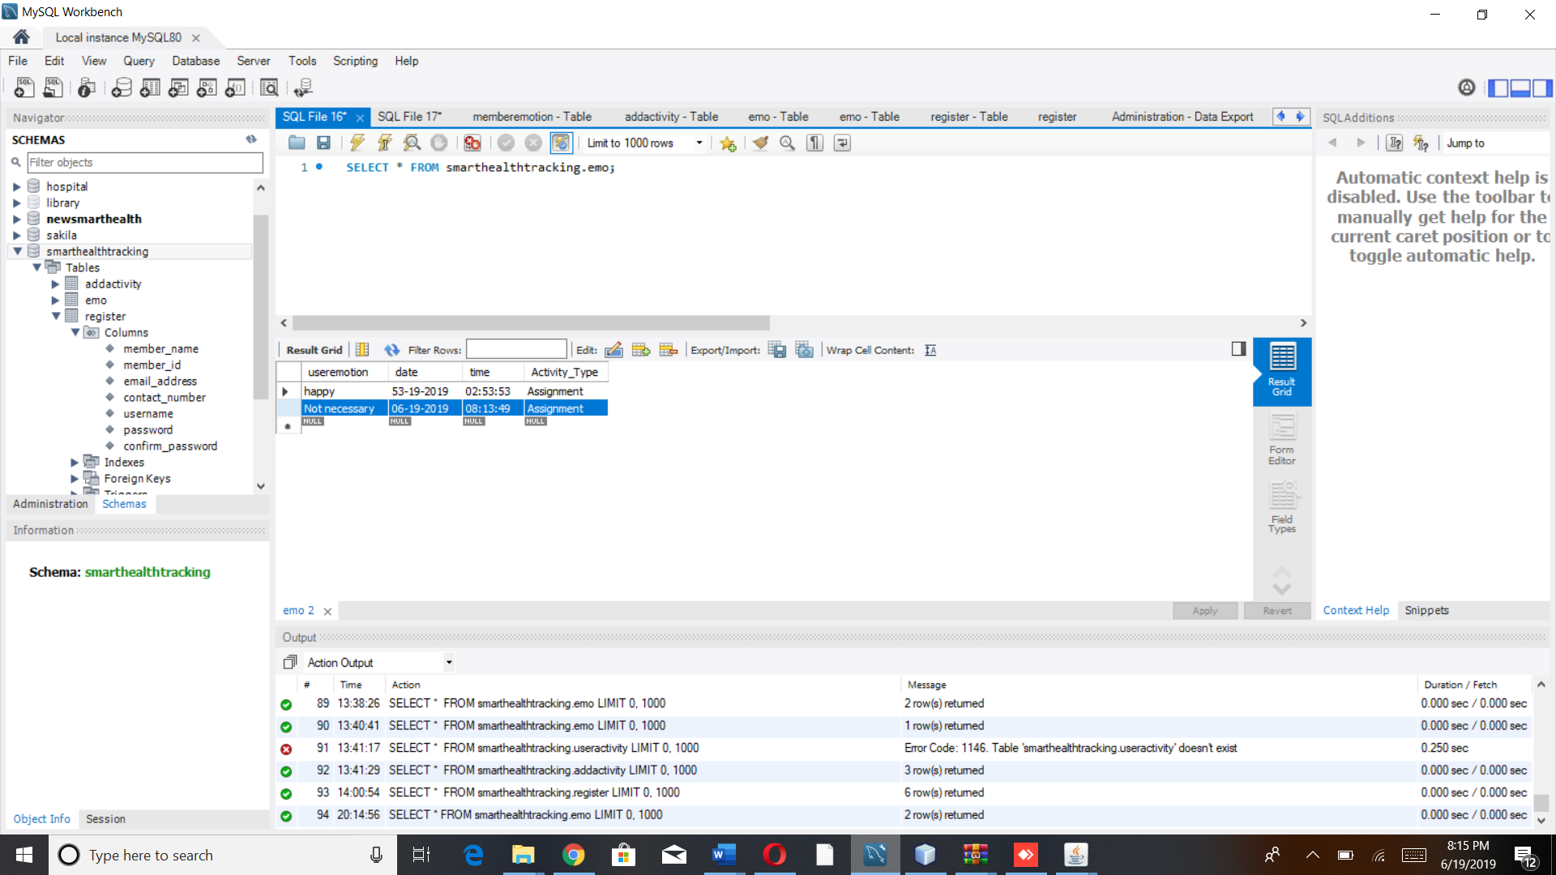

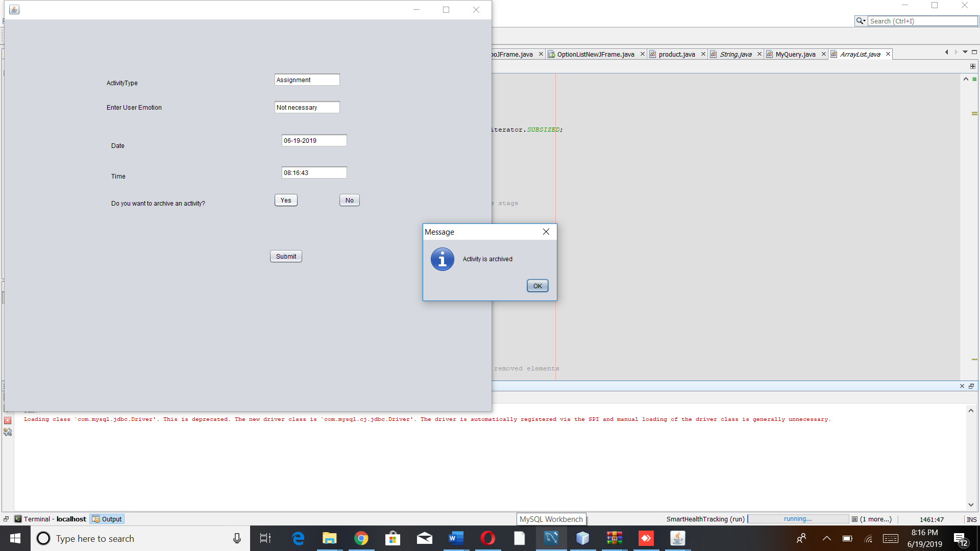

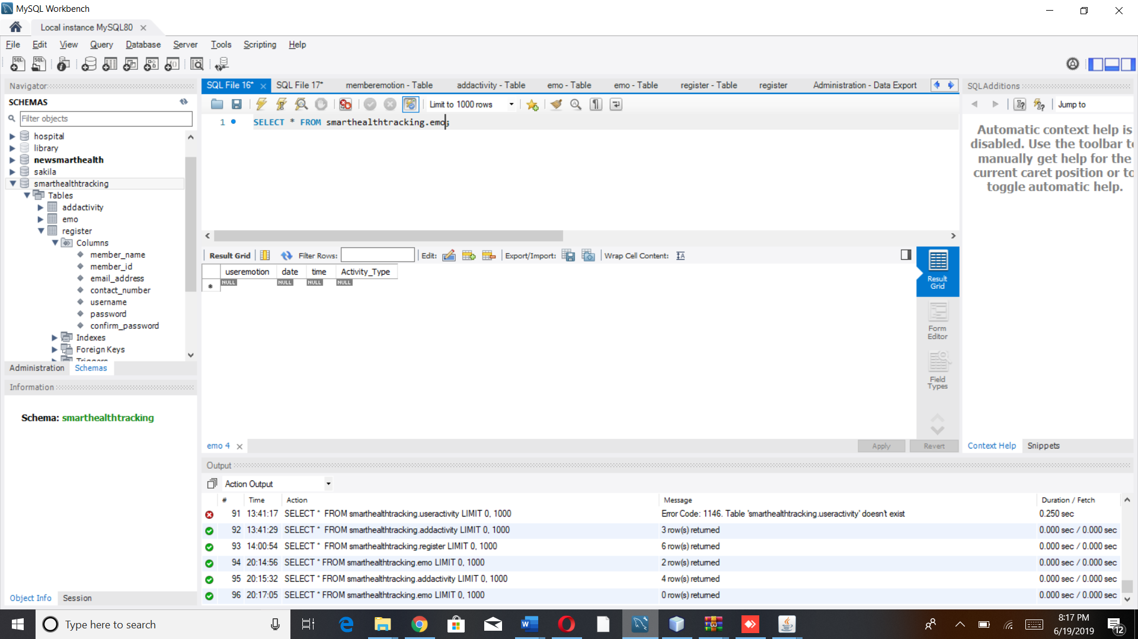

DB:

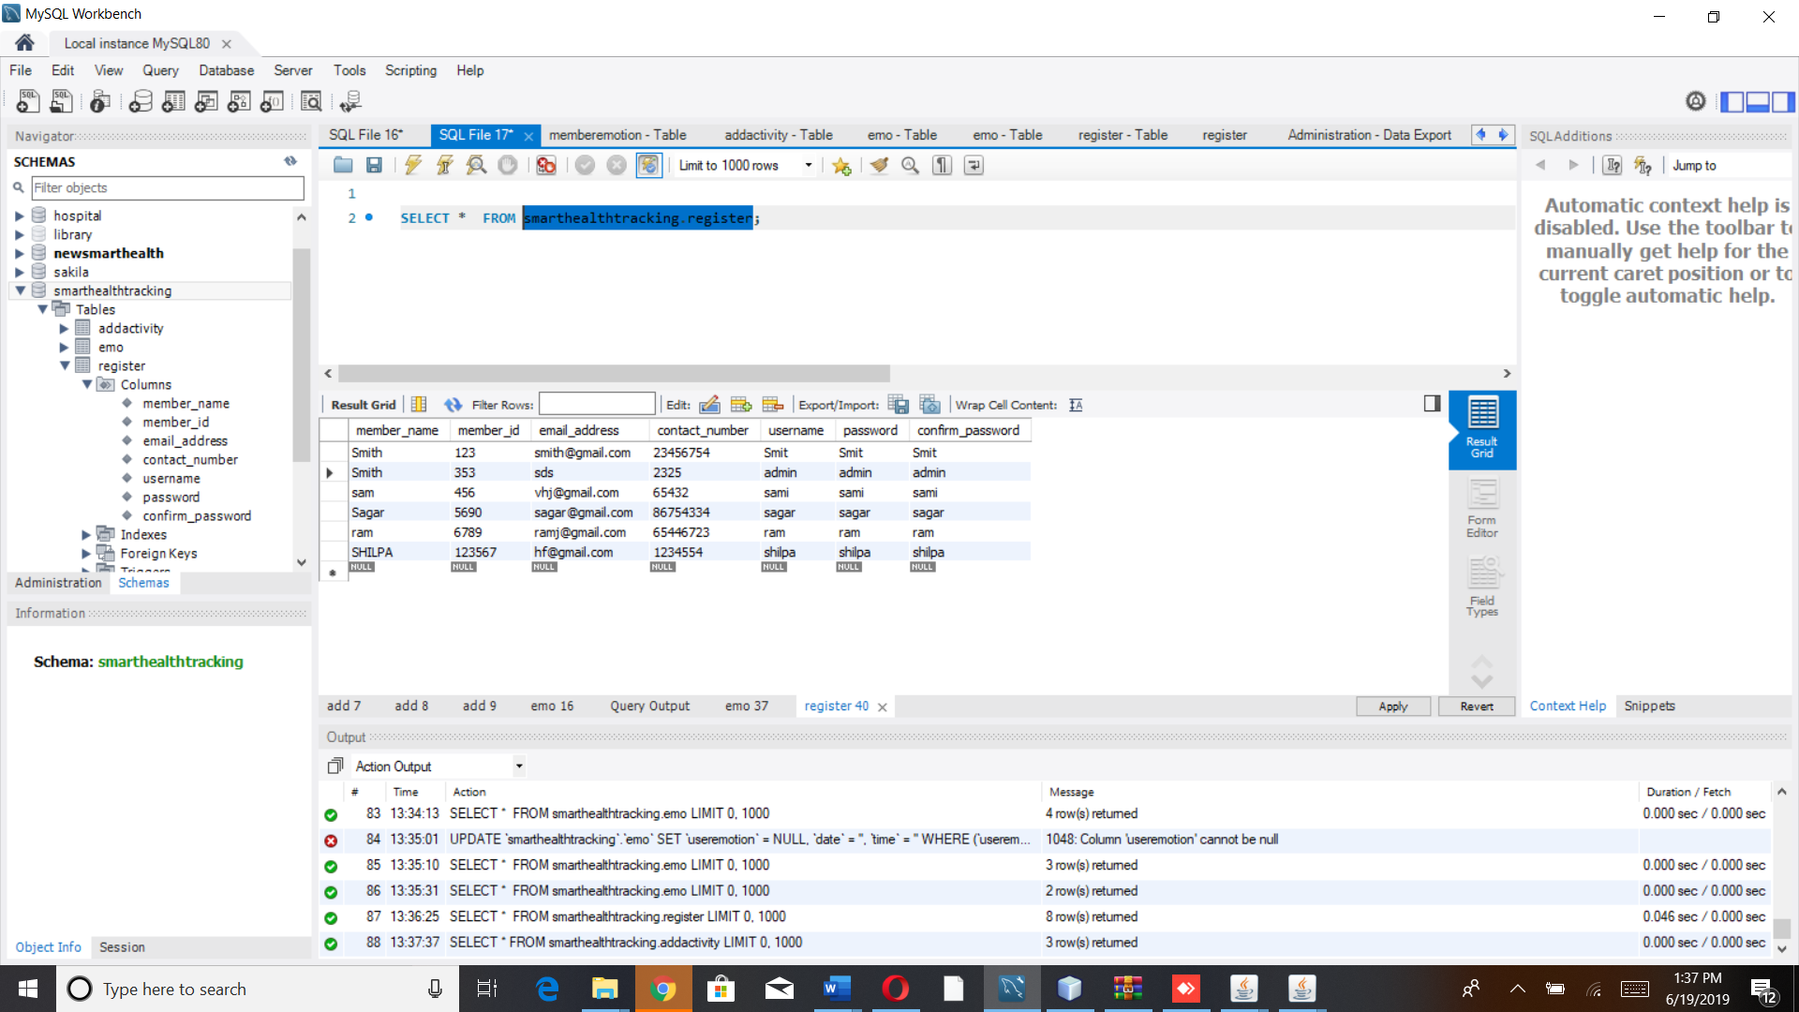

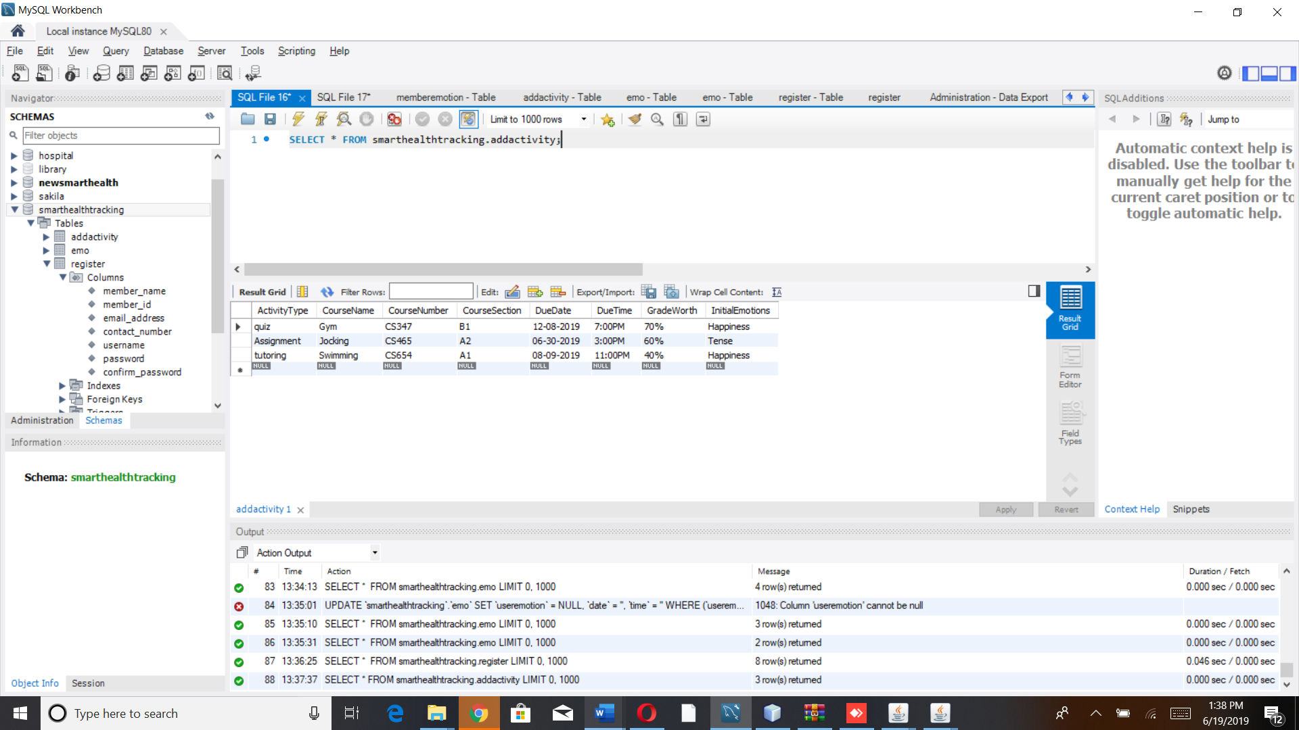

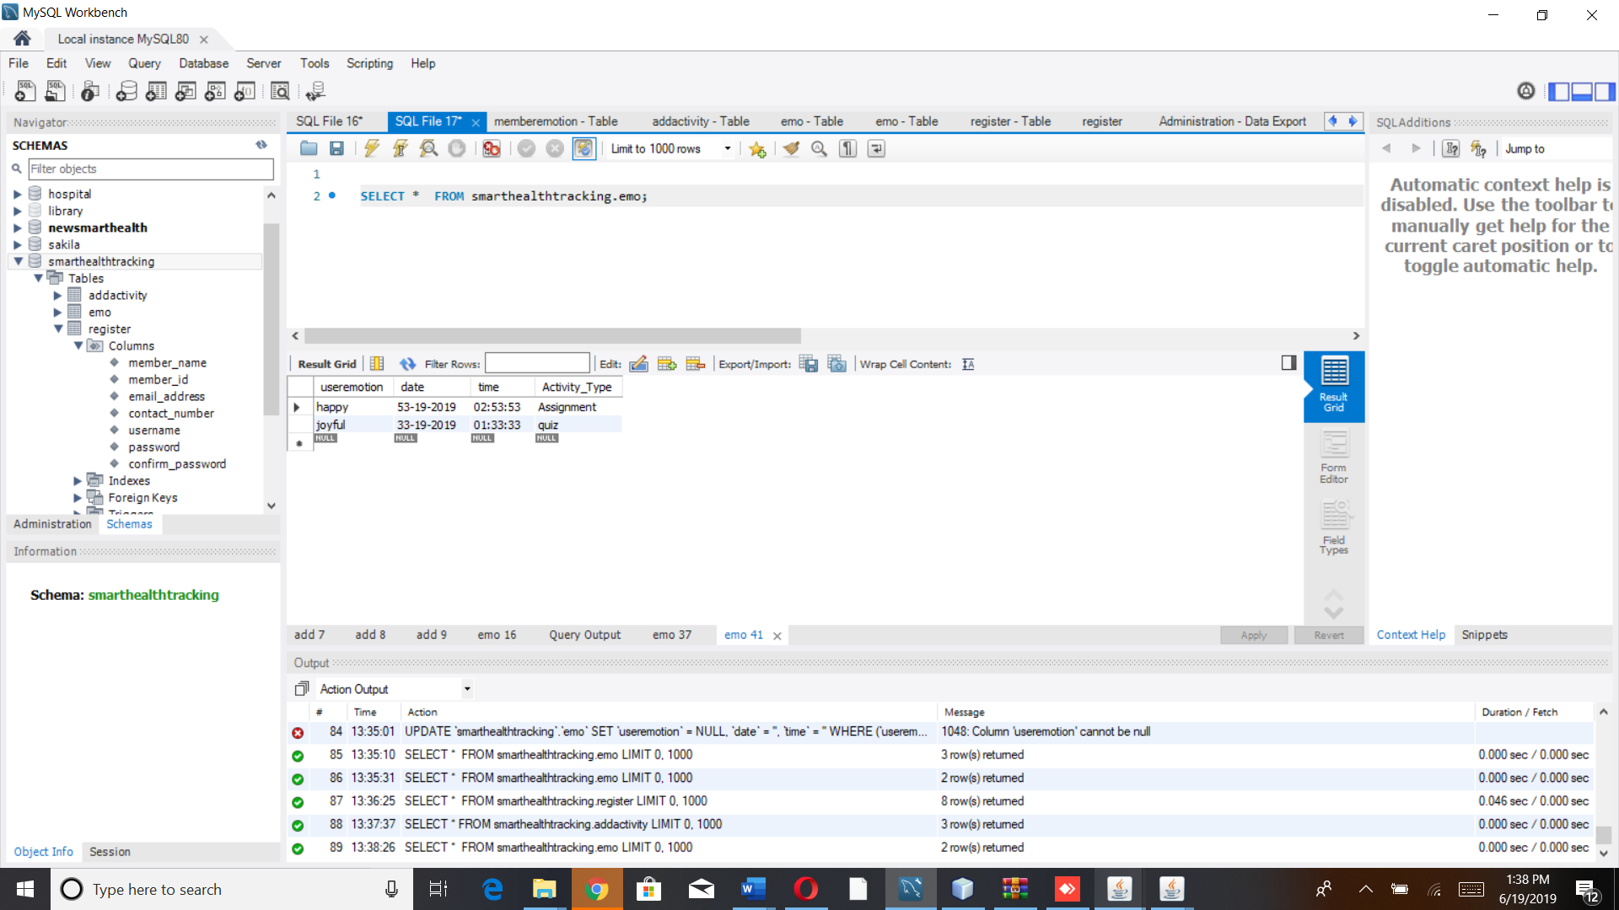

*Archived Activity*

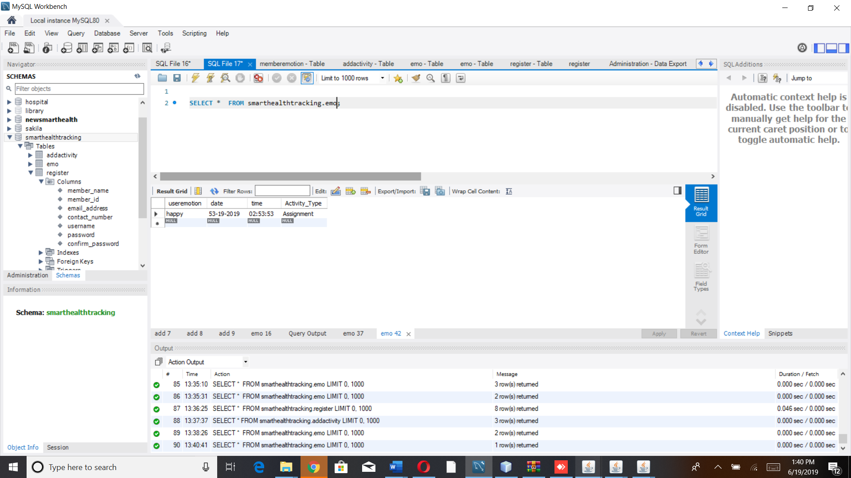

***CONCLUSION***

My experience in implementing the system is I am very grateful to work on this system it has provided me a lot of knowledge on stress activity and how to implement the interface for that. I had some troubles in retrieving the activity details like coursename, coursenumber etc ., for the selected activity.

***PROJECT CODE***

*Homepage*

/*

* To change this license header, choose License Headers in Project Properties.

* To change this template file, choose Tools | Templates

* and open the template in the editor.

*/

package Loginpackage;

import javax.swing.JFrame;

import javax.swing.JOptionPane;

/**

*

* @author neeru

*/

public class HomePageJFrame extends javax.swing.JFrame {

/**

* Creates new form HomePageJFrame

*/

public HomePageJFrame() {

initComponents();

}

/**

* This method is called from within the constructor to initialize the form.

* WARNING: Do NOT modify this code. The content of this method is always

* regenerated by the Form Editor.

*/

@SuppressWarnings("unchecked")

// <editor-fold defaultstate="collapsed" desc="Generated Code">

private void initComponents() {

jPanel1 = new javax.swing.JPanel();

jLabel1 = new javax.swing.JLabel();

jButton1 = new javax.swing.JButton();

jButton2 = new javax.swing.JButton();

jLabel2 = new javax.swing.JLabel();

jLabel3 = new javax.swing.JLabel();

jButton3 = new javax.swing.JButton();

jButton4 = new javax.swing.JButton();

setDefaultCloseOperation(javax.swing.WindowConstants.EXIT_ON_CLOSE);

jPanel1.setBorder(javax.swing.BorderFactory.createMatteBorder(1, 1, 1, 1, new java.awt.Color(204, 51, 0)));

jLabel1.setIcon(new javax.swing.ImageIcon("C:\\Users\\neeru\\Desktop\\homepage_hci.jpg")); // NOI18N

jButton1.setBackground(new java.awt.Color(0, 153, 153));

jButton1.setFont(new java.awt.Font("Times New Roman", 0, 24)); // NOI18N

jButton1.setForeground(new java.awt.Color(204, 0, 153));

jButton1.setText("New Member? Register");

jButton1.addActionListener(new java.awt.event.ActionListener() {

public void actionPerformed(java.awt.event.ActionEvent evt) {

jButton1ActionPerformed(evt);

}

});

jButton2.setBackground(new java.awt.Color(0, 153, 153));

jButton2.setFont(new java.awt.Font("Times New Roman", 0, 24)); // NOI18N

jButton2.setForeground(new java.awt.Color(255, 51, 153));

jButton2.setText("Already Member? Login");

jButton2.addActionListener(new java.awt.event.ActionListener() {

public void actionPerformed(java.awt.event.ActionEvent evt) {

jButton2ActionPerformed(evt);

}

});

jLabel2.setIcon(new javax.swing.ImageIcon("C:\\Users\\neeru\\Desktop\\Social-Emotional-Intelligence-in-the-Classroom.jpg")); // NOI18N

jLabel3.setBackground(new java.awt.Color(255, 153, 153));

jLabel3.setFont(new java.awt.Font("Times New Roman", 1, 18)); // NOI18N

jLabel3.setForeground(new java.awt.Color(255, 0, 51));

jLabel3.setText("SMART HEALTH TRACKING SYSTEM (TRACKING EMOTION)");

jButton3.setBackground(new java.awt.Color(255, 0, 0));

jButton3.setFont(new java.awt.Font("Times New Roman", 0, 14)); // NOI18N

jButton3.setForeground(new java.awt.Color(102, 0, 255));

jButton3.setText("ABOUT");

jButton4.setBackground(new java.awt.Color(204, 0, 153));

jButton4.setFont(new java.awt.Font("Times New Roman", 0, 14)); // NOI18N

jButton4.setForeground(new java.awt.Color(51, 0, 255));

jButton4.setText("CONTACT US");

javax.swing.GroupLayout jPanel1Layout = new javax.swing.GroupLayout(jPanel1);

jPanel1.setLayout(jPanel1Layout);

jPanel1Layout.setHorizontalGroup(

jPanel1Layout.createParallelGroup(javax.swing.GroupLayout.Alignment.LEADING)

.addGroup(jPanel1Layout.createSequentialGroup()

.addGap(20, 20, 20)

.addComponent(jLabel1)

.addGroup(jPanel1Layout.createParallelGroup(javax.swing.GroupLayout.Alignment.LEADING)

.addGroup(jPanel1Layout.createSequentialGroup()

.addGap(77, 77, 77)

.addComponent(jButton2, javax.swing.GroupLayout.PREFERRED_SIZE, 321, javax.swing.GroupLayout.PREFERRED_SIZE)

.addGap(147, 147, 147)

.addComponent(jButton1, javax.swing.GroupLayout.PREFERRED_SIZE, 321, javax.swing.GroupLayout.PREFERRED_SIZE))

.addGroup(jPanel1Layout.createSequentialGroup()

.addGap(26, 26, 26)

.addComponent(jLabel2, javax.swing.GroupLayout.PREFERRED_SIZE, 1082, javax.swing.GroupLayout.PREFERRED_SIZE)))

.addContainerGap(javax.swing.GroupLayout.DEFAULT_SIZE, Short.MAX_VALUE))

.addGroup(jPanel1Layout.createSequentialGroup()

.addGap(355, 355, 355)

.addComponent(jLabel3, javax.swing.GroupLayout.PREFERRED_SIZE, 556, javax.swing.GroupLayout.PREFERRED_SIZE)

.addPreferredGap(javax.swing.LayoutStyle.ComponentPlacement.RELATED, javax.swing.GroupLayout.DEFAULT_SIZE, Short.MAX_VALUE)

.addComponent(jButton3, javax.swing.GroupLayout.PREFERRED_SIZE, 92, javax.swing.GroupLayout.PREFERRED_SIZE)

.addGap(32, 32, 32)

.addComponent(jButton4)

.addGap(41, 41, 41))

);

jPanel1Layout.setVerticalGroup(

jPanel1Layout.createParallelGroup(javax.swing.GroupLayout.Alignment.LEADING)

.addGroup(jPanel1Layout.createSequentialGroup()

.addContainerGap()

.addGroup(jPanel1Layout.createParallelGroup(javax.swing.GroupLayout.Alignment.BASELINE)

.addComponent(jLabel3, javax.swing.GroupLayout.PREFERRED_SIZE, 36, javax.swing.GroupLayout.PREFERRED_SIZE)

.addComponent(jButton3)

.addComponent(jButton4))

.addPreferredGap(javax.swing.LayoutStyle.ComponentPlacement.RELATED)

.addGroup(jPanel1Layout.createParallelGroup(javax.swing.GroupLayout.Alignment.LEADING)

.addGroup(jPanel1Layout.createSequentialGroup()

.addGap(27, 27, 27)

.addGroup(jPanel1Layout.createParallelGroup(javax.swing.GroupLayout.Alignment.BASELINE)

.addComponent(jButton2)

.addComponent(jButton1))

.addPreferredGap(javax.swing.LayoutStyle.ComponentPlacement.RELATED)

.addComponent(jLabel2, javax.swing.GroupLayout.PREFERRED_SIZE, 828, javax.swing.GroupLayout.PREFERRED_SIZE)

.addContainerGap(javax.swing.GroupLayout.DEFAULT_SIZE, Short.MAX_VALUE))

.addGroup(jPanel1Layout.createSequentialGroup()

.addComponent(jLabel1, javax.swing.GroupLayout.PREFERRED_SIZE, 853, javax.swing.GroupLayout.PREFERRED_SIZE)

.addGap(0, 0, Short.MAX_VALUE))))

);

javax.swing.GroupLayout layout = new javax.swing.GroupLayout(getContentPane());

getContentPane().setLayout(layout);

layout.setHorizontalGroup(

layout.createParallelGroup(javax.swing.GroupLayout.Alignment.LEADING)

.addGroup(javax.swing.GroupLayout.Alignment.TRAILING, layout.createSequentialGroup()

.addContainerGap()

.addComponent(jPanel1, javax.swing.GroupLayout.DEFAULT_SIZE, javax.swing.GroupLayout.DEFAULT_SIZE, Short.MAX_VALUE)

.addContainerGap())

);

layout.setVerticalGroup(

layout.createParallelGroup(javax.swing.GroupLayout.Alignment.LEADING)

.addGroup(layout.createSequentialGroup()

.addContainerGap()

.addComponent(jPanel1, javax.swing.GroupLayout.DEFAULT_SIZE, javax.swing.GroupLayout.DEFAULT_SIZE, Short.MAX_VALUE)

.addContainerGap())

);

pack();

}// </editor-fold>

private void jButton1ActionPerformed(java.awt.event.ActionEvent evt) {

RegisterJFrame r = new RegisterJFrame();

r.setVisible(true);

// TODO add your handling code here:

}

private void jButton2ActionPerformed(java.awt.event.ActionEvent evt) {

LoginJFrame j = new LoginJFrame();

j.setVisible(true); // TODO add your handling code here:

}

/**

* @param args the command line arguments

*/

public static void main(String args[]) {

/* Set the Nimbus look and feel */

//<editor-fold defaultstate="collapsed" desc=" Look and feel setting code (optional) ">

/* If Nimbus (introduced in Java SE 6) is not available, stay with the default look and feel.

* For details see http://download.oracle.com/javase/tutorial/uiswing/lookandfeel/plaf.html

*/

try {

for (javax.swing.UIManager.LookAndFeelInfo info : javax.swing.UIManager.getInstalledLookAndFeels()) {

if ("Nimbus".equals(info.getName())) {

javax.swing.UIManager.setLookAndFeel(info.getClassName());

break;

}

}

} catch (ClassNotFoundException ex) {

java.util.logging.Logger.getLogger(HomePageJFrame.class.getName()).log(java.util.logging.Level.SEVERE, null, ex);

} catch (InstantiationException ex) {

java.util.logging.Logger.getLogger(HomePageJFrame.class.getName()).log(java.util.logging.Level.SEVERE, null, ex);

} catch (IllegalAccessException ex) {

java.util.logging.Logger.getLogger(HomePageJFrame.class.getName()).log(java.util.logging.Level.SEVERE, null, ex);

} catch (javax.swing.UnsupportedLookAndFeelException ex) {

java.util.logging.Logger.getLogger(HomePageJFrame.class.getName()).log(java.util.logging.Level.SEVERE, null, ex);

}

//</editor-fold>

//</editor-fold>

/* Create and display the form */

java.awt.EventQueue.invokeLater(new Runnable() {

public void run() {

new HomePageJFrame().setVisible(true);

}

});

}

// Variables declaration - do not modify

private javax.swing.JButton jButton1;

private javax.swing.JButton jButton2;

private javax.swing.JButton jButton3;

private javax.swing.JButton jButton4;

private javax.swing.JLabel jLabel1;

private javax.swing.JLabel jLabel2;

private javax.swing.JLabel jLabel3;

private javax.swing.JPanel jPanel1;

// End of variables declaration

}

*RegisterPage*

/*

* To change this license header, choose License Headers in Project Properties.

* To change this template file, choose Tools | Templates

* and open the template in the editor.

*/

package Loginpackage;

import java.sql.Connection;

import java.sql.DriverManager;

import java.sql.PreparedStatement;

import javax.swing.JOptionPane;

/**

*

* @author neeru

*/

public class RegisterJFrame extends javax.swing.JFrame {

/**

* Creates new form RegisterJFrame

*/

public RegisterJFrame() {

initComponents();

}

/**

* This method is called from within the constructor to initialize the form.

* WARNING: Do NOT modify this code. The content of this method is always

* regenerated by the Form Editor.

*/

@SuppressWarnings("unchecked")

// <editor-fold defaultstate="collapsed" desc="Generated Code">

private void initComponents() {

jPanel1 = new javax.swing.JPanel();

jLabel1 = new javax.swing.JLabel();

jLabel2 = new javax.swing.JLabel();

jLabel3 = new javax.swing.JLabel();

jLabel4 = new javax.swing.JLabel();

jLabel5 = new javax.swing.JLabel();

jLabel6 = new javax.swing.JLabel();

jLabel7 = new javax.swing.JLabel();

jLabel8 = new javax.swing.JLabel();

jLabel9 = new javax.swing.JLabel();

jLabel10 = new javax.swing.JLabel();

mn = new javax.swing.JTextField();

mi = new javax.swing.JTextField();

ea = new javax.swing.JTextField();

cn = new javax.swing.JTextField();

un = new javax.swing.JTextField();

pwd = new javax.swing.JTextField();

cpwd = new javax.swing.JTextField();

btn_add = new javax.swing.JButton();

jButton1 = new javax.swing.JButton();

setDefaultCloseOperation(javax.swing.WindowConstants.EXIT_ON_CLOSE);

getContentPane().setLayout(null);

jLabel1.setIcon(new javax.swing.ImageIcon("C:\\Users\\neeru\\Desktop\\REG.png")); // NOI18N

jLabel2.setBackground(new java.awt.Color(255, 0, 102));

jLabel2.setFont(new java.awt.Font("Times New Roman", 0, 18)); // NOI18N

jLabel2.setForeground(new java.awt.Color(255, 0, 0));

jLabel2.setText("WELCOME TO SMART HEALTH TRACKING SYSTEM - REGISTRATION!!!");

jLabel3.setText("MEMBER NAME");

jLabel4.setText("MEMBER ID");

jLabel5.setText("EMAIL ADDRESS");

jLabel6.setText("CONTACT NO");

jLabel7.setText("USER NAME");

jLabel9.setText("PASSWORD");

jLabel10.setText("CONFIRM PASSWORD");

cn.addActionListener(new java.awt.event.ActionListener() {

public void actionPerformed(java.awt.event.ActionEvent evt) {

cnActionPerformed(evt);

}

});

btn_add.setText("ADD_MEMBER");

btn_add.addActionListener(new java.awt.event.ActionListener() {

public void actionPerformed(java.awt.event.ActionEvent evt) {

btn_addActionPerformed(evt);

}

});

jButton1.setForeground(new java.awt.Color(255, 51, 51));

jButton1.setText("Back>>>");

jButton1.addActionListener(new java.awt.event.ActionListener() {

public void actionPerformed(java.awt.event.ActionEvent evt) {

jButton1ActionPerformed(evt);

}

});

javax.swing.GroupLayout jPanel1Layout = new javax.swing.GroupLayout(jPanel1);

jPanel1.setLayout(jPanel1Layout);

jPanel1Layout.setHorizontalGroup(

jPanel1Layout.createParallelGroup(javax.swing.GroupLayout.Alignment.LEADING)

.addGroup(jPanel1Layout.createSequentialGroup()

.addGroup(jPanel1Layout.createParallelGroup(javax.swing.GroupLayout.Alignment.LEADING)

.addGroup(jPanel1Layout.createSequentialGroup()

.addGap(42, 42, 42)

.addComponent(jLabel1, javax.swing.GroupLayout.PREFERRED_SIZE, 491, javax.swing.GroupLayout.PREFERRED_SIZE)

.addGap(108, 108, 108)

.addGroup(jPanel1Layout.createParallelGroup(javax.swing.GroupLayout.Alignment.LEADING)

.addGroup(jPanel1Layout.createSequentialGroup()

.addGap(75, 75, 75)

.addComponent(jLabel8))

.addGroup(jPanel1Layout.createSequentialGroup()

.addGroup(jPanel1Layout.createParallelGroup(javax.swing.GroupLayout.Alignment.LEADING)

.addGroup(jPanel1Layout.createParallelGroup(javax.swing.GroupLayout.Alignment.LEADING, false)

.addComponent(jLabel5, javax.swing.GroupLayout.PREFERRED_SIZE, 102, javax.swing.GroupLayout.PREFERRED_SIZE)

.addComponent(jLabel6, javax.swing.GroupLayout.DEFAULT_SIZE, javax.swing.GroupLayout.DEFAULT_SIZE, Short.MAX_VALUE)

.addComponent(jLabel4, javax.swing.GroupLayout.DEFAULT_SIZE, javax.swing.GroupLayout.DEFAULT_SIZE, Short.MAX_VALUE)

.addComponent(jLabel3, javax.swing.GroupLayout.DEFAULT_SIZE, 122, Short.MAX_VALUE)

.addComponent(jLabel7, javax.swing.GroupLayout.PREFERRED_SIZE, 92, javax.swing.GroupLayout.PREFERRED_SIZE))

.addComponent(jLabel9, javax.swing.GroupLayout.PREFERRED_SIZE, 92, javax.swing.GroupLayout.PREFERRED_SIZE)

.addComponent(jLabel10, javax.swing.GroupLayout.PREFERRED_SIZE, 135, javax.swing.GroupLayout.PREFERRED_SIZE))

.addGap(80, 80, 80)

.addGroup(jPanel1Layout.createParallelGroup(javax.swing.GroupLayout.Alignment.LEADING, false)

.addComponent(ea, javax.swing.GroupLayout.DEFAULT_SIZE, 112, Short.MAX_VALUE)

.addComponent(mn)

.addComponent(mi)

.addComponent(cn)

.addComponent(un)

.addComponent(pwd)

.addComponent(cpwd)))))

.addGroup(jPanel1Layout.createSequentialGroup()

.addGap(388, 388, 388)

.addComponent(jLabel2)))

.addContainerGap(76, Short.MAX_VALUE))

.addGroup(javax.swing.GroupLayout.Alignment.TRAILING, jPanel1Layout.createSequentialGroup()

.addGap(0, 0, Short.MAX_VALUE)

.addGroup(jPanel1Layout.createParallelGroup(javax.swing.GroupLayout.Alignment.LEADING)

.addGroup(javax.swing.GroupLayout.Alignment.TRAILING, jPanel1Layout.createSequentialGroup()

.addComponent(btn_add)

.addGap(218, 218, 218))

.addGroup(javax.swing.GroupLayout.Alignment.TRAILING, jPanel1Layout.createSequentialGroup()

.addComponent(jButton1)

.addContainerGap())))

);

jPanel1Layout.setVerticalGroup(

jPanel1Layout.createParallelGroup(javax.swing.GroupLayout.Alignment.LEADING)

.addGroup(javax.swing.GroupLayout.Alignment.TRAILING, jPanel1Layout.createSequentialGroup()

.addGap(26, 26, 26)

.addComponent(jButton1)

.addGap(30, 30, 30)

.addComponent(jLabel2)

.addGroup(jPanel1Layout.createParallelGroup(javax.swing.GroupLayout.Alignment.LEADING)

.addGroup(jPanel1Layout.createSequentialGroup()

.addPreferredGap(javax.swing.LayoutStyle.ComponentPlacement.RELATED, javax.swing.GroupLayout.DEFAULT_SIZE, Short.MAX_VALUE)

.addComponent(jLabel1, javax.swing.GroupLayout.PREFERRED_SIZE, 383, javax.swing.GroupLayout.PREFERRED_SIZE)

.addGap(187, 187, 187))

.addGroup(jPanel1Layout.createSequentialGroup()

.addGap(121, 121, 121)

.addGroup(jPanel1Layout.createParallelGroup(javax.swing.GroupLayout.Alignment.BASELINE)

.addComponent(jLabel3, javax.swing.GroupLayout.PREFERRED_SIZE, 35, javax.swing.GroupLayout.PREFERRED_SIZE)

.addComponent(mn, javax.swing.GroupLayout.PREFERRED_SIZE, javax.swing.GroupLayout.DEFAULT_SIZE, javax.swing.GroupLayout.PREFERRED_SIZE))

.addGap(33, 33, 33)

.addGroup(jPanel1Layout.createParallelGroup(javax.swing.GroupLayout.Alignment.BASELINE)

.addComponent(jLabel4, javax.swing.GroupLayout.PREFERRED_SIZE, 22, javax.swing.GroupLayout.PREFERRED_SIZE)

.addComponent(mi, javax.swing.GroupLayout.PREFERRED_SIZE, javax.swing.GroupLayout.DEFAULT_SIZE, javax.swing.GroupLayout.PREFERRED_SIZE))

.addGap(38, 38, 38)

.addGroup(jPanel1Layout.createParallelGroup(javax.swing.GroupLayout.Alignment.BASELINE)

.addComponent(jLabel5, javax.swing.GroupLayout.PREFERRED_SIZE, 26, javax.swing.GroupLayout.PREFERRED_SIZE)

.addComponent(ea, javax.swing.GroupLayout.PREFERRED_SIZE, javax.swing.GroupLayout.DEFAULT_SIZE, javax.swing.GroupLayout.PREFERRED_SIZE))

.addGap(32, 32, 32)

.addGroup(jPanel1Layout.createParallelGroup(javax.swing.GroupLayout.Alignment.BASELINE)

.addComponent(jLabel6, javax.swing.GroupLayout.PREFERRED_SIZE, 29, javax.swing.GroupLayout.PREFERRED_SIZE)

.addComponent(cn, javax.swing.GroupLayout.PREFERRED_SIZE, javax.swing.GroupLayout.DEFAULT_SIZE, javax.swing.GroupLayout.PREFERRED_SIZE))

.addGap(30, 30, 30)

.addGroup(jPanel1Layout.createParallelGroup(javax.swing.GroupLayout.Alignment.BASELINE)

.addComponent(jLabel7, javax.swing.GroupLayout.PREFERRED_SIZE, 31, javax.swing.GroupLayout.PREFERRED_SIZE)

.addComponent(un, javax.swing.GroupLayout.PREFERRED_SIZE, javax.swing.GroupLayout.DEFAULT_SIZE, javax.swing.GroupLayout.PREFERRED_SIZE))

.addGap(28, 28, 28)

.addGroup(jPanel1Layout.createParallelGroup(javax.swing.GroupLayout.Alignment.LEADING)

.addComponent(jLabel9, javax.swing.GroupLayout.PREFERRED_SIZE, 29, javax.swing.GroupLayout.PREFERRED_SIZE)

.addComponent(pwd, javax.swing.GroupLayout.PREFERRED_SIZE, javax.swing.GroupLayout.DEFAULT_SIZE, javax.swing.GroupLayout.PREFERRED_SIZE))

.addPreferredGap(javax.swing.LayoutStyle.ComponentPlacement.RELATED)

.addComponent(jLabel8)

.addPreferredGap(javax.swing.LayoutStyle.ComponentPlacement.UNRELATED)

.addGroup(jPanel1Layout.createParallelGroup(javax.swing.GroupLayout.Alignment.BASELINE)

.addComponent(jLabel10, javax.swing.GroupLayout.PREFERRED_SIZE, 27, javax.swing.GroupLayout.PREFERRED_SIZE)

.addComponent(cpwd, javax.swing.GroupLayout.PREFERRED_SIZE, javax.swing.GroupLayout.DEFAULT_SIZE, javax.swing.GroupLayout.PREFERRED_SIZE))

.addGap(51, 51, 51)

.addComponent(btn_add)

.addContainerGap(90, Short.MAX_VALUE))))

);

getContentPane().add(jPanel1);

jPanel1.setBounds(10, -10, 1070, 770);

pack();

}// </editor-fold>

private void cnActionPerformed(java.awt.event.ActionEvent evt) {

// TODO add your handling code here:

}

private void btn_addActionPerformed(java.awt.event.ActionEvent evt) {

// TODO add your handling code here:

String MEMBER_NAME = mn.getText();

String MEMBER_ID = mi.getText();

String EMAIL_ADDRESS = ea.getText();

int CONTACT_NO = Integer.parseInt(cn.getText());

String USER_NAME = un.getText();

String PASSWORD = pwd.getText();

String CONFIRM_PASSWORD = cpwd.getText();

Connection conn = null;

PreparedStatement pstmt=null;

try

{

Class.forName("com.mysql.jdbc.Driver");

conn=DriverManager.getConnection("jdbc:mysql:///smarthealthtracking", "root", "ne$ER1001");

pstmt =conn.prepareStatement("insert into register values(?,?,?,?,?,?,?)");

pstmt.setString(1, MEMBER_NAME );

pstmt.setString(2, MEMBER_ID);

pstmt.setString(3, EMAIL_ADDRESS);

pstmt.setInt(4, CONTACT_NO);

pstmt.setString(5, USER_NAME);

pstmt.setString(6, PASSWORD);

pstmt.setString(7, CONFIRM_PASSWORD);

int i=pstmt.executeUpdate();//will update database

if (i>0) {

JOptionPane.showMessageDialog(null, "Member is Registered");

LoginJFrame f = new LoginJFrame();

f.setVisible(true);

}

else {

JOptionPane.showMessageDialog(null, "Data not saved");

}

}

catch(Exception e){

JOptionPane.showMessageDialog(null, e);

}

}

private void jButton1ActionPerformed(java.awt.event.ActionEvent evt) {

// TODO add your handling code here:

HomePageJFrame jfd = new HomePageJFrame();

jfd.setVisible(true);

}

/**

* @param args the command line arguments

*/

public static void main(String args[]) {

/* Set the Nimbus look and feel */

//<editor-fold defaultstate="collapsed" desc=" Look and feel setting code (optional) ">

/* If Nimbus (introduced in Java SE 6) is not available, stay with the default look and feel.

* For details see http://download.oracle.com/javase/tutorial/uiswing/lookandfeel/plaf.html

*/

try {

for (javax.swing.UIManager.LookAndFeelInfo info : javax.swing.UIManager.getInstalledLookAndFeels()) {

if ("Nimbus".equals(info.getName())) {

javax.swing.UIManager.setLookAndFeel(info.getClassName());

break;

}

}

} catch (ClassNotFoundException ex) {

java.util.logging.Logger.getLogger(RegisterJFrame.class.getName()).log(java.util.logging.Level.SEVERE, null, ex);

} catch (InstantiationException ex) {

java.util.logging.Logger.getLogger(RegisterJFrame.class.getName()).log(java.util.logging.Level.SEVERE, null, ex);

} catch (IllegalAccessException ex) {

java.util.logging.Logger.getLogger(RegisterJFrame.class.getName()).log(java.util.logging.Level.SEVERE, null, ex);

} catch (javax.swing.UnsupportedLookAndFeelException ex) {

java.util.logging.Logger.getLogger(RegisterJFrame.class.getName()).log(java.util.logging.Level.SEVERE, null, ex);

}

//</editor-fold>

/* Create and display the form */

java.awt.EventQueue.invokeLater(new Runnable() {

public void run() {

new RegisterJFrame().setVisible(true);

}

});

}

// Variables declaration - do not modify

private javax.swing.JButton btn_add;

private javax.swing.JTextField cn;

private javax.swing.JTextField cpwd;

private javax.swing.JTextField ea;

private javax.swing.JButton jButton1;

private javax.swing.JLabel jLabel1;

private javax.swing.JLabel jLabel10;

private javax.swing.JLabel jLabel2;

private javax.swing.JLabel jLabel3;

private javax.swing.JLabel jLabel4;

private javax.swing.JLabel jLabel5;

private javax.swing.JLabel jLabel6;

private javax.swing.JLabel jLabel7;

private javax.swing.JLabel jLabel8;

private javax.swing.JLabel jLabel9;

private javax.swing.JPanel jPanel1;

private javax.swing.JTextField mi;

private javax.swing.JTextField mn;

private javax.swing.JTextField pwd;

private javax.swing.JTextField un;

// End of variables declaration

}

*LoginPage*

/*

* To change this license header, choose License Headers in Project Properties.

* To change this template file, choose Tools | Templates

* and open the template in the editor.

*/

package Loginpackage;

import java.sql.Connection;

import java.sql.DriverManager;

import java.sql.*;

import java.sql.PreparedStatement;

import java.sql.ResultSet;

import javax.swing.JOptionPane;

/**

*

* @author neeru

*/

public class LoginJFrame extends javax.swing.JFrame {

Connection con = null;

PreparedStatement pst = null;

ResultSet rs = null;

/**

* Creates new form LoginJFrame

*/

public LoginJFrame() {

initComponents();

}

/**

* This method is called from within the constructor to initialize the form.

* WARNING: Do NOT modify this code. The content of this method is always

* regenerated by the Form Editor.

*/

@SuppressWarnings("unchecked")

// <editor-fold defaultstate="collapsed" desc="Generated Code">

private void initComponents() {

jPanel1 = new javax.swing.JPanel();

jLabel1 = new javax.swing.JLabel();

jLabel2 = new javax.swing.JLabel();

jLabel3 = new javax.swing.JLabel();

jLabel4 = new javax.swing.JLabel();

name = new javax.swing.JTextField();

pwd = new javax.swing.JTextField();

jButton1 = new javax.swing.JButton();

jButton2 = new javax.swing.JButton();

jButton3 = new javax.swing.JButton();

setDefaultCloseOperation(javax.swing.WindowConstants.EXIT_ON_CLOSE);

getContentPane().setLayout(null);

jPanel1.setLayout(null);

jLabel1.setIcon(new javax.swing.ImageIcon("C:\\Users\\neeru\\Desktop\\Login.png")); // NOI18N

jPanel1.add(jLabel1);

jLabel1.setBounds(121, 195, 694, 417);

jLabel2.setBackground(new java.awt.Color(51, 51, 255));

jLabel2.setFont(new java.awt.Font("Times New Roman", 0, 28)); // NOI18N

jLabel2.setForeground(new java.awt.Color(255, 0, 0));

jLabel2.setText("WELCOME TO SMART HEALTH TRACKING SYSTEM - TRACKING EMOTIONS");

jPanel1.add(jLabel2);

jLabel2.setBounds(109, 49, 1114, 74);

jLabel3.setFont(new java.awt.Font("Times New Roman", 0, 20)); // NOI18N

jLabel3.setForeground(new java.awt.Color(153, 0, 153));

jLabel3.setText("USERNAME");

jPanel1.add(jLabel3);

jLabel3.setBounds(840, 340, 120, 40);

jLabel4.setFont(new java.awt.Font("Times New Roman", 0, 20)); // NOI18N

jLabel4.setForeground(new java.awt.Color(153, 0, 153));

jLabel4.setText("PASSWORD");

jPanel1.add(jLabel4);

jLabel4.setBounds(840, 410, 110, 30);

jPanel1.add(name);

name.setBounds(980, 350, 130, 30);

jPanel1.add(pwd);

pwd.setBounds(980, 410, 130, 30);

jButton1.setText("SUBMIT");

jButton1.addActionListener(new java.awt.event.ActionListener() {

public void actionPerformed(java.awt.event.ActionEvent evt) {

jButton1ActionPerformed(evt);

}

});

jPanel1.add(jButton1);

jButton1.setBounds(890, 490, 77, 25);

jButton2.setText("RESET");

jButton2.addActionListener(new java.awt.event.ActionListener() {

public void actionPerformed(java.awt.event.ActionEvent evt) {

jButton2ActionPerformed(evt);

}

});

jPanel1.add(jButton2);

jButton2.setBounds(1000, 490, 71, 25);

jButton3.setFont(new java.awt.Font("Times New Roman", 0, 14)); // NOI18N

jButton3.setForeground(new java.awt.Color(255, 102, 102));

jButton3.setText("Back>>");

jButton3.addActionListener(new java.awt.event.ActionListener() {

public void actionPerformed(java.awt.event.ActionEvent evt) {

jButton3ActionPerformed(evt);

}

});

jPanel1.add(jButton3);

jButton3.setBounds(1000, 10, 77, 25);

getContentPane().add(jPanel1);

jPanel1.setBounds(20, 10, 1120, 760);

pack();

}// </editor-fold>

private void jButton1ActionPerformed(java.awt.event.ActionEvent evt) {

// TODO add your handling code here:

String pass = pwd.getText();

try

{

Class.forName("com.mysql.jdbc.Driver");

con =DriverManager.getConnection("jdbc:mysql:///smarthealthtracking", "root", "ne$ER1001");

String query = "SELECT username, password FROM register WHERE username =? and password =?";

pst = con.prepareStatement(query);

pst.setString(1, name.getText());

pst.setString(2, pwd.getText());

rs = pst.executeQuery();

if(rs.next()){

JOptionPane.showMessageDialog(null, "Login Successfully");

OptionListNewJFrame l = new OptionListNewJFrame();

l.setVisible(true);

}

else

{

JOptionPane.showMessageDialog(null, "Login Failed!!! please try again later");

dispose();

}

}

catch(Exception e)

{

JOptionPane.showMessageDialog(null, e);

}

}

private void jButton2ActionPerformed(java.awt.event.ActionEvent evt) {

name.setText("");

pwd.setText("");

}

private void jButton3ActionPerformed(java.awt.event.ActionEvent evt) {

// TODO add your handling code here:

HomePageJFrame jfd = new HomePageJFrame();

jfd.setVisible(true);

}

/**

* @param args the command line arguments

*/

public static void main(String args[]) {

/* Set the Nimbus look and feel */

//<editor-fold defaultstate="collapsed" desc=" Look and feel setting code (optional) ">

/* If Nimbus (introduced in Java SE 6) is not available, stay with the default look and feel.

* For details see http://download.oracle.com/javase/tutorial/uiswing/lookandfeel/plaf.html

*/

try {

for (javax.swing.UIManager.LookAndFeelInfo info : javax.swing.UIManager.getInstalledLookAndFeels()) {

if ("Nimbus".equals(info.getName())) {

javax.swing.UIManager.setLookAndFeel(info.getClassName());

break;

}

}

} catch (ClassNotFoundException ex) {

java.util.logging.Logger.getLogger(LoginJFrame.class.getName()).log(java.util.logging.Level.SEVERE, null, ex);

} catch (InstantiationException ex) {

java.util.logging.Logger.getLogger(LoginJFrame.class.getName()).log(java.util.logging.Level.SEVERE, null, ex);

} catch (IllegalAccessException ex) {

java.util.logging.Logger.getLogger(LoginJFrame.class.getName()).log(java.util.logging.Level.SEVERE, null, ex);

} catch (javax.swing.UnsupportedLookAndFeelException ex) {

java.util.logging.Logger.getLogger(LoginJFrame.class.getName()).log(java.util.logging.Level.SEVERE, null, ex);

}

//</editor-fold>

/* Create and display the form */

java.awt.EventQueue.invokeLater(new Runnable() {

public void run() {

new LoginJFrame().setVisible(true);

}

});

}

// Variables declaration - do not modify

private javax.swing.JButton jButton1;

private javax.swing.JButton jButton2;

private javax.swing.JButton jButton3;

private javax.swing.JLabel jLabel1;

private javax.swing.JLabel jLabel2;

private javax.swing.JLabel jLabel3;

private javax.swing.JLabel jLabel4;

private javax.swing.JPanel jPanel1;

private javax.swing.JTextField name;

private javax.swing.JTextField pwd;

// End of variables declaration

}

*MainPage*

/*

* To change this license header, choose License Headers in Project Properties.

* To change this template file, choose Tools | Templates

* and open the template in the editor.

*/

package Loginpackage;

import java.sql.SQLException;

import java.util.logging.Level;

import java.util.logging.Logger;

/**

*

* @author neeru

*/

public class OptionListNewJFrame extends javax.swing.JFrame {

/**

* Creates new form OptionListNewJFrame

*/

public OptionListNewJFrame() {

initComponents();

}

/**

* This method is called from within the constructor to initialize the form.

* WARNING: Do NOT modify this code. The content of this method is always

* regenerated by the Form Editor.

*/

@SuppressWarnings("unchecked")

// <editor-fold defaultstate="collapsed" desc="Generated Code">

private void initComponents() {

jButton1 = new javax.swing.JButton();

jButton2 = new javax.swing.JButton();

jButton3 = new javax.swing.JButton();

jLabel1 = new javax.swing.JLabel();

jLabel2 = new javax.swing.JLabel();

jLabel3 = new javax.swing.JLabel();

jButton4 = new javax.swing.JButton();

setDefaultCloseOperation(javax.swing.WindowConstants.EXIT_ON_CLOSE);

jButton1.setFont(new java.awt.Font("Times New Roman", 0, 18)); // NOI18N

jButton1.setForeground(new java.awt.Color(51, 51, 255));

jButton1.setText("Do you want to add an activity?");

jButton1.addActionListener(new java.awt.event.ActionListener() {

public void actionPerformed(java.awt.event.ActionEvent evt) {

jButton1ActionPerformed(evt);

}

});

jButton2.setFont(new java.awt.Font("Times New Roman", 0, 18)); // NOI18N

jButton2.setForeground(new java.awt.Color(51, 51, 255));

jButton2.setText("Do you want to view list of scheduled active activities?");

jButton2.addActionListener(new java.awt.event.ActionListener() {

public void actionPerformed(java.awt.event.ActionEvent evt) {

jButton2ActionPerformed(evt);

}

});

jButton3.setFont(new java.awt.Font("Times New Roman", 0, 18)); // NOI18N

jButton3.setForeground(new java.awt.Color(51, 51, 255));

jButton3.setText("View history?");

jButton3.addActionListener(new java.awt.event.ActionListener() {

public void actionPerformed(java.awt.event.ActionEvent evt) {

jButton3ActionPerformed(evt);

}

});

jLabel1.setIcon(new javax.swing.ImageIcon("C:\\Users\\neeru\\Desktop\\addi.jpg")); // NOI18N

jLabel2.setBackground(new java.awt.Color(102, 102, 255));

jLabel2.setFont(new java.awt.Font("Times New Roman", 0, 24)); // NOI18N

jLabel2.setForeground(new java.awt.Color(255, 51, 0));

jLabel2.setText("SELECT THE BELOW OPTION");

jLabel3.setIcon(new javax.swing.ImageIcon("C:\\Users\\neeru\\Desktop\\OPTION.jpg")); // NOI18N

jButton4.setFont(new java.awt.Font("Times New Roman", 0, 14)); // NOI18N

jButton4.setForeground(new java.awt.Color(255, 51, 51));

jButton4.setText("Back>>>");

jButton4.addActionListener(new java.awt.event.ActionListener() {

public void actionPerformed(java.awt.event.ActionEvent evt) {

jButton4ActionPerformed(evt);

}

});

javax.swing.GroupLayout layout = new javax.swing.GroupLayout(getContentPane());

getContentPane().setLayout(layout);

layout.setHorizontalGroup(

layout.createParallelGroup(javax.swing.GroupLayout.Alignment.LEADING)

.addGroup(layout.createSequentialGroup()

.addGap(106, 106, 106)

.addComponent(jLabel3, javax.swing.GroupLayout.PREFERRED_SIZE, 247, javax.swing.GroupLayout.PREFERRED_SIZE)

.addPreferredGap(javax.swing.LayoutStyle.ComponentPlacement.RELATED, 207, Short.MAX_VALUE)

.addGroup(layout.createParallelGroup(javax.swing.GroupLayout.Alignment.LEADING)

.addGroup(javax.swing.GroupLayout.Alignment.TRAILING, layout.createParallelGroup(javax.swing.GroupLayout.Alignment.LEADING)

.addGroup(javax.swing.GroupLayout.Alignment.TRAILING, layout.createSequentialGroup()

.addComponent(jButton1, javax.swing.GroupLayout.PREFERRED_SIZE, 427, javax.swing.GroupLayout.PREFERRED_SIZE)

.addGap(171, 171, 171))

.addGroup(layout.createSequentialGroup()

.addComponent(jButton2)

.addPreferredGap(javax.swing.LayoutStyle.ComponentPlacement.RELATED)))

.addGroup(javax.swing.GroupLayout.Alignment.TRAILING, layout.createSequentialGroup()

.addComponent(jButton3, javax.swing.GroupLayout.PREFERRED_SIZE, 427, javax.swing.GroupLayout.PREFERRED_SIZE)

.addGap(163, 163, 163)))

.addComponent(jLabel1)

.addGap(51, 51, 51))

.addGroup(javax.swing.GroupLayout.Alignment.TRAILING, layout.createSequentialGroup()

.addContainerGap(javax.swing.GroupLayout.DEFAULT_SIZE, Short.MAX_VALUE)

.addComponent(jButton4)

.addGap(60, 60, 60))

.addGroup(layout.createSequentialGroup()

.addGap(357, 357, 357)

.addComponent(jLabel2, javax.swing.GroupLayout.PREFERRED_SIZE, 347, javax.swing.GroupLayout.PREFERRED_SIZE)

.addContainerGap(javax.swing.GroupLayout.DEFAULT_SIZE, Short.MAX_VALUE))

);

layout.setVerticalGroup(

layout.createParallelGroup(javax.swing.GroupLayout.Alignment.LEADING)

.addGroup(layout.createSequentialGroup()

.addGap(28, 28, 28)

.addComponent(jButton4)

.addGroup(layout.createParallelGroup(javax.swing.GroupLayout.Alignment.LEADING)

.addGroup(layout.createSequentialGroup()

.addGap(102, 102, 102)

.addComponent(jLabel1, javax.swing.GroupLayout.PREFERRED_SIZE, 283, javax.swing.GroupLayout.PREFERRED_SIZE))

.addGroup(layout.createSequentialGroup()

.addGap(52, 52, 52)

.addComponent(jLabel2)

.addGroup(layout.createParallelGroup(javax.swing.GroupLayout.Alignment.LEADING)

.addGroup(layout.createSequentialGroup()

.addGap(69, 69, 69)

.addComponent(jButton1, javax.swing.GroupLayout.PREFERRED_SIZE, 49, javax.swing.GroupLayout.PREFERRED_SIZE)

.addGap(53, 53, 53)

.addComponent(jButton2, javax.swing.GroupLayout.PREFERRED_SIZE, 52, javax.swing.GroupLayout.PREFERRED_SIZE)

.addGap(54, 54, 54)

.addComponent(jButton3, javax.swing.GroupLayout.PREFERRED_SIZE, 47, javax.swing.GroupLayout.PREFERRED_SIZE))

.addGroup(layout.createSequentialGroup()

.addGap(50, 50, 50)

.addComponent(jLabel3, javax.swing.GroupLayout.PREFERRED_SIZE, 282, javax.swing.GroupLayout.PREFERRED_SIZE)))))

.addContainerGap(207, Short.MAX_VALUE))

);

pack();

}// </editor-fold>

private void jButton1ActionPerformed(java.awt.event.ActionEvent evt) {

// TODO add your handling code here:

AddActivityJFrame j = new AddActivityJFrame();

j.setVisible(true);

}

private void jButton2ActionPerformed(java.awt.event.ActionEvent evt) {

// TODO add your handling code here:

RetriveJFrame rj = null;

try {

rj = new RetriveJFrame();

} catch (ClassNotFoundException ex) {

Logger.getLogger(OptionListNewJFrame.class.getName()).log(Level.SEVERE, null, ex);

} catch (SQLException ex) {

Logger.getLogger(OptionListNewJFrame.class.getName()).log(Level.SEVERE, null, ex);

}

rj.setVisible(true);

}

private void jButton3ActionPerformed(java.awt.event.ActionEvent evt) {

// TODO add your handling code here:

ComboJFrame cj = new ComboJFrame();

cj.setVisible(true);

}

private void jButton4ActionPerformed(java.awt.event.ActionEvent evt) {

// TODO add your handling code here:

HomePageJFrame jfd = new HomePageJFrame();

jfd.setVisible(true);

}

/**

* @param args the command line arguments

*/

public static void main(String args[]) {

/* Set the Nimbus look and feel */

//<editor-fold defaultstate="collapsed" desc=" Look and feel setting code (optional) ">

/* If Nimbus (introduced in Java SE 6) is not available, stay with the default look and feel.

* For details see http://download.oracle.com/javase/tutorial/uiswing/lookandfeel/plaf.html

*/

try {

for (javax.swing.UIManager.LookAndFeelInfo info : javax.swing.UIManager.getInstalledLookAndFeels()) {

if ("Nimbus".equals(info.getName())) {

javax.swing.UIManager.setLookAndFeel(info.getClassName());

break;

}

}

} catch (ClassNotFoundException ex) {

java.util.logging.Logger.getLogger(OptionListNewJFrame.class.getName()).log(java.util.logging.Level.SEVERE, null, ex);

} catch (InstantiationException ex) {

java.util.logging.Logger.getLogger(OptionListNewJFrame.class.getName()).log(java.util.logging.Level.SEVERE, null, ex);

} catch (IllegalAccessException ex) {

java.util.logging.Logger.getLogger(OptionListNewJFrame.class.getName()).log(java.util.logging.Level.SEVERE, null, ex);

} catch (javax.swing.UnsupportedLookAndFeelException ex) {

java.util.logging.Logger.getLogger(OptionListNewJFrame.class.getName()).log(java.util.logging.Level.SEVERE, null, ex);

}

//</editor-fold>

/* Create and display the form */

java.awt.EventQueue.invokeLater(new Runnable() {

public void run() {

new OptionListNewJFrame().setVisible(true);

}

});

}

// Variables declaration - do not modify

private javax.swing.JButton jButton1;

private javax.swing.JButton jButton2;

private javax.swing.JButton jButton3;

private javax.swing.JButton jButton4;

private javax.swing.JLabel jLabel1;

private javax.swing.JLabel jLabel2;

private javax.swing.JLabel jLabel3;

// End of variables declaration

}

*AddActivity*

/*

* To change this license header, choose License Headers in Project Properties.

* To change this template file, choose Tools | Templates

* and open the template in the editor.

*/

package Loginpackage;

import java.awt.event.ActionEvent;

import java.awt.event.ActionListener;

import java.sql.Connection;

import java.sql.DriverManager;

import java.sql.PreparedStatement;

import java.text.SimpleDateFormat;

import java.util.Date;

import javax.swing.JOptionPane;

import javax.swing.JTextField;

import javax.swing.Timer;

/**

*

* @author neeru

*/

public class AddActivityJFrame extends javax.swing.JFrame {

/**

* Creates new form AddActivityJFrame

*/

public AddActivityJFrame() {

initComponents();

showDate();

showTime();

}

void showDate(){

Date d = new Date();

SimpleDateFormat s = new SimpleDateFormat("MM-DD-YYYY");

dt.setText(s.format(d));

}

void showTime(){

new Timer(0, new ActionListener(){

@Override

public void actionPerformed(ActionEvent e) {

Date d = new Date();

SimpleDateFormat s = new SimpleDateFormat("hh:mm:ss");

tm.setText(s.format(d));

}

}

).start();

}

/**

* This method is called from within the constructor to initialize the form.

* WARNING: Do NOT modify this code. The content of this method is always

* regenerated by the Form Editor.

*/

@SuppressWarnings("unchecked")

// <editor-fold defaultstate="collapsed" desc="Generated Code">

private void initComponents() {

jLabel1 = new javax.swing.JLabel();

jLabel2 = new javax.swing.JLabel();

jLabel3 = new javax.swing.JLabel();

jLabel4 = new javax.swing.JLabel();

cn = new javax.swing.JTextField();

jLabel5 = new javax.swing.JLabel();

con = new javax.swing.JTextField();

jLabel6 = new javax.swing.JLabel();

cs = new javax.swing.JTextField();

jLabel7 = new javax.swing.JLabel();

jLabel8 = new javax.swing.JLabel();

txt_dtime = new javax.swing.JTextField();

jLabel9 = new javax.swing.JLabel();

gw = new javax.swing.JTextField();

dt = new javax.swing.JLabel();

tm = new javax.swing.JLabel();

jLabel10 = new javax.swing.JLabel();

jLabel11 = new javax.swing.JLabel();

jButton1 = new javax.swing.JButton();

dd = new javax.swing.JTextField();

att = new javax.swing.JComboBox<>();

jLabel12 = new javax.swing.JLabel();

te = new javax.swing.JRadioButton();

ha = new javax.swing.JRadioButton();

sa = new javax.swing.JRadioButton();

jRadioButton1 = new javax.swing.JRadioButton();

jRadioButton2 = new javax.swing.JRadioButton();

jButton2 = new javax.swing.JButton();

setDefaultCloseOperation(javax.swing.WindowConstants.EXIT_ON_CLOSE);

getContentPane().setLayout(null);

jLabel1.setBackground(new java.awt.Color(255, 0, 102));

jLabel1.setFont(new java.awt.Font("Times New Roman", 0, 20)); // NOI18N

jLabel1.setForeground(new java.awt.Color(0, 153, 153));

jLabel1.setText("ADD AN ACTIVITY");

getContentPane().add(jLabel1);

jLabel1.setBounds(1130, 70, 240, 30);

jLabel2.setIcon(new javax.swing.ImageIcon("C:\\Users\\neeru\\Desktop\\Activity.jpg")); // NOI18N

getContentPane().add(jLabel2);

jLabel2.setBounds(12, 186, 1290, 550);

jLabel3.setText("ActivityType");

getContentPane().add(jLabel3);

jLabel3.setBounds(1420, 220, 100, 30);

jLabel4.setText("CourseName");

getContentPane().add(jLabel4);

jLabel4.setBounds(1420, 290, 90, 20);

getContentPane().add(cn);

cn.setBounds(1590, 290, 140, 22);

jLabel5.setText("CourseNumber");

getContentPane().add(jLabel5);

jLabel5.setBounds(1420, 346, 110, 30);

getContentPane().add(con);

con.setBounds(1590, 350, 140, 22);

jLabel6.setText("CourseSection");

getContentPane().add(jLabel6);

jLabel6.setBounds(1420, 406, 90, 20);

getContentPane().add(cs);

cs.setBounds(1590, 410, 140, 22);

jLabel7.setText("DueDate");

getContentPane().add(jLabel7);

jLabel7.setBounds(1420, 470, 90, 16);

jLabel8.setText("DueTime");

getContentPane().add(jLabel8);

jLabel8.setBounds(1420, 530, 80, 16);

getContentPane().add(txt_dtime);

txt_dtime.setBounds(1590, 520, 140, 22);

jLabel9.setText("Grade Worth");

getContentPane().add(jLabel9);

jLabel9.setBounds(1420, 580, 90, 16);

getContentPane().add(gw);

gw.setBounds(1590, 570, 140, 22);

dt.setText("Date");

getContentPane().add(dt);

dt.setBounds(1600, 686, 130, 20);

dt.getAccessibleContext().setAccessibleName("MM-DD-YYYY");

tm.setText("Time");

getContentPane().add(tm);

tm.setBounds(1599, 730, 130, 16);

jLabel10.setText("Date");

getContentPane().add(jLabel10);

jLabel10.setBounds(1436, 686, 40, 20);

jLabel11.setText("Time");

getContentPane().add(jLabel11);

jLabel11.setBounds(1440, 730, 29, 16);

jButton1.setText("Add_Activity");

jButton1.addActionListener(new java.awt.event.ActionListener() {

public void actionPerformed(java.awt.event.ActionEvent evt) {

jButton1ActionPerformed(evt);

}

});

getContentPane().add(jButton1);

jButton1.setBounds(1560, 770, 130, 25);

getContentPane().add(dd);

dd.setBounds(1590, 470, 140, 22);

att.setModel(new javax.swing.DefaultComboBoxModel<>(new String[] { "Assignment", "quiz", "tutoring", "exam", "homework", "club meeting", "discussion", "paper" }));

getContentPane().add(att);

att.setBounds(1590, 220, 130, 22);

jLabel12.setText("InitialEmotions");

getContentPane().add(jLabel12);

jLabel12.setBounds(1420, 630, 110, 16);

te.setText("Tense");

te.addActionListener(new java.awt.event.ActionListener() {

public void actionPerformed(java.awt.event.ActionEvent evt) {

teActionPerformed(evt);

}

});

getContentPane().add(te);

te.setBounds(1580, 630, 63, 25);

ha.setText("Happiness");

ha.addActionListener(new java.awt.event.ActionListener() {

public void actionPerformed(java.awt.event.ActionEvent evt) {

haActionPerformed(evt);

}

});

getContentPane().add(ha);

ha.setBounds(1650, 630, 87, 25);

sa.setText("Sadness");

sa.addActionListener(new java.awt.event.ActionListener() {

public void actionPerformed(java.awt.event.ActionEvent evt) {

saActionPerformed(evt);

}

});

getContentPane().add(sa);

sa.setBounds(1740, 630, 77, 25);

jRadioButton1.setText("Horrible");

jRadioButton1.addActionListener(new java.awt.event.ActionListener() {

public void actionPerformed(java.awt.event.ActionEvent evt) {

jRadioButton1ActionPerformed(evt);

}

});

getContentPane().add(jRadioButton1);

jRadioButton1.setBounds(1820, 630, 73, 25);

jRadioButton2.setText("Discomforting");

jRadioButton2.addActionListener(new java.awt.event.ActionListener() {

public void actionPerformed(java.awt.event.ActionEvent evt) {

jRadioButton2ActionPerformed(evt);

}

});

getContentPane().add(jRadioButton2);

jRadioButton2.setBounds(1580, 660, 107, 25);

jButton2.setFont(new java.awt.Font("Times New Roman", 0, 14)); // NOI18N

jButton2.setForeground(new java.awt.Color(255, 51, 51));

jButton2.setText("BACK>>>>");

jButton2.addActionListener(new java.awt.event.ActionListener() {

public void actionPerformed(java.awt.event.ActionEvent evt) {

jButton2ActionPerformed(evt);

}

});

getContentPane().add(jButton2);

jButton2.setBounds(1800, 90, 110, 25);

pack();

}// </editor-fold>

private void jButton1ActionPerformed(java.awt.event.ActionEvent evt) {

String ActivityType = att.getSelectedItem().toString();

String CourseName = cn.getText();

String CourseNumber = con.getText();

String CourseSection = cs.getText();

String DueDate = dd.getText();

String DueTime = txt_dtime.getText();

String GradeWorth = gw.getText();

// TODO add your handling code here:

Connection conn = null;

PreparedStatement pstmt=null;

try

{

Class.forName("com.mysql.jdbc.Driver");

conn=DriverManager.getConnection("jdbc:mysql:///smarthealthtracking", "root", "ne$ER1001");

pstmt =conn.prepareStatement("INSERT INTO addactivity VALUES (?,?,?,?,?,?,?,?)");

pstmt.setString(1, ActivityType );

pstmt.setString(2, CourseName);

pstmt.setString(3, CourseNumber);

pstmt.setString(4, CourseSection);

pstmt.setString(5, DueDate);

pstmt.setString(6, DueTime);

pstmt.setString(7, GradeWorth);

pstmt.setString(8, InitialEmotions);

int i=pstmt.executeUpdate();//will update database

if (i>0) {

JOptionPane.showMessageDialog(null, "Member is Added");

LoginJFrame f = new LoginJFrame();

f.setVisible(true);

}

else {

JOptionPane.showMessageDialog(null, "Data not saved");

}

}

catch(Exception e){

JOptionPane.showMessageDialog(null, e);

}

}

private void teActionPerformed(java.awt.event.ActionEvent evt) {

// TODO add your handling code here:

InitialEmotions = "Tense";

}

private void haActionPerformed(java.awt.event.ActionEvent evt) {

// TODO add your handling code here:

InitialEmotions = "Happiness";

}

private void saActionPerformed(java.awt.event.ActionEvent evt) {

// TODO add your handling code here:

InitialEmotions = "Sadness";

}

private void jRadioButton1ActionPerformed(java.awt.event.ActionEvent evt) {

// TODO add your handling code here:

InitialEmotions = "Horrible";

}

private void jRadioButton2ActionPerformed(java.awt.event.ActionEvent evt) {

// TODO add your handling code here:

InitialEmotions = "Horrible";

}

private void jButton2ActionPerformed(java.awt.event.ActionEvent evt) {

// TODO add your handling code here:

OptionListNewJFrame ol = new OptionListNewJFrame();

ol.setVisible(true);

}

/**

* @param args the command line arguments

*/

public static void main(String args[]) {

/* Set the Nimbus look and feel */

//<editor-fold defaultstate="collapsed" desc=" Look and feel setting code (optional) ">

/* If Nimbus (introduced in Java SE 6) is not available, stay with the default look and feel.

* For details see http://download.oracle.com/javase/tutorial/uiswing/lookandfeel/plaf.html

*/

try {

for (javax.swing.UIManager.LookAndFeelInfo info : javax.swing.UIManager.getInstalledLookAndFeels()) {

if ("Nimbus".equals(info.getName())) {

javax.swing.UIManager.setLookAndFeel(info.getClassName());

break;

}

}

} catch (ClassNotFoundException ex) {

java.util.logging.Logger.getLogger(AddActivityJFrame.class.getName()).log(java.util.logging.Level.SEVERE, null, ex);

} catch (InstantiationException ex) {

java.util.logging.Logger.getLogger(AddActivityJFrame.class.getName()).log(java.util.logging.Level.SEVERE, null, ex);

} catch (IllegalAccessException ex) {

java.util.logging.Logger.getLogger(AddActivityJFrame.class.getName()).log(java.util.logging.Level.SEVERE, null, ex);

} catch (javax.swing.UnsupportedLookAndFeelException ex) {

java.util.logging.Logger.getLogger(AddActivityJFrame.class.getName()).log(java.util.logging.Level.SEVERE, null, ex);

}

//</editor-fold>

/* Create and display the form */

java.awt.EventQueue.invokeLater(new Runnable() {

public void run() {

new AddActivityJFrame().setVisible(true);

}

});

}

// Variables declaration - do not modify

private javax.swing.JComboBox<String> att;

private javax.swing.JTextField cn;

private javax.swing.JTextField con;

private javax.swing.JTextField cs;

private javax.swing.JTextField dd;

private javax.swing.JLabel dt;

private javax.swing.JTextField gw;

private javax.swing.JRadioButton ha;

private javax.swing.JButton jButton1;

private javax.swing.JButton jButton2;

private javax.swing.JLabel jLabel1;

private javax.swing.JLabel jLabel10;

private javax.swing.JLabel jLabel11;

private javax.swing.JLabel jLabel12;

private javax.swing.JLabel jLabel2;

private javax.swing.JLabel jLabel3;

private javax.swing.JLabel jLabel4;

private javax.swing.JLabel jLabel5;

private javax.swing.JLabel jLabel6;

private javax.swing.JLabel jLabel7;

private javax.swing.JLabel jLabel8;

private javax.swing.JLabel jLabel9;

private javax.swing.JRadioButton jRadioButton1;

private javax.swing.JRadioButton jRadioButton2;

private javax.swing.JRadioButton sa;

private javax.swing.JRadioButton te;

private javax.swing.JLabel tm;

private javax.swing.JTextField txt_dtime;

// End of variables declaration

private String InitialEmotions;

}

*ViewScheduledActivity*

/*

* To change this license header, choose License Headers in Project Properties.

* To change this template file, choose Tools | Templates

* and open the template in the editor.

*/

package Loginpackage;

import java.sql.Connection;

import java.sql.DriverManager;

import java.sql.ResultSet;

import java.sql.SQLException;

import java.sql.Statement;

import java.util.ArrayList;

import java.util.logging.Level;

import java.util.logging.Logger;

import javax.swing.table.DefaultTableModel;

/**

*

* @author neeru

*/

public class RetriveJFrame extends javax.swing.JFrame {

public static String activityType="";

/**

* Creates new form RetriveJFrame

*/

public RetriveJFrame() throws ClassNotFoundException, SQLException {

initComponents();

showtable();

}

/**

* This method is called from within the constructor to initialize the form.

* WARNING: Do NOT modify this code. The content of this method is always

* regenerated by the Form Editor.

*/

@SuppressWarnings("unchecked")

// <editor-fold defaultstate="collapsed" desc="Generated Code">

private void initComponents() {

jLabel1 = new javax.swing.JLabel();

jLabel2 = new javax.swing.JLabel();

jLabel3 = new javax.swing.JLabel();

jLabel4 = new javax.swing.JLabel();

jLabel5 = new javax.swing.JLabel();

jLabel6 = new javax.swing.JLabel();

jLabel7 = new javax.swing.JLabel();

aty = new javax.swing.JTextField();

cna = new javax.swing.JTextField();

cnn = new javax.swing.JTextField();

cse = new javax.swing.JTextField();

dda = new javax.swing.JTextField();

dti = new javax.swing.JTextField();

gwo = new javax.swing.JTextField();

jScrollPane1 = new javax.swing.JScrollPane();

putable = new javax.swing.JTable();

jButton1 = new javax.swing.JButton();

jButton2 = new javax.swing.JButton();

setDefaultCloseOperation(javax.swing.WindowConstants.EXIT_ON_CLOSE);

getContentPane().setLayout(null);

jLabel1.setText("ActivityType");

getContentPane().add(jLabel1);

jLabel1.setBounds(158, 125, 92, 22);

jLabel2.setText("CourseName");

getContentPane().add(jLabel2);

jLabel2.setBounds(146, 218, 76, 15);

jLabel3.setText("CourseNumber");

getContentPane().add(jLabel3);

jLabel3.setBounds(146, 286, 88, 22);

jLabel4.setText("CourseSection");

getContentPane().add(jLabel4);

jLabel4.setBounds(146, 358, 86, 39);

jLabel5.setText("DueDate");

getContentPane().add(jLabel5);

jLabel5.setBounds(158, 472, 74, 16);

jLabel6.setText("DueTime");

getContentPane().add(jLabel6);

jLabel6.setBounds(158, 555, 74, 16);

jLabel7.setText("GradeWorth");

getContentPane().add(jLabel7);

jLabel7.setBounds(158, 625, 74, 16);

getContentPane().add(aty);

aty.setBounds(438, 125, 94, 22);

getContentPane().add(cna);

cna.setBounds(438, 189, 94, 22);

getContentPane().add(cnn);

cnn.setBounds(438, 286, 94, 22);

getContentPane().add(cse);

cse.setBounds(438, 375, 94, 22);

getContentPane().add(dda);

dda.setBounds(438, 456, 94, 22);

getContentPane().add(dti);

dti.setBounds(438, 552, 94, 22);

getContentPane().add(gwo);

gwo.setBounds(438, 619, 102, 22);

putable.setModel(new javax.swing.table.DefaultTableModel(

new Object [][] {

},

new String [] {

"ActivityType", "CourseName", "CourseNumber", "CourseSection", "DueDate", "DueTime", "GradeWorth"

}

));

putable.setAlignmentX(2);

putable.addMouseListener(new java.awt.event.MouseAdapter() {

public void mouseClicked(java.awt.event.MouseEvent evt) {

putableMouseClicked(evt);

}

});

jScrollPane1.setViewportView(putable);

getContentPane().add(jScrollPane1);

jScrollPane1.setBounds(602, 130, 620, 220);

jButton1.setText("Member Emotion ");

jButton1.addActionListener(new java.awt.event.ActionListener() {

public void actionPerformed(java.awt.event.ActionEvent evt) {

jButton1ActionPerformed(evt);

}

});

getContentPane().add(jButton1);

jButton1.setBounds(300, 680, 140, 25);

jButton2.setFont(new java.awt.Font("Times New Roman", 0, 14)); // NOI18N

jButton2.setForeground(new java.awt.Color(255, 0, 0));

jButton2.setText("BACK>>>");

jButton2.addActionListener(new java.awt.event.ActionListener() {

public void actionPerformed(java.awt.event.ActionEvent evt) {

jButton2ActionPerformed(evt);

}

});

getContentPane().add(jButton2);

jButton2.setBounds(1200, 10, 100, 25);

pack();

}// </editor-fold>

public ArrayList<ActivityInfo> patients() throws ClassNotFoundException, SQLException

{

ArrayList<ActivityInfo> Activitylist = new ArrayList<ActivityInfo>();

Class.forName("com.mysql.cj.jdbc.Driver");

Connection con=DriverManager.getConnection("jdbc:mysql:///smarthealthtracking", "root", "ne$ER1001");

String sql ="select ActivityType, CourseName, CourseNumber, CourseSection, DueDate, DueTime, GradeWorth from addactivity";

Statement st = con.createStatement();

ResultSet rs = st.executeQuery(sql);

ActivityInfo u;

while(rs.next())

{

u= new ActivityInfo(rs.getString("ActivityType"),rs.getString("CourseName"),rs.getString("CourseNumber"),rs.getString("CourseSection"),rs.getString("DueDate"),rs.getString("DueTime"),rs.getString("GradeWorth"));

Activitylist.add(u);

}

return Activitylist;

}

public void showtable() throws ClassNotFoundException, SQLException

{

ArrayList<ActivityInfo> list = patients();

DefaultTableModel model =(DefaultTableModel)putable.getModel();

Object[] r = new Object[10];

for (int i=0;i<list.size();i++)

{

r[0]=list.get(i).getActivityType();

r[1]=list.get(i).getCourseName();

r[2]=list.get(i).getCourseNumber();

r[3]=list.get(i).getCourseSection();

r[4]=list.get(i).getDueDate();

r[5]=list.get(i).getDueTime();

r[6]=list.get(i).getGradeWorth();

model.addRow(r);

}

}

private void putableMouseClicked(java.awt.event.MouseEvent evt) {

// TODO add your handling code here:

int rows= putable.getSelectedRow();

DefaultTableModel m = (DefaultTableModel)putable.getModel();

activityType=m.getValueAt(rows, 0).toString();

aty.setText(m.getValueAt(rows, 0).toString());

cna.setText(m.getValueAt(rows, 1).toString());

cnn.setText(m.getValueAt(rows, 2).toString());

cse.setText(m.getValueAt(rows, 3).toString());

dda.setText(m.getValueAt(rows, 4).toString());

dti.setText(m.getValueAt(rows, 5).toString());

gwo.setText(m.getValueAt(rows, 6).toString());

}

private void jButton1ActionPerformed(java.awt.event.ActionEvent evt) {

// TODO add your handling code here:

UserEmotionFrame fd = new UserEmotionFrame();

fd.setVisible(true);

}

private void jButton2ActionPerformed(java.awt.event.ActionEvent evt) {

// TODO add your handling code here:

OptionListNewJFrame ol = new OptionListNewJFrame();

ol.setVisible(true);

}

/**

* @param args the command line arguments

*/

public static void main(String args[]) {

/* Set the Nimbus look and feel */

//<editor-fold defaultstate="collapsed" desc=" Look and feel setting code (optional) ">

/* If Nimbus (introduced in Java SE 6) is not available, stay with the default look and feel.

* For details see http://download.oracle.com/javase/tutorial/uiswing/lookandfeel/plaf.html

*/

try {

for (javax.swing.UIManager.LookAndFeelInfo info : javax.swing.UIManager.getInstalledLookAndFeels()) {

if ("Nimbus".equals(info.getName())) {

javax.swing.UIManager.setLookAndFeel(info.getClassName());

break;

}

}

} catch (ClassNotFoundException ex) {

java.util.logging.Logger.getLogger(RetriveJFrame.class.getName()).log(java.util.logging.Level.SEVERE, null, ex);

} catch (InstantiationException ex) {

java.util.logging.Logger.getLogger(RetriveJFrame.class.getName()).log(java.util.logging.Level.SEVERE, null, ex);

} catch (IllegalAccessException ex) {

java.util.logging.Logger.getLogger(RetriveJFrame.class.getName()).log(java.util.logging.Level.SEVERE, null, ex);

} catch (javax.swing.UnsupportedLookAndFeelException ex) {

java.util.logging.Logger.getLogger(RetriveJFrame.class.getName()).log(java.util.logging.Level.SEVERE, null, ex);

}

//</editor-fold>

/* Create and display the form */

java.awt.EventQueue.invokeLater(new Runnable() {

public void run() {

try {

new RetriveJFrame().setVisible(true);

} catch (ClassNotFoundException ex) {

Logger.getLogger(RetriveJFrame.class.getName()).log(Level.SEVERE, null, ex);

} catch (SQLException ex) {

Logger.getLogger(RetriveJFrame.class.getName()).log(Level.SEVERE, null, ex);

}

}

});

}

// Variables declaration - do not modify

private javax.swing.JTextField aty;

private javax.swing.JTextField cna;

private javax.swing.JTextField cnn;

private javax.swing.JTextField cse;

private javax.swing.JTextField dda;

private javax.swing.JTextField dti;

private javax.swing.JTextField gwo;

private javax.swing.JButton jButton1;

private javax.swing.JButton jButton2;

private javax.swing.JLabel jLabel1;

private javax.swing.JLabel jLabel2;

private javax.swing.JLabel jLabel3;

private javax.swing.JLabel jLabel4;

private javax.swing.JLabel jLabel5;

private javax.swing.JLabel jLabel6;

private javax.swing.JLabel jLabel7;

private javax.swing.JScrollPane jScrollPane1;

private javax.swing.JTable putable;

// End of variables declaration

}

*UserEmotion*

/*

* To change this license header, choose License Headers in Project Properties.

* To change this template file, choose Tools | Templates

* and open the template in the editor.

*/

package Loginpackage;

import java.awt.event.ActionEvent;

import java.awt.event.ActionListener;

import java.sql.Connection;

import java.sql.DriverManager;

import java.sql.PreparedStatement;

import java.sql.ResultSet;

import java.sql.Statement;

import java.sql.Time;

import java.text.SimpleDateFormat;

import java.util.Date;

import javax.swing.JLabel;

import javax.swing.JOptionPane;

import javax.swing.Timer;

/**

*

* @author neeru

*/

public class UserEmotionFrame extends javax.swing.JFrame {

/**

* Creates new form UserEmotionFrame

*/

public UserEmotionFrame() {

initComponents();

showDate();

showTime();

actty.setText(RetriveJFrame.activityType);

}

void showDate(){

Date d = new Date();

SimpleDateFormat s = new SimpleDateFormat("MM-dd-yyyy");

cd.setText(s.format(d));

}

void showTime(){

new Timer(0, new ActionListener(){

@Override

public void actionPerformed(ActionEvent e) {

Date d = new Date();

SimpleDateFormat s = new SimpleDateFormat("hh:mm:ss");

ct.setText(s.format(d));

}

}

).start();

}

/**

* This method is called from within the constructor to initialize the form.

* WARNING: Do NOT modify this code. The content of this method is always

* regenerated by the Form Editor.

*/

@SuppressWarnings("unchecked")

// <editor-fold defaultstate="collapsed" desc="Generated Code">

private void initComponents() {

useremotion = new javax.swing.JLabel();

ue = new javax.swing.JTextField();

date = new javax.swing.JLabel();

time = new javax.swing.JLabel();

jLabel4 = new javax.swing.JLabel();

jButton1 = new javax.swing.JButton();

jButton2 = new javax.swing.JButton();

cd = new javax.swing.JTextField();

ct = new javax.swing.JTextField();

jButton3 = new javax.swing.JButton();

jLabel1 = new javax.swing.JLabel();

actty = new javax.swing.JTextField();

setDefaultCloseOperation(javax.swing.WindowConstants.EXIT_ON_CLOSE);

useremotion.setText("Enter User Emotion");

date.setText("Date");

time.setText("Time");

jLabel4.setText("Do you want to archive an activity?");

jButton1.setText("Yes");

jButton1.addActionListener(new java.awt.event.ActionListener() {

public void actionPerformed(java.awt.event.ActionEvent evt) {

jButton1ActionPerformed(evt);

}

});

jButton2.setText("No");

jButton2.addActionListener(new java.awt.event.ActionListener() {

public void actionPerformed(java.awt.event.ActionEvent evt) {

jButton2ActionPerformed(evt);

}

});

cd.addActionListener(new java.awt.event.ActionListener() {

public void actionPerformed(java.awt.event.ActionEvent evt) {

cdActionPerformed(evt);

}

});

jButton3.setText("Submit");

jButton3.addActionListener(new java.awt.event.ActionListener() {

public void actionPerformed(java.awt.event.ActionEvent evt) {

jButton3ActionPerformed(evt);

}

});

jLabel1.setText("ActivityType");

javax.swing.GroupLayout layout = new javax.swing.GroupLayout(getContentPane());

getContentPane().setLayout(layout);

layout.setHorizontalGroup(

layout.createParallelGroup(javax.swing.GroupLayout.Alignment.LEADING)

.addGroup(layout.createSequentialGroup()

.addGroup(layout.createParallelGroup(javax.swing.GroupLayout.Alignment.LEADING)

.addGroup(layout.createSequentialGroup()

.addGap(209, 209, 209)

.addGroup(layout.createParallelGroup(javax.swing.GroupLayout.Alignment.LEADING)

.addGroup(layout.createSequentialGroup()

.addComponent(jLabel4)

.addGap(134, 134, 134)

.addGroup(layout.createParallelGroup(javax.swing.GroupLayout.Alignment.LEADING)

.addGroup(layout.createSequentialGroup()

.addComponent(jButton1)

.addGap(78, 78, 78)

.addComponent(jButton2))

.addGroup(layout.createParallelGroup(javax.swing.GroupLayout.Alignment.TRAILING, false)

.addComponent(actty, javax.swing.GroupLayout.Alignment.LEADING)

.addComponent(ue, javax.swing.GroupLayout.Alignment.LEADING, javax.swing.GroupLayout.DEFAULT_SIZE, 132, Short.MAX_VALUE))))

.addGroup(layout.createSequentialGroup()

.addGroup(layout.createParallelGroup(javax.swing.GroupLayout.Alignment.LEADING)

.addComponent(date, javax.swing.GroupLayout.PREFERRED_SIZE, 77, javax.swing.GroupLayout.PREFERRED_SIZE)

.addComponent(time))

.addGap(255, 255, 255)

.addGroup(layout.createParallelGroup(javax.swing.GroupLayout.Alignment.LEADING, false)

.addComponent(ct, javax.swing.GroupLayout.DEFAULT_SIZE, 132, Short.MAX_VALUE)

.addComponent(cd)))))

.addGroup(layout.createSequentialGroup()

.addGap(200, 200, 200)

.addGroup(layout.createParallelGroup(javax.swing.GroupLayout.Alignment.LEADING)

.addComponent(jLabel1)

.addComponent(useremotion))))

.addContainerGap(256, Short.MAX_VALUE))

.addGroup(javax.swing.GroupLayout.Alignment.TRAILING, layout.createSequentialGroup()

.addGap(0, 0, Short.MAX_VALUE)

.addComponent(jButton3)

.addGap(369, 369, 369))

);

layout.setVerticalGroup(

layout.createParallelGroup(javax.swing.GroupLayout.Alignment.LEADING)

.addGroup(layout.createSequentialGroup()

.addGap(104, 104, 104)

.addGroup(layout.createParallelGroup(javax.swing.GroupLayout.Alignment.TRAILING)

.addComponent(jLabel1)

.addComponent(actty, javax.swing.GroupLayout.PREFERRED_SIZE, javax.swing.GroupLayout.DEFAULT_SIZE, javax.swing.GroupLayout.PREFERRED_SIZE))

.addGap(26, 26, 26)

.addGroup(layout.createParallelGroup(javax.swing.GroupLayout.Alignment.BASELINE)

.addComponent(useremotion)

.addComponent(ue, javax.swing.GroupLayout.PREFERRED_SIZE, javax.swing.GroupLayout.DEFAULT_SIZE, javax.swing.GroupLayout.PREFERRED_SIZE))

.addGroup(layout.createParallelGroup(javax.swing.GroupLayout.Alignment.TRAILING, false)

.addGroup(layout.createSequentialGroup()

.addGap(53, 53, 53)

.addComponent(date)

.addGap(44, 44, 44)

.addComponent(time)

.addGap(37, 37, 37)

.addComponent(jLabel4))

.addGroup(layout.createSequentialGroup()

.addGap(37, 37, 37)

.addComponent(cd, javax.swing.GroupLayout.PREFERRED_SIZE, javax.swing.GroupLayout.DEFAULT_SIZE, javax.swing.GroupLayout.PREFERRED_SIZE)

.addGap(35, 35, 35)

.addComponent(ct, javax.swing.GroupLayout.PREFERRED_SIZE, javax.swing.GroupLayout.DEFAULT_SIZE, javax.swing.GroupLayout.PREFERRED_SIZE)

.addPreferredGap(javax.swing.LayoutStyle.ComponentPlacement.RELATED, javax.swing.GroupLayout.DEFAULT_SIZE, Short.MAX_VALUE)

.addGroup(layout.createParallelGroup(javax.swing.GroupLayout.Alignment.BASELINE)

.addComponent(jButton1)

.addComponent(jButton2))))

.addGap(82, 82, 82)

.addComponent(jButton3)

.addContainerGap(290, Short.MAX_VALUE))

);

pack();

}// </editor-fold>

private void jButton3ActionPerformed(java.awt.event.ActionEvent evt) {

// TODO add your handling code here:

String useremotion = ue.getText();

String date = cd.getText();

String time = ct.getText();

// TODO add your handling code here:

Connection conn = null;

PreparedStatement pstmt=null;

try

{

Class.forName("com.mysql.jdbc.Driver");

conn=DriverManager.getConnection("jdbc:mysql:///smarthealthtracking", "root", "ne$ER1001");

pstmt =conn.prepareStatement("INSERT INTO emo VALUES (?,?,?,?)");

pstmt.setString(1, useremotion );

pstmt.setString(2, date );

pstmt.setString(3, time );

pstmt.setString(4, actty.getText() );

//pstmt.setString(2, date);

//pstmt.setString(3, time);

int i=pstmt.executeUpdate();//will update database

if (i>0) {

JOptionPane.showMessageDialog(null, "User emotion is Captured");

}

else {

JOptionPane.showMessageDialog(null, "Data not saved");

}

}

catch(Exception e){

JOptionPane.showMessageDialog(null, e);

}

}

private void jButton2ActionPerformed(java.awt.event.ActionEvent evt) {

// TODO add your handling code here:

System.out.print("Activity is not archived");

JOptionPane.showMessageDialog(null, "Activity is not archived");

}

private void jButton1ActionPerformed(java.awt.event.ActionEvent evt) {

// TODO add your handling code here:

Connection conn = null;

PreparedStatement pstmt=null;

ResultSet rs = null;

try

{

Class.forName("com.mysql.jdbc.Driver");

conn=DriverManager.getConnection("jdbc:mysql:///smarthealthtracking", "root", "ne$ER1001");

pstmt =conn.prepareStatement("DELETE FROM emo WHERE Activity_Type = '"+actty.getText()+"'");

pstmt.executeUpdate();

JOptionPane.showMessageDialog(null, "Activity is archived");

}

catch(Exception e){

JOptionPane.showMessageDialog(null, e);

}

}

private void cdActionPerformed(java.awt.event.ActionEvent evt) {

// TODO add your handling code here:

}

/**

* @param args the command line arguments

*/

public static void main(String args[]) {

/* Set the Nimbus look and feel */

//<editor-fold defaultstate="collapsed" desc=" Look and feel setting code (optional) ">

/* If Nimbus (introduced in Java SE 6) is not available, stay with the default look and feel.

* For details see http://download.oracle.com/javase/tutorial/uiswing/lookandfeel/plaf.html

*/

try {

for (javax.swing.UIManager.LookAndFeelInfo info : javax.swing.UIManager.getInstalledLookAndFeels()) {

if ("Nimbus".equals(info.getName())) {

javax.swing.UIManager.setLookAndFeel(info.getClassName());

break;

}

}

} catch (ClassNotFoundException ex) {

java.util.logging.Logger.getLogger(UserEmotionFrame.class.getName()).log(java.util.logging.Level.SEVERE, null, ex);

} catch (InstantiationException ex) {

java.util.logging.Logger.getLogger(UserEmotionFrame.class.getName()).log(java.util.logging.Level.SEVERE, null, ex);

} catch (IllegalAccessException ex) {

java.util.logging.Logger.getLogger(UserEmotionFrame.class.getName()).log(java.util.logging.Level.SEVERE, null, ex);

} catch (javax.swing.UnsupportedLookAndFeelException ex) {

java.util.logging.Logger.getLogger(UserEmotionFrame.class.getName()).log(java.util.logging.Level.SEVERE, null, ex);

}

//</editor-fold>

/* Create and display the form */

java.awt.EventQueue.invokeLater(new Runnable() {

public void run() {

new UserEmotionFrame().setVisible(true);

}

});

}

// Variables declaration - do not modify

private javax.swing.JTextField actty;

private javax.swing.JTextField cd;

private javax.swing.JTextField ct;

private javax.swing.JLabel date;

private javax.swing.JButton jButton1;

private javax.swing.JButton jButton2;

private javax.swing.JButton jButton3;

private javax.swing.JLabel jLabel1;

private javax.swing.JLabel jLabel4;

private javax.swing.JLabel time;

private javax.swing.JTextField ue;

private javax.swing.JLabel useremotion;

// End of variables declaration

}

*History*

/*

* To change this license header, choose License Headers in Project Properties.

* To change this template file, choose Tools | Templates

* and open the template in the editor.

*/

package Loginpackage;

import java.lang.String;

import java.util.*;

import javax.swing.table.DefaultTableModel;

import javax.swing.table.TableColumnModel;

import javax.swing.table.TableModel;

/**

*

* @author neeru

*/

public class ComboJFrame extends javax.swing.JFrame {

/**

* Creates new form ComboJFrame

*/

public ComboJFrame() {

initComponents();

jTable1.getColumnModel().getColumn(0).setPreferredWidth(200);

}

/**

* This method is called from within the constructor to initialize the form.

* WARNING: Do NOT modify this code. The content of this method is always

* regenerated by the Form Editor.

*/

@SuppressWarnings("unchecked")

// <editor-fold defaultstate="collapsed" desc="Generated Code">

private void initComponents() {

jComboBox1 = new javax.swing.JComboBox<>();

jScrollPane1 = new javax.swing.JScrollPane();

jTable1 = new javax.swing.JTable();

jLabel1 = new javax.swing.JLabel();

jLabel2 = new javax.swing.JLabel();

jButton1 = new javax.swing.JButton();

setDefaultCloseOperation(javax.swing.WindowConstants.EXIT_ON_CLOSE);

jComboBox1.setModel(new javax.swing.DefaultComboBoxModel<>(new String[] { "Assignment", "quiz", "tutoring", "exam", "homework", "club meeting", "discussion", "paper" }));

jComboBox1.addActionListener(new java.awt.event.ActionListener() {

public void actionPerformed(java.awt.event.ActionEvent evt) {

jComboBox1ActionPerformed(evt);

}

});

jTable1.setModel(new javax.swing.table.DefaultTableModel(

new Object [][] {

{null, null, null, null, null, null, null, null, null},

{null, null, null, null, null, null, null, null, null},

{null, null, null, null, null, null, null, null, null},

{null, null, null, null, null, null, null, null, null}

},

new String [] {

"Title 1", "Title 2", "Title 3", "Title 4", "Title 5", "Title 6", "Title 7", "Title 8", "Title 9"

}

));

jTable1.setIntercellSpacing(new java.awt.Dimension(6, 1));

jTable1.addMouseListener(new java.awt.event.MouseAdapter() {

public void mouseClicked(java.awt.event.MouseEvent evt) {

jTable1MouseClicked(evt);

}

});

jScrollPane1.setViewportView(jTable1);

jLabel1.setBackground(new java.awt.Color(102, 102, 255));

jLabel1.setFont(new java.awt.Font("Times New Roman", 0, 14)); // NOI18N

jLabel1.setForeground(new java.awt.Color(255, 51, 102));

jLabel1.setText("HISTORY OF ACTIVITY");

jLabel2.setIcon(new javax.swing.ImageIcon("C:\\Users\\neeru\\Desktop\\history.jpg")); // NOI18N

jButton1.setFont(new java.awt.Font("Times New Roman", 0, 14)); // NOI18N

jButton1.setForeground(new java.awt.Color(255, 0, 51));

jButton1.setText("BACK>>>");

jButton1.addActionListener(new java.awt.event.ActionListener() {

public void actionPerformed(java.awt.event.ActionEvent evt) {

jButton1ActionPerformed(evt);

}

});

javax.swing.GroupLayout layout = new javax.swing.GroupLayout(getContentPane());

getContentPane().setLayout(layout);

layout.setHorizontalGroup(

layout.createParallelGroup(javax.swing.GroupLayout.Alignment.LEADING)

.addGroup(layout.createSequentialGroup()

.addGroup(layout.createParallelGroup(javax.swing.GroupLayout.Alignment.LEADING)

.addGroup(layout.createSequentialGroup()

.addGap(28, 28, 28)

.addComponent(jScrollPane1, javax.swing.GroupLayout.PREFERRED_SIZE, 806, javax.swing.GroupLayout.PREFERRED_SIZE)

.addPreferredGap(javax.swing.LayoutStyle.ComponentPlacement.RELATED, 42, Short.MAX_VALUE)

.addComponent(jLabel2))

.addGroup(layout.createSequentialGroup()

.addGap(98, 98, 98)

.addComponent(jLabel1)

.addPreferredGap(javax.swing.LayoutStyle.ComponentPlacement.RELATED, javax.swing.GroupLayout.DEFAULT_SIZE, Short.MAX_VALUE)

.addComponent(jButton1)))

.addGap(61, 61, 61))

.addGroup(layout.createSequentialGroup()

.addGap(418, 418, 418)

.addComponent(jComboBox1, javax.swing.GroupLayout.PREFERRED_SIZE, javax.swing.GroupLayout.DEFAULT_SIZE, javax.swing.GroupLayout.PREFERRED_SIZE)

.addContainerGap(javax.swing.GroupLayout.DEFAULT_SIZE, Short.MAX_VALUE))

);

layout.setVerticalGroup(

layout.createParallelGroup(javax.swing.GroupLayout.Alignment.LEADING)

.addGroup(layout.createSequentialGroup()

.addGroup(layout.createParallelGroup(javax.swing.GroupLayout.Alignment.LEADING)

.addGroup(layout.createSequentialGroup()

.addContainerGap(javax.swing.GroupLayout.DEFAULT_SIZE, Short.MAX_VALUE)

.addComponent(jLabel1)

.addGap(35, 35, 35))

.addGroup(layout.createSequentialGroup()

.addGap(66, 66, 66)

.addComponent(jButton1)

.addPreferredGap(javax.swing.LayoutStyle.ComponentPlacement.RELATED, 13, Short.MAX_VALUE)))

.addGap(109, 109, 109)

.addComponent(jLabel2, javax.swing.GroupLayout.PREFERRED_SIZE, 240, javax.swing.GroupLayout.PREFERRED_SIZE)

.addGap(178, 178, 178))

.addGroup(javax.swing.GroupLayout.Alignment.TRAILING, layout.createSequentialGroup()

.addContainerGap(javax.swing.GroupLayout.DEFAULT_SIZE, Short.MAX_VALUE)

.addComponent(jComboBox1, javax.swing.GroupLayout.PREFERRED_SIZE, javax.swing.GroupLayout.DEFAULT_SIZE, javax.swing.GroupLayout.PREFERRED_SIZE)

.addGap(44, 44, 44)

.addComponent(jScrollPane1, javax.swing.GroupLayout.PREFERRED_SIZE, javax.swing.GroupLayout.DEFAULT_SIZE, javax.swing.GroupLayout.PREFERRED_SIZE)

.addGap(31, 31, 31))

);

pack();

}// </editor-fold>

private void jComboBox1ActionPerformed(java.awt.event.ActionEvent evt) {

// TODO add your handling code here:

MyQuery mq = new MyQuery();

List<product> list = new ArrayList();

// list = mq.getData(jComboBox1.getSelectedItem());

String type_value;

type_value=(jComboBox1.getSelectedItem()).toString();

System.out.println("Selected Value"+type_value);

list=mq.getData(type_value);

DefaultTableModel model = new DefaultTableModel();

model.setColumnIdentifiers(new Object[] {"CourseName","CourseNumber","CourseSection","DueDate","GradeWorth","DueTime","UserEmotion","CapturedDate","CapturedTime"});

// Object[] row=new Object[list.size()];

for(int i=0; i < list.size(); i++)

{

Object[] objs = {list.get(i).getCourseName(),list.get(i).getCourseNumber(), list.get(i).getCourseSection(),list.get(i).getDueDate(),list.get(i).getGradeWorth(),list.get(i).getDueTime(),list.get(i).getUseremotion(),list.get(i).getDate(),list.get(i).getTime()};

// row[0] = list.get(i).getCourseName();

// row[1] = list.get(i).getCourseNumber();

// row[2] = list.get(i).getCourseSection();

model.addRow(objs);

}

jTable1.setModel(model);

}

private void jButton1ActionPerformed(java.awt.event.ActionEvent evt) {

// TODO add your handling code here:

OptionListNewJFrame ol = new OptionListNewJFrame();

ol.setVisible(true);

}

private void jTable1MouseClicked(java.awt.event.MouseEvent evt) {

// TODO add your handling code here:

TableColumnModel modelecolonne = jTable1.getColumnModel();

TableModel modele = jTable1.getModel();

int total = modelecolonne.getColumnCount();

for(int i =0; i<total; i++)

{

int taille = 0;

int total2 = modele.getRowCount();

for(int j=0; j<total; j++){

if(modele.getValueAt(j,i)!=null){

int taille2=modele.getValueAt(j,i).toString().length()*7;

if(taille2>taille){

taille=taille2;

}

}modelecolonne.getColumn(i).setPreferredWidth(taille);

}

}

}

/**

* @param args the command line arguments

*/

public static void main(String args[]) {

/* Set the Nimbus look and feel */

//<editor-fold defaultstate="collapsed" desc=" Look and feel setting code (optional) ">

/* If Nimbus (introduced in Java SE 6) is not available, stay with the default look and feel.

* For details see http://download.oracle.com/javase/tutorial/uiswing/lookandfeel/plaf.html

*/

try {

for (javax.swing.UIManager.LookAndFeelInfo info : javax.swing.UIManager.getInstalledLookAndFeels()) {

if ("Nimbus".equals(info.getName())) {

javax.swing.UIManager.setLookAndFeel(info.getClassName());

break;

}

}

} catch (ClassNotFoundException ex) {

java.util.logging.Logger.getLogger(ComboJFrame.class.getName()).log(java.util.logging.Level.SEVERE, null, ex);

} catch (InstantiationException ex) {

java.util.logging.Logger.getLogger(ComboJFrame.class.getName()).log(java.util.logging.Level.SEVERE, null, ex);

} catch (IllegalAccessException ex) {

java.util.logging.Logger.getLogger(ComboJFrame.class.getName()).log(java.util.logging.Level.SEVERE, null, ex);

} catch (javax.swing.UnsupportedLookAndFeelException ex) {

java.util.logging.Logger.getLogger(ComboJFrame.class.getName()).log(java.util.logging.Level.SEVERE, null, ex);

}

//</editor-fold>

/* Create and display the form */

java.awt.EventQueue.invokeLater(new Runnable() {

public void run() {

new ComboJFrame().setVisible(true);

}

});

}

// Variables declaration - do not modify

private javax.swing.JButton jButton1;

public javax.swing.JComboBox<String> jComboBox1;

private javax.swing.JLabel jLabel1;

private javax.swing.JLabel jLabel2;

private javax.swing.JScrollPane jScrollPane1;

private javax.swing.JTable jTable1;

// End of variables declaration

}

/*

* Copyright (c) 1994, 2013, Oracle and/or its affiliates. All rights reserved.

* ORACLE PROPRIETARY/CONFIDENTIAL. Use is subject to license terms.

*

*

*

*

*

*

*

*

*

*

*

*

*

*

*

*

*

*

*

*

*/

package java.lang;

import java.io.ObjectStreamField;

import java.io.UnsupportedEncodingException;

import java.nio.charset.Charset;

import java.util.ArrayList;

import java.util.Arrays;

import java.util.Comparator;

import java.util.Formatter;

import java.util.Locale;

import java.util.Objects;

import java.util.StringJoiner;

import java.util.regex.Matcher;

import java.util.regex.Pattern;

import java.util.regex.PatternSyntaxException;

/**

* The {@code String} class represents character strings. All

* string literals in Java programs, such as {@code "abc"}, are

* implemented as instances of this class.

* <p>

* Strings are constant; their values cannot be changed after they

* are created. String buffers support mutable strings.

* Because String objects are immutable they can be shared. For example:

* <blockquote><pre>

* String str = "abc";

* </pre></blockquote><p>

* is equivalent to:

* <blockquote><pre>

* char data[] = {'a', 'b', 'c'};

* String str = new String(data);

* </pre></blockquote><p>

* Here are some more examples of how strings can be used:

* <blockquote><pre>

* System.out.println("abc");

* String cde = "cde";

* System.out.println("abc" + cde);

* String c = "abc".substring(2,3);

* String d = cde.substring(1, 2);

* </pre></blockquote>

* <p>

* The class {@code String} includes methods for examining

* individual characters of the sequence, for comparing strings, for

* searching strings, for extracting substrings, and for creating a

* copy of a string with all characters translated to uppercase or to

* lowercase. Case mapping is based on the Unicode Standard version

* specified by the {@link java.lang.Character Character} class.

* <p>

* The Java language provides special support for the string

* concatenation operator (&nbsp;+&nbsp;), and for conversion of

* other objects to strings. String concatenation is implemented

* through the {@code StringBuilder}(or {@code StringBuffer})

* class and its {@code append} method.

* String conversions are implemented through the method

* {@code toString}, defined by {@code Object} and

* inherited by all classes in Java. For additional information on

* string concatenation and conversion, see Gosling, Joy, and Steele,

* <i>The Java Language Specification</i>.

*

* <p> Unless otherwise noted, passing a <tt>null</tt> argument to a constructor

* or method in this class will cause a {@link NullPointerException} to be

* thrown.

*

* <p>A {@code String} represents a string in the UTF-16 format

* in which <em>supplementary characters</em> are represented by <em>surrogate

* pairs</em> (see the section <a href="Character.html#unicode">Unicode

* Character Representations</a> in the {@code Character} class for

* more information).

* Index values refer to {@code char} code units, so a supplementary

* character uses two positions in a {@code String}.

* <p>The {@code String} class provides methods for dealing with

* Unicode code points (i.e., characters), in addition to those for

* dealing with Unicode code units (i.e., {@code char} values).

*

* @author Lee Boynton

* @author Arthur van Hoff

* @author Martin Buchholz

* @author Ulf Zibis

* @see java.lang.Object#toString()

* @see java.lang.StringBuffer

* @see java.lang.StringBuilder

* @see java.nio.charset.Charset

* @since JDK1.0

*/

public final class String

implements java.io.Serializable, Comparable<String>, CharSequence {

/** The value is used for character storage. */

private final char value[];

/** Cache the hash code for the string */

private int hash; // Default to 0

/** use serialVersionUID from JDK 1.0.2 for interoperability */

private static final long serialVersionUID = -6849794470754667710L;

/**

* Class String is special cased within the Serialization Stream Protocol.

*

* A String instance is written into an ObjectOutputStream according to

* <a href="{@docRoot}/../platform/serialization/spec/output.html">

* Object Serialization Specification, Section 6.2, "Stream Elements"</a>

*/

private static final ObjectStreamField[] serialPersistentFields =

new ObjectStreamField[0];

/**

* Initializes a newly created {@code String} object so that it represents

* an empty character sequence. Note that use of this constructor is

* unnecessary since Strings are immutable.

*/

public String() {

this.value = "".value;

}

/**

* Initializes a newly created {@code String} object so that it represents

* the same sequence of characters as the argument; in other words, the

* newly created string is a copy of the argument string. Unless an

* explicit copy of {@code original} is needed, use of this constructor is

* unnecessary since Strings are immutable.

*

* @param original

* A {@code String}

*/

public String(String original) {

this.value = original.value;

this.hash = original.hash;

}

/**

* Allocates a new {@code String} so that it represents the sequence of

* characters currently contained in the character array argument. The

* contents of the character array are copied; subsequent modification of

* the character array does not affect the newly created string.

*

* @param value

* The initial value of the string

*/

public String(char value[]) {

this.value = Arrays.copyOf(value, value.length);

}

/**

* Allocates a new {@code String} that contains characters from a subarray

* of the character array argument. The {@code offset} argument is the

* index of the first character of the subarray and the {@code count}

* argument specifies the length of the subarray. The contents of the

* subarray are copied; subsequent modification of the character array does

* not affect the newly created string.

*

* @param value

* Array that is the source of characters

*

* @param offset

* The initial offset

*

* @param count

* The length

*

* @throws IndexOutOfBoundsException

* If the {@code offset} and {@code count} arguments index

* characters outside the bounds of the {@code value} array

*/

public String(char value[], int offset, int count) {

if (offset < 0) {

throw new StringIndexOutOfBoundsException(offset);

}

if (count <= 0) {

if (count < 0) {

throw new StringIndexOutOfBoundsException(count);

}

if (offset <= value.length) {

this.value = "".value;

return;

}

}

// Note: offset or count might be near -1>>>1.

if (offset > value.length - count) {

throw new StringIndexOutOfBoundsException(offset + count);

}

this.value = Arrays.copyOfRange(value, offset, offset+count);

}

/**

* Allocates a new {@code String} that contains characters from a subarray

* of the <a href="Character.html#unicode">Unicode code point</a> array

* argument. The {@code offset} argument is the index of the first code

* point of the subarray and the {@code count} argument specifies the

* length of the subarray. The contents of the subarray are converted to

* {@code char}s; subsequent modification of the {@code int} array does not

* affect the newly created string.

*

* @param codePoints

* Array that is the source of Unicode code points

*

* @param offset

* The initial offset

*

* @param count

* The length

*

* @throws IllegalArgumentException

* If any invalid Unicode code point is found in {@code

* codePoints}

*

* @throws IndexOutOfBoundsException

* If the {@code offset} and {@code count} arguments index

* characters outside the bounds of the {@code codePoints} array

*

* @since 1.5

*/

public String(int[] codePoints, int offset, int count) {

if (offset < 0) {

throw new StringIndexOutOfBoundsException(offset);

}

if (count <= 0) {

if (count < 0) {

throw new StringIndexOutOfBoundsException(count);

}

if (offset <= codePoints.length) {

this.value = "".value;

return;

}

}

// Note: offset or count might be near -1>>>1.

if (offset > codePoints.length - count) {

throw new StringIndexOutOfBoundsException(offset + count);

}

final int end = offset + count;

// Pass 1: Compute precise size of char[]

int n = count;

for (int i = offset; i < end; i++) {

int c = codePoints[i];

if (Character.isBmpCodePoint(c))

continue;

else if (Character.isValidCodePoint(c))

n++;

else throw new IllegalArgumentException(Integer.toString(c));

}

// Pass 2: Allocate and fill in char[]

final char[] v = new char[n];

for (int i = offset, j = 0; i < end; i++, j++) {

int c = codePoints[i];

if (Character.isBmpCodePoint(c))

v[j] = (char)c;

else

Character.toSurrogates(c, v, j++);

}

this.value = v;

}

/**

* Allocates a new {@code String} constructed from a subarray of an array

* of 8-bit integer values.

*

* <p> The {@code offset} argument is the index of the first byte of the

* subarray, and the {@code count} argument specifies the length of the

* subarray.

*

* <p> Each {@code byte} in the subarray is converted to a {@code char} as

* specified in the method above.

*

* @deprecated This method does not properly convert bytes into characters.

* As of JDK&nbsp;1.1, the preferred way to do this is via the

* {@code String} constructors that take a {@link

* java.nio.charset.Charset}, charset name, or that use the platform's

* default charset.

*

* @param ascii

* The bytes to be converted to characters

*

* @param hibyte

* The top 8 bits of each 16-bit Unicode code unit

*

* @param offset

* The initial offset

* @param count

* The length

*

* @throws IndexOutOfBoundsException

* If the {@code offset} or {@code count} argument is invalid

*

* @see #String(byte[], int)

* @see #String(byte[], int, int, java.lang.String)

* @see #String(byte[], int, int, java.nio.charset.Charset)

* @see #String(byte[], int, int)

* @see #String(byte[], java.lang.String)

* @see #String(byte[], java.nio.charset.Charset)

* @see #String(byte[])

*/

@Deprecated

public String(byte ascii[], int hibyte, int offset, int count) {

checkBounds(ascii, offset, count);

char value[] = new char[count];

if (hibyte == 0) {

for (int i = count; i-- > 0;) {

value[i] = (char)(ascii[i + offset] & 0xff);

}

} else {

hibyte <<= 8;

for (int i = count; i-- > 0;) {

value[i] = (char)(hibyte | (ascii[i + offset] & 0xff));

}

}

this.value = value;

}

/**

* Allocates a new {@code String} containing characters constructed from

* an array of 8-bit integer values. Each character <i>c</i>in the

* resulting string is constructed from the corresponding component

* <i>b</i> in the byte array such that:

*

* <blockquote><pre>

* <b><i>c</i></b> == (char)(((hibyte &amp; 0xff) &lt;&lt; 8)

* | (<b><i>b</i></b> &amp; 0xff))

* </pre></blockquote>

*

* @deprecated This method does not properly convert bytes into

* characters. As of JDK&nbsp;1.1, the preferred way to do this is via the

* {@code String} constructors that take a {@link

* java.nio.charset.Charset}, charset name, or that use the platform's

* default charset.

*

* @param ascii

* The bytes to be converted to characters

*

* @param hibyte

* The top 8 bits of each 16-bit Unicode code unit

*

* @see #String(byte[], int, int, java.lang.String)

* @see #String(byte[], int, int, java.nio.charset.Charset)

* @see #String(byte[], int, int)

* @see #String(byte[], java.lang.String)

* @see #String(byte[], java.nio.charset.Charset)

* @see #String(byte[])

*/

@Deprecated

public String(byte ascii[], int hibyte) {

this(ascii, hibyte, 0, ascii.length);

}

/* Common private utility method used to bounds check the byte array

* and requested offset & length values used by the String(byte[],..)

* constructors.

*/

private static void checkBounds(byte[] bytes, int offset, int length) {

if (length < 0)

throw new StringIndexOutOfBoundsException(length);

if (offset < 0)

throw new StringIndexOutOfBoundsException(offset);

if (offset > bytes.length - length)

throw new StringIndexOutOfBoundsException(offset + length);

}

/**

* Constructs a new {@code String} by decoding the specified subarray of

* bytes using the specified charset. The length of the new {@code String}

* is a function of the charset, and hence may not be equal to the length

* of the subarray.

*

* <p> The behavior of this constructor when the given bytes are not valid

* in the given charset is unspecified. The {@link

* java.nio.charset.CharsetDecoder} class should be used when more control

* over the decoding process is required.

*

* @param bytes

* The bytes to be decoded into characters

*

* @param offset

* The index of the first byte to decode

*

* @param length

* The number of bytes to decode

* @param charsetName

* The name of a supported {@linkplain java.nio.charset.Charset

* charset}

*

* @throws UnsupportedEncodingException

* If the named charset is not supported

*

* @throws IndexOutOfBoundsException

* If the {@code offset} and {@code length} arguments index

* characters outside the bounds of the {@code bytes} array

*

* @since JDK1.1

*/

public String(byte bytes[], int offset, int length, String charsetName)

throws UnsupportedEncodingException {

if (charsetName == null)

throw new NullPointerException("charsetName");

checkBounds(bytes, offset, length);

this.value = StringCoding.decode(charsetName, bytes, offset, length);

}

/**

* Constructs a new {@code String} by decoding the specified subarray of

* bytes using the specified {@linkplain java.nio.charset.Charset charset}.

* The length of the new {@code String} is a function of the charset, and

* hence may not be equal to the length of the subarray.

*

* <p> This method always replaces malformed-input and unmappable-character

* sequences with this charset's default replacement string. The {@link

* java.nio.charset.CharsetDecoder} class should be used when more control

* over the decoding process is required.

*

* @param bytes

* The bytes to be decoded into characters

*

* @param offset

* The index of the first byte to decode

*

* @param length

* The number of bytes to decode

*

* @param charset

* The {@linkplain java.nio.charset.Charset charset} to be used to

* decode the {@code bytes}

*

* @throws IndexOutOfBoundsException

* If the {@code offset} and {@code length} arguments index

* characters outside the bounds of the {@code bytes} array

*

* @since 1.6

*/

public String(byte bytes[], int offset, int length, Charset charset) {

if (charset == null)

throw new NullPointerException("charset");

checkBounds(bytes, offset, length);

this.value = StringCoding.decode(charset, bytes, offset, length);

}

/**

* Constructs a new {@code String} by decoding the specified array of bytes

* using the specified {@linkplain java.nio.charset.Charset charset}. The

* length of the new {@code String} is a function of the charset, and hence

* may not be equal to the length of the byte array.

*

* <p> The behavior of this constructor when the given bytes are not valid

* in the given charset is unspecified. The {@link

* java.nio.charset.CharsetDecoder} class should be used when more control

* over the decoding process is required.

*

* @param bytes

* The bytes to be decoded into characters

*

* @param charsetName

* The name of a supported {@linkplain java.nio.charset.Charset

* charset}

*

* @throws UnsupportedEncodingException

* If the named charset is not supported

*

* @since JDK1.1

*/

public String(byte bytes[], String charsetName)

throws UnsupportedEncodingException {

this(bytes, 0, bytes.length, charsetName);

}

/**

* Constructs a new {@code String} by decoding the specified array of

* bytes using the specified {@linkplain java.nio.charset.Charset charset}.

* The length of the new {@code String} is a function of the charset, and

* hence may not be equal to the length of the byte array.

*

* <p> This method always replaces malformed-input and unmappable-character

* sequences with this charset's default replacement string. The {@link

* java.nio.charset.CharsetDecoder} class should be used when more control

* over the decoding process is required.

*

* @param bytes

* The bytes to be decoded into characters

*

* @param charset

* The {@linkplain java.nio.charset.Charset charset} to be used to

* decode the {@code bytes}

*

* @since 1.6

*/

public String(byte bytes[], Charset charset) {

this(bytes, 0, bytes.length, charset);

}

/**

* Constructs a new {@code String} by decoding the specified subarray of

* bytes using the platform's default charset. The length of the new

* {@code String} is a function of the charset, and hence may not be equal

* to the length of the subarray.

*

* <p> The behavior of this constructor when the given bytes are not valid

* in the default charset is unspecified. The {@link

* java.nio.charset.CharsetDecoder} class should be used when more control

* over the decoding process is required.

*

* @param bytes

* The bytes to be decoded into characters

*

* @param offset

* The index of the first byte to decode

*

* @param length

* The number of bytes to decode

*

* @throws IndexOutOfBoundsException

* If the {@code offset} and the {@code length} arguments index

* characters outside the bounds of the {@code bytes} array

*

* @since JDK1.1

*/

public String(byte bytes[], int offset, int length) {

checkBounds(bytes, offset, length);

this.value = StringCoding.decode(bytes, offset, length);

}

/**

* Constructs a new {@code String} by decoding the specified array of bytes

* using the platform's default charset. The length of the new {@code

* String} is a function of the charset, and hence may not be equal to the

* length of the byte array.

*

* <p> The behavior of this constructor when the given bytes are not valid

* in the default charset is unspecified. The {@link

* java.nio.charset.CharsetDecoder} class should be used when more control

* over the decoding process is required.

*

* @param bytes

* The bytes to be decoded into characters

*

* @since JDK1.1

*/

public String(byte bytes[]) {

this(bytes, 0, bytes.length);

}

/**

* Allocates a new string that contains the sequence of characters

* currently contained in the string buffer argument. The contents of the

* string buffer are copied; subsequent modification of the string buffer

* does not affect the newly created string.

*

* @param buffer

* A {@code StringBuffer}

*/

public String(StringBuffer buffer) {

synchronized(buffer) {

this.value = Arrays.copyOf(buffer.getValue(), buffer.length());

}

}

/**

* Allocates a new string that contains the sequence of characters

* currently contained in the string builder argument. The contents of the

* string builder are copied; subsequent modification of the string builder

* does not affect the newly created string.

*

* <p> This constructor is provided to ease migration to {@code

* StringBuilder}. Obtaining a string from a string builder via the {@code

* toString} method is likely to run faster and is generally preferred.

*

* @param builder

* A {@code StringBuilder}

*

* @since 1.5

*/

public String(StringBuilder builder) {

this.value = Arrays.copyOf(builder.getValue(), builder.length());

}

/*

* Package private constructor which shares value array for speed.

* this constructor is always expected to be called with share==true.

* a separate constructor is needed because we already have a public

* String(char[]) constructor that makes a copy of the given char[].

*/

String(char[] value, boolean share) {

// assert share : "unshared not supported";

this.value = value;

}

/**

* Returns the length of this string.

* The length is equal to the number of <a href="Character.html#unicode">Unicode

* code units</a> in the string.

*

* @return the length of the sequence of characters represented by this

* object.

*/

public int length() {

return value.length;

}

/**

* Returns {@code true} if, and only if, {@link #length()} is {@code 0}.

*

* @return {@code true} if {@link #length()} is {@code 0}, otherwise

* {@code false}

*

* @since 1.6

*/

public boolean isEmpty() {

return value.length == 0;

}

/**

* Returns the {@code char} value at the

* specified index. An index ranges from {@code 0} to

* {@code length() - 1}. The first {@code char} value of the sequence

* is at index {@code 0}, the next at index {@code 1},

* and so on, as for array indexing.

*

* <p>If the {@code char} value specified by the index is a

* <a href="Character.html#unicode">surrogate</a>, the surrogate

* value is returned.

*

* @param index the index of the {@code char} value.

* @return the {@code char} value at the specified index of this string.

* The first {@code char} value is at index {@code 0}.

* @exception IndexOutOfBoundsException if the {@code index}

* argument is negative or not less than the length of this

* string.

*/

public char charAt(int index) {

if ((index < 0) || (index >= value.length)) {

throw new StringIndexOutOfBoundsException(index);

}

return value[index];

}

/**

* Returns the character (Unicode code point) at the specified

* index. The index refers to {@code char} values

* (Unicode code units) and ranges from {@code 0} to

* {@link #length()}{@code - 1}.

*

* <p> If the {@code char} value specified at the given index

* is in the high-surrogate range, the following index is less

* than the length of this {@code String}, and the

* {@code char} value at the following index is in the

* low-surrogate range, then the supplementary code point

* corresponding to this surrogate pair is returned. Otherwise,

* the {@code char} value at the given index is returned.

*

* @param index the index to the {@code char} values

* @return the code point value of the character at the

* {@code index}

* @exception IndexOutOfBoundsException if the {@code index}

* argument is negative or not less than the length of this

* string.

* @since 1.5

*/

public int codePointAt(int index) {

if ((index < 0) || (index >= value.length)) {

throw new StringIndexOutOfBoundsException(index);

}

return Character.codePointAtImpl(value, index, value.length);

}

/**

* Returns the character (Unicode code point) before the specified

* index. The index refers to {@code char} values

* (Unicode code units) and ranges from {@code 1} to {@link

* CharSequence#length() length}.

*

* <p> If the {@code char} value at {@code (index - 1)}

* is in the low-surrogate range, {@code (index - 2)} is not

* negative, and the {@code char} value at {@code (index -

* 2)} is in the high-surrogate range, then the

* supplementary code point value of the surrogate pair is

* returned. If the {@code char} value at {@code index -

* 1} is an unpaired low-surrogate or a high-surrogate, the

* surrogate value is returned.

*

* @param index the index following the code point that should be returned

* @return the Unicode code point value before the given index.

* @exception IndexOutOfBoundsException if the {@code index}

* argument is less than 1 or greater than the length

* of this string.

* @since 1.5

*/

public int codePointBefore(int index) {

int i = index - 1;

if ((i < 0) || (i >= value.length)) {

throw new StringIndexOutOfBoundsException(index);

}

return Character.codePointBeforeImpl(value, index, 0);

}

/**

* Returns the number of Unicode code points in the specified text

* range of this {@code String}. The text range begins at the

* specified {@code beginIndex} and extends to the

* {@code char} at index {@code endIndex - 1}. Thus the

* length (in {@code char}s) of the text range is

* {@code endIndex-beginIndex}. Unpaired surrogates within

* the text range count as one code point each.

*

* @param beginIndex the index to the first {@code char} of

* the text range.

* @param endIndex the index after the last {@code char} of

* the text range.

* @return the number of Unicode code points in the specified text

* range

* @exception IndexOutOfBoundsException if the

* {@code beginIndex} is negative, or {@code endIndex}

* is larger than the length of this {@code String}, or

* {@code beginIndex} is larger than {@code endIndex}.

* @since 1.5

*/

public int codePointCount(int beginIndex, int endIndex) {

if (beginIndex < 0 || endIndex > value.length || beginIndex > endIndex) {

throw new IndexOutOfBoundsException();

}

return Character.codePointCountImpl(value, beginIndex, endIndex - beginIndex);

}

/**

* Returns the index within this {@code String} that is

* offset from the given {@code index} by

* {@code codePointOffset} code points. Unpaired surrogates

* within the text range given by {@code index} and

* {@code codePointOffset} count as one code point each.

*

* @param index the index to be offset

* @param codePointOffset the offset in code points

* @return the index within this {@code String}

* @exception IndexOutOfBoundsException if {@code index}

* is negative or larger then the length of this

* {@code String}, or if {@code codePointOffset} is positive

* and the substring starting with {@code index} has fewer

* than {@code codePointOffset} code points,

* or if {@code codePointOffset} is negative and the substring

* before {@code index} has fewer than the absolute value

* of {@code codePointOffset} code points.

* @since 1.5

*/

public int offsetByCodePoints(int index, int codePointOffset) {

if (index < 0 || index > value.length) {

throw new IndexOutOfBoundsException();

}

return Character.offsetByCodePointsImpl(value, 0, value.length,

index, codePointOffset);

}

/**

* Copy characters from this string into dst starting at dstBegin.

* This method doesn't perform any range checking.

*/

void getChars(char dst[], int dstBegin) {

System.arraycopy(value, 0, dst, dstBegin, value.length);

}

/**

* Copies characters from this string into the destination character

* array.

* <p>

* The first character to be copied is at index {@code srcBegin};

* the last character to be copied is at index {@code srcEnd-1}

* (thus the total number of characters to be copied is

* {@code srcEnd-srcBegin}). The characters are copied into the

* subarray of {@code dst} starting at index {@code dstBegin}

* and ending at index:

* <blockquote><pre>

* dstBegin + (srcEnd-srcBegin) - 1

* </pre></blockquote>

*

* @param srcBegin index of the first character in the string

* to copy.

* @param srcEnd index after the last character in the string

* to copy.

* @param dst the destination array.

* @param dstBegin the start offset in the destination array.

* @exception IndexOutOfBoundsException If any of the following

* is true:

* <ul><li>{@code srcBegin} is negative.

* <li>{@code srcBegin} is greater than {@code srcEnd}

* <li>{@code srcEnd} is greater than the length of this

* string

* <li>{@code dstBegin} is negative

* <li>{@code dstBegin+(srcEnd-srcBegin)} is larger than

* {@code dst.length}</ul>

*/

public void getChars(int srcBegin, int srcEnd, char dst[], int dstBegin) {

if (srcBegin < 0) {

throw new StringIndexOutOfBoundsException(srcBegin);

}

if (srcEnd > value.length) {

throw new StringIndexOutOfBoundsException(srcEnd);

}

if (srcBegin > srcEnd) {

throw new StringIndexOutOfBoundsException(srcEnd - srcBegin);

}

System.arraycopy(value, srcBegin, dst, dstBegin, srcEnd - srcBegin);

}

/**

* Copies characters from this string into the destination byte array. Each

* byte receives the 8 low-order bits of the corresponding character. The

* eight high-order bits of each character are not copied and do not

* participate in the transfer in any way.

*

* <p> The first character to be copied is at index {@code srcBegin}; the

* last character to be copied is at index {@code srcEnd-1}. The total

* number of characters to be copied is {@code srcEnd-srcBegin}. The

* characters, converted to bytes, are copied into the subarray of {@code

* dst} starting at index {@code dstBegin} and ending at index:

*

* <blockquote><pre>

* dstBegin + (srcEnd-srcBegin) - 1

* </pre></blockquote>

*

* @deprecated This method does not properly convert characters into

* bytes. As of JDK&nbsp;1.1, the preferred way to do this is via the

* {@link #getBytes()} method, which uses the platform's default charset.

*

* @param srcBegin

* Index of the first character in the string to copy

*

* @param srcEnd

* Index after the last character in the string to copy

*

* @param dst

* The destination array

*

* @param dstBegin

* The start offset in the destination array

*

* @throws IndexOutOfBoundsException

* If any of the following is true:

* <ul>

* <li> {@code srcBegin} is negative

* <li> {@code srcBegin} is greater than {@code srcEnd}

* <li> {@code srcEnd} is greater than the length of this String

* <li> {@code dstBegin} is negative

* <li> {@code dstBegin+(srcEnd-srcBegin)} is larger than {@code

* dst.length}

* </ul>

*/

@Deprecated

public void getBytes(int srcBegin, int srcEnd, byte dst[], int dstBegin) {

if (srcBegin < 0) {

throw new StringIndexOutOfBoundsException(srcBegin);

}

if (srcEnd > value.length) {

throw new StringIndexOutOfBoundsException(srcEnd);

}

if (srcBegin > srcEnd) {

throw new StringIndexOutOfBoundsException(srcEnd - srcBegin);

}

Objects.requireNonNull(dst);

int j = dstBegin;

int n = srcEnd;

int i = srcBegin;

char[] val = value; /* avoid getfield opcode */

while (i < n) {

dst[j++] = (byte)val[i++];

}

}

/**

* Encodes this {@code String} into a sequence of bytes using the named

* charset, storing the result into a new byte array.

*

* <p> The behavior of this method when this string cannot be encoded in

* the given charset is unspecified. The {@link

* java.nio.charset.CharsetEncoder} class should be used when more control

* over the encoding process is required.

*

* @param charsetName

* The name of a supported {@linkplain java.nio.charset.Charset

* charset}

*

* @return The resultant byte array

*

* @throws UnsupportedEncodingException

* If the named charset is not supported

*

* @since JDK1.1

*/

public byte[] getBytes(String charsetName)

throws UnsupportedEncodingException {

if (charsetName == null) throw new NullPointerException();

return StringCoding.encode(charsetName, value, 0, value.length);

}

/**

* Encodes this {@code String} into a sequence of bytes using the given

* {@linkplain java.nio.charset.Charset charset}, storing the result into a

* new byte array.

*

* <p> This method always replaces malformed-input and unmappable-character

* sequences with this charset's default replacement byte array. The

* {@link java.nio.charset.CharsetEncoder} class should be used when more

* control over the encoding process is required.

*

* @param charset

* The {@linkplain java.nio.charset.Charset} to be used to encode

* the {@code String}

*

* @return The resultant byte array

*

* @since 1.6

*/

public byte[] getBytes(Charset charset) {

if (charset == null) throw new NullPointerException();

return StringCoding.encode(charset, value, 0, value.length);

}

/**

* Encodes this {@code String} into a sequence of bytes using the

* platform's default charset, storing the result into a new byte array.

*

* <p> The behavior of this method when this string cannot be encoded in

* the default charset is unspecified. The {@link

* java.nio.charset.CharsetEncoder} class should be used when more control

* over the encoding process is required.

*

* @return The resultant byte array

*

* @since JDK1.1

*/

public byte[] getBytes() {

return StringCoding.encode(value, 0, value.length);

}

/**

* Compares this string to the specified object. The result is {@code

* true} if and only if the argument is not {@code null} and is a {@code

* String} object that represents the same sequence of characters as this

* object.

*

* @param anObject

* The object to compare this {@code String} against

*

* @return {@code true} if the given object represents a {@code String}

* equivalent to this string, {@code false} otherwise

*

* @see #compareTo(String)

* @see #equalsIgnoreCase(String)

*/

public boolean equals(Object anObject) {

if (this == anObject) {

return true;

}

if (anObject instanceof String) {

String anotherString = (String)anObject;

int n = value.length;

if (n == anotherString.value.length) {

char v1[] = value;

char v2[] = anotherString.value;

int i = 0;

while (n-- != 0) {

if (v1[i] != v2[i])

return false;

i++;

}

return true;

}

}

return false;

}

/**

* Compares this string to the specified {@code StringBuffer}. The result

* is {@code true} if and only if this {@code String} represents the same

* sequence of characters as the specified {@code StringBuffer}. This method

* synchronizes on the {@code StringBuffer}.

*

* @param sb

* The {@code StringBuffer} to compare this {@code String} against

*

* @return {@code true} if this {@code String} represents the same

* sequence of characters as the specified {@code StringBuffer},

* {@code false} otherwise

*

* @since 1.4

*/

public boolean contentEquals(StringBuffer sb) {

return contentEquals((CharSequence)sb);

}

private boolean nonSyncContentEquals(AbstractStringBuilder sb) {

char v1[] = value;

char v2[] = sb.getValue();

int n = v1.length;

if (n != sb.length()) {

return false;

}

for (int i = 0; i < n; i++) {

if (v1[i] != v2[i]) {

return false;

}

}

return true;

}

/**

* Compares this string to the specified {@code CharSequence}. The

* result is {@code true} if and only if this {@code String} represents the

* same sequence of char values as the specified sequence. Note that if the

* {@code CharSequence} is a {@code StringBuffer} then the method

* synchronizes on it.

*

* @param cs

* The sequence to compare this {@code String} against

*

* @return {@code true} if this {@code String} represents the same

* sequence of char values as the specified sequence, {@code

* false} otherwise

*

* @since 1.5

*/

public boolean contentEquals(CharSequence cs) {

// Argument is a StringBuffer, StringBuilder

if (cs instanceof AbstractStringBuilder) {

if (cs instanceof StringBuffer) {

synchronized(cs) {

return nonSyncContentEquals((AbstractStringBuilder)cs);

}

} else {

return nonSyncContentEquals((AbstractStringBuilder)cs);

}

}

// Argument is a String

if (cs instanceof String) {

return equals(cs);

}

// Argument is a generic CharSequence

char v1[] = value;

int n = v1.length;

if (n != cs.length()) {

return false;

}

for (int i = 0; i < n; i++) {

if (v1[i] != cs.charAt(i)) {

return false;

}

}

return true;

}

/**

* Compares this {@code String} to another {@code String}, ignoring case

* considerations. Two strings are considered equal ignoring case if they

* are of the same length and corresponding characters in the two strings

* are equal ignoring case.

*

* <p> Two characters {@code c1} and {@code c2} are considered the same

* ignoring case if at least one of the following is true:

* <ul>

* <li> The two characters are the same (as compared by the

* {@code ==} operator)

* <li> Applying the method {@link

* java.lang.Character#toUpperCase(char)} to each character

* produces the same result

* <li> Applying the method {@link

* java.lang.Character#toLowerCase(char)} to each character

* produces the same result

* </ul>

*

* @param anotherString

* The {@code String} to compare this {@code String} against

*

* @return {@code true} if the argument is not {@code null} and it

* represents an equivalent {@code String} ignoring case; {@code

* false} otherwise

*

* @see #equals(Object)

*/

public boolean equalsIgnoreCase(String anotherString) {

return (this == anotherString) ? true

: (anotherString != null)

&& (anotherString.value.length == value.length)

&& regionMatches(true, 0, anotherString, 0, value.length);

}

/**

* Compares two strings lexicographically.

* The comparison is based on the Unicode value of each character in

* the strings. The character sequence represented by this

* {@code String} object is compared lexicographically to the

* character sequence represented by the argument string. The result is

* a negative integer if this {@code String} object

* lexicographically precedes the argument string. The result is a

* positive integer if this {@code String} object lexicographically

* follows the argument string. The result is zero if the strings

* are equal; {@code compareTo} returns {@code 0} exactly when

* the {@link #equals(Object)} method would return {@code true}.

* <p>

* This is the definition of lexicographic ordering. If two strings are

* different, then either they have different characters at some index

* that is a valid index for both strings, or their lengths are different,

* or both. If they have different characters at one or more index

* positions, let <i>k</i> be the smallest such index; then the string

* whose character at position <i>k</i> has the smaller value, as

* determined by using the &lt; operator, lexicographically precedes the

* other string. In this case, {@code compareTo} returns the

* difference of the two character values at position {@code k} in

* the two string -- that is, the value:

* <blockquote><pre>

* this.charAt(k)-anotherString.charAt(k)

* </pre></blockquote>

* If there is no index position at which they differ, then the shorter

* string lexicographically precedes the longer string. In this case,

* {@code compareTo} returns the difference of the lengths of the

* strings -- that is, the value:

* <blockquote><pre>

* this.length()-anotherString.length()

* </pre></blockquote>

*

* @param anotherString the {@code String} to be compared.

* @return the value {@code 0} if the argument string is equal to

* this string; a value less than {@code 0} if this string

* is lexicographically less than the string argument; and a

* value greater than {@code 0} if this string is

* lexicographically greater than the string argument.

*/

public int compareTo(String anotherString) {

int len1 = value.length;

int len2 = anotherString.value.length;

int lim = Math.min(len1, len2);

char v1[] = value;

char v2[] = anotherString.value;

int k = 0;

while (k < lim) {

char c1 = v1[k];

char c2 = v2[k];

if (c1 != c2) {

return c1 - c2;

}

k++;

}

return len1 - len2;

}

/**

* A Comparator that orders {@code String} objects as by

* {@code compareToIgnoreCase}. This comparator is serializable.

* <p>

* Note that this Comparator does <em>not</em> take locale into account,

* and will result in an unsatisfactory ordering for certain locales.

* The java.text package provides <em>Collators</em> to allow

* locale-sensitive ordering.

*

* @see java.text.Collator#compare(String, String)

* @since 1.2

*/

public static final Comparator<String> CASE_INSENSITIVE_ORDER

= new CaseInsensitiveComparator();

private static class CaseInsensitiveComparator

implements Comparator<String>, java.io.Serializable {

// use serialVersionUID from JDK 1.2.2 for interoperability

private static final long serialVersionUID = 8575799808933029326L;

public int compare(String s1, String s2) {

int n1 = s1.length();

int n2 = s2.length();

int min = Math.min(n1, n2);

for (int i = 0; i < min; i++) {

char c1 = s1.charAt(i);

char c2 = s2.charAt(i);

if (c1 != c2) {

c1 = Character.toUpperCase(c1);

c2 = Character.toUpperCase(c2);

if (c1 != c2) {

c1 = Character.toLowerCase(c1);

c2 = Character.toLowerCase(c2);

if (c1 != c2) {

// No overflow because of numeric promotion

return c1 - c2;

}

}

}

}

return n1 - n2;

}

/** Replaces the de-serialized object. */

private Object readResolve() { return CASE_INSENSITIVE_ORDER; }

}

/**

* Compares two strings lexicographically, ignoring case

* differences. This method returns an integer whose sign is that of

* calling {@code compareTo} with normalized versions of the strings

* where case differences have been eliminated by calling

* {@code Character.toLowerCase(Character.toUpperCase(character))} on

* each character.

* <p>

* Note that this method does <em>not</em> take locale into account,

* and will result in an unsatisfactory ordering for certain locales.

* The java.text package provides <em>collators</em> to allow

* locale-sensitive ordering.

*

* @param str the {@code String} to be compared.

* @return a negative integer, zero, or a positive integer as the

* specified String is greater than, equal to, or less

* than this String, ignoring case considerations.

* @see java.text.Collator#compare(String, String)

* @since 1.2

*/

public int compareToIgnoreCase(String str) {

return CASE_INSENSITIVE_ORDER.compare(this, str);

}

/**

* Tests if two string regions are equal.

* <p>

* A substring of this {@code String} object is compared to a substring

* of the argument other. The result is true if these substrings

* represent identical character sequences. The substring of this

* {@code String} object to be compared begins at index {@code toffset}

* and has length {@code len}. The substring of other to be compared

* begins at index {@code ooffset} and has length {@code len}. The

* result is {@code false} if and only if at least one of the following

* is true:

* <ul><li>{@code toffset} is negative.

* <li>{@code ooffset} is negative.

* <li>{@code toffset+len} is greater than the length of this

* {@code String} object.

* <li>{@code ooffset+len} is greater than the length of the other

* argument.

* <li>There is some nonnegative integer <i>k</i> less than {@code len}

* such that:

* {@code this.charAt(toffset + }<i>k</i>{@code ) != other.charAt(ooffset + }

* <i>k</i>{@code )}

* </ul>

*

* @param toffset the starting offset of the subregion in this string.

* @param other the string argument.

* @param ooffset the starting offset of the subregion in the string

* argument.

* @param len the number of characters to compare.

* @return {@code true} if the specified subregion of this string

* exactly matches the specified subregion of the string argument;

* {@code false} otherwise.

*/

public boolean regionMatches(int toffset, String other, int ooffset,

int len) {

char ta[] = value;

int to = toffset;

char pa[] = other.value;

int po = ooffset;

// Note: toffset, ooffset, or len might be near -1>>>1.

if ((ooffset < 0) || (toffset < 0)

|| (toffset > (long)value.length - len)

|| (ooffset > (long)other.value.length - len)) {

return false;

}

while (len-- > 0) {

if (ta[to++] != pa[po++]) {

return false;

}

}

return true;

}

/**

* Tests if two string regions are equal.

* <p>

* A substring of this {@code String} object is compared to a substring

* of the argument {@code other}. The result is {@code true} if these

* substrings represent character sequences that are the same, ignoring

* case if and only if {@code ignoreCase} is true. The substring of

* this {@code String} object to be compared begins at index

* {@code toffset} and has length {@code len}. The substring of

* {@code other} to be compared begins at index {@code ooffset} and

* has length {@code len}. The result is {@code false} if and only if

* at least one of the following is true:

* <ul><li>{@code toffset} is negative.

* <li>{@code ooffset} is negative.

* <li>{@code toffset+len} is greater than the length of this

* {@code String} object.

* <li>{@code ooffset+len} is greater than the length of the other

* argument.

* <li>{@code ignoreCase} is {@code false} and there is some nonnegative

* integer <i>k</i> less than {@code len} such that:

* <blockquote><pre>

* this.charAt(toffset+k) != other.charAt(ooffset+k)

* </pre></blockquote>

* <li>{@code ignoreCase} is {@code true} and there is some nonnegative

* integer <i>k</i> less than {@code len} such that:

* <blockquote><pre>

* Character.toLowerCase(this.charAt(toffset+k)) !=

Character.toLowerCase(other.charAt(ooffset+k))

* </pre></blockquote>

* and:

* <blockquote><pre>

* Character.toUpperCase(this.charAt(toffset+k)) !=

* Character.toUpperCase(other.charAt(ooffset+k))

* </pre></blockquote>

* </ul>

*

* @param ignoreCase if {@code true}, ignore case when comparing

* characters.

* @param toffset the starting offset of the subregion in this

* string.

* @param other the string argument.

* @param ooffset the starting offset of the subregion in the string

* argument.

* @param len the number of characters to compare.

* @return {@code true} if the specified subregion of this string

* matches the specified subregion of the string argument;

* {@code false} otherwise. Whether the matching is exact

* or case insensitive depends on the {@code ignoreCase}

* argument.

*/

public boolean regionMatches(boolean ignoreCase, int toffset,

String other, int ooffset, int len) {

char ta[] = value;

int to = toffset;

char pa[] = other.value;

int po = ooffset;

// Note: toffset, ooffset, or len might be near -1>>>1.

if ((ooffset < 0) || (toffset < 0)

|| (toffset > (long)value.length - len)

|| (ooffset > (long)other.value.length - len)) {

return false;

}

while (len-- > 0) {

char c1 = ta[to++];

char c2 = pa[po++];

if (c1 == c2) {

continue;

}

if (ignoreCase) {

// If characters don't match but case may be ignored,

// try converting both characters to uppercase.

// If the results match, then the comparison scan should

// continue.

char u1 = Character.toUpperCase(c1);

char u2 = Character.toUpperCase(c2);

if (u1 == u2) {

continue;

}

// Unfortunately, conversion to uppercase does not work properly

// for the Georgian alphabet, which has strange rules about case

// conversion. So we need to make one last check before

// exiting.

if (Character.toLowerCase(u1) == Character.toLowerCase(u2)) {

continue;

}

}

return false;

}

return true;

}

/**

* Tests if the substring of this string beginning at the

* specified index starts with the specified prefix.

*

* @param prefix the prefix.

* @param toffset where to begin looking in this string.

* @return {@code true} if the character sequence represented by the

* argument is a prefix of the substring of this object starting

* at index {@code toffset}; {@code false} otherwise.

* The result is {@code false} if {@code toffset} is

* negative or greater than the length of this

* {@code String} object; otherwise the result is the same

* as the result of the expression

* <pre>

* this.substring(toffset).startsWith(prefix)

* </pre>

*/

public boolean startsWith(String prefix, int toffset) {

char ta[] = value;

int to = toffset;

char pa[] = prefix.value;

int po = 0;

int pc = prefix.value.length;

// Note: toffset might be near -1>>>1.

if ((toffset < 0) || (toffset > value.length - pc)) {

return false;

}

while (--pc >= 0) {

if (ta[to++] != pa[po++]) {

return false;

}

}

return true;

}

/**

* Tests if this string starts with the specified prefix.

*

* @param prefix the prefix.

* @return {@code true} if the character sequence represented by the

* argument is a prefix of the character sequence represented by

* this string; {@code false} otherwise.

* Note also that {@code true} will be returned if the

* argument is an empty string or is equal to this

* {@code String} object as determined by the

* {@link #equals(Object)} method.

* @since 1. 0

*/

public boolean startsWith(String prefix) {

return startsWith(prefix, 0);

}

/**

* Tests if this string ends with the specified suffix.

*

* @param suffix the suffix.

* @return {@code true} if the character sequence represented by the

* argument is a suffix of the character sequence represented by

* this object; {@code false} otherwise. Note that the

* result will be {@code true} if the argument is the

* empty string or is equal to this {@code String} object

* as determined by the {@link #equals(Object)} method.

*/

public boolean endsWith(String suffix) {

return startsWith(suffix, value.length - suffix.value.length);

}

/**

* Returns a hash code for this string. The hash code for a

* {@code String} object is computed as

* <blockquote><pre>

* s[0]*31^(n-1) + s[1]*31^(n-2) + ... + s[n-1]

* </pre></blockquote>

* using {@code int} arithmetic, where {@code s[i]} is the

* <i>i</i>th character of the string, {@code n} is the length of

* the string, and {@code ^} indicates exponentiation.

* (The hash value of the empty string is zero.)

*

* @return a hash code value for this object.

*/

public int hashCode() {

int h = hash;

if (h == 0 && value.length > 0) {

char val[] = value;

for (int i = 0; i < value.length; i++) {

h = 31 * h + val[i];

}

hash = h;

}

return h;

}

/**

* Returns the index within this string of the first occurrence of

* the specified character. If a character with value

* {@code ch} occurs in the character sequence represented by

* this {@code String} object, then the index (in Unicode

* code units) of the first such occurrence is returned. For

* values of {@code ch} in the range from 0 to 0xFFFF

* (inclusive), this is the smallest value <i>k</i> such that:

* <blockquote><pre>

* this.charAt(<i>k</i>) == ch

* </pre></blockquote>

* is true. For other values of {@code ch}, it is the

* smallest value <i>k</i> such that:

* <blockquote><pre>

* this.codePointAt(<i>k</i>) == ch

* </pre></blockquote>

* is true. In either case, if no such character occurs in this

* string, then {@code -1} is returned.

*

* @param ch a character (Unicode code point).

* @return the index of the first occurrence of the character in the

* character sequence represented by this object, or

* {@code -1} if the character does not occur.

*/

public int indexOf(int ch) {

return indexOf(ch, 0);

}

/**

* Returns the index within this string of the first occurrence of the

* specified character, starting the search at the specified index.

* <p>

* If a character with value {@code ch} occurs in the

* character sequence represented by this {@code String}

* object at an index no smaller than {@code fromIndex}, then

* the index of the first such occurrence is returned. For values

* of {@code ch} in the range from 0 to 0xFFFF (inclusive),

* this is the smallest value <i>k</i> such that:

* <blockquote><pre>

* (this.charAt(<i>k</i>) == ch) {@code &&} (<i>k</i> &gt;= fromIndex)

* </pre></blockquote>

* is true. For other values of {@code ch}, it is the

* smallest value <i>k</i> such that:

* <blockquote><pre>

* (this.codePointAt(<i>k</i>) == ch) {@code &&} (<i>k</i> &gt;= fromIndex)

* </pre></blockquote>

* is true. In either case, if no such character occurs in this

* string at or after position {@code fromIndex}, then

* {@code -1} is returned.

*

* <p>

* There is no restriction on the value of {@code fromIndex}. If it

* is negative, it has the same effect as if it were zero: this entire

* string may be searched. If it is greater than the length of this

* string, it has the same effect as if it were equal to the length of

* this string: {@code -1} is returned.

*

* <p>All indices are specified in {@code char} values

* (Unicode code units).

*

* @param ch a character (Unicode code point).

* @param fromIndex the index to start the search from.

* @return the index of the first occurrence of the character in the

* character sequence represented by this object that is greater

* than or equal to {@code fromIndex}, or {@code -1}

* if the character does not occur.

*/

public int indexOf(int ch, int fromIndex) {

final int max = value.length;

if (fromIndex < 0) {

fromIndex = 0;

} else if (fromIndex >= max) {

// Note: fromIndex might be near -1>>>1.

return -1;

}

if (ch < Character.MIN_SUPPLEMENTARY_CODE_POINT) {

// handle most cases here (ch is a BMP code point or a

// negative value (invalid code point))

final char[] value = this.value;

for (int i = fromIndex; i < max; i++) {

if (value[i] == ch) {

return i;

}

}

return -1;

} else {

return indexOfSupplementary(ch, fromIndex);

}

}

/**

* Handles (rare) calls of indexOf with a supplementary character.

*/

private int indexOfSupplementary(int ch, int fromIndex) {

if (Character.isValidCodePoint(ch)) {

final char[] value = this.value;

final char hi = Character.highSurrogate(ch);

final char lo = Character.lowSurrogate(ch);

final int max = value.length - 1;

for (int i = fromIndex; i < max; i++) {

if (value[i] == hi && value[i + 1] == lo) {

return i;

}

}

}

return -1;

}

/**

* Returns the index within this string of the last occurrence of

* the specified character. For values of {@code ch} in the

* range from 0 to 0xFFFF (inclusive), the index (in Unicode code

* units) returned is the largest value <i>k</i> such that:

* <blockquote><pre>

* this.charAt(<i>k</i>) == ch

* </pre></blockquote>

* is true. For other values of {@code ch}, it is the

* largest value <i>k</i> such that:

* <blockquote><pre>

* this.codePointAt(<i>k</i>) == ch

* </pre></blockquote>

* is true. In either case, if no such character occurs in this

* string, then {@code -1} is returned. The

* {@code String} is searched backwards starting at the last

* character.

*

* @param ch a character (Unicode code point).

* @return the index of the last occurrence of the character in the

* character sequence represented by this object, or

* {@code -1} if the character does not occur.

*/

public int lastIndexOf(int ch) {

return lastIndexOf(ch, value.length - 1);

}

/**

* Returns the index within this string of the last occurrence of

* the specified character, searching backward starting at the

* specified index. For values of {@code ch} in the range

* from 0 to 0xFFFF (inclusive), the index returned is the largest

* value <i>k</i> such that:

* <blockquote><pre>

* (this.charAt(<i>k</i>) == ch) {@code &&} (<i>k</i> &lt;= fromIndex)

* </pre></blockquote>

* is true. For other values of {@code ch}, it is the

* largest value <i>k</i> such that:

* <blockquote><pre>

* (this.codePointAt(<i>k</i>) == ch) {@code &&} (<i>k</i> &lt;= fromIndex)

* </pre></blockquote>

* is true. In either case, if no such character occurs in this

* string at or before position {@code fromIndex}, then

* {@code -1} is returned.

*

* <p>All indices are specified in {@code char} values

* (Unicode code units).

*

* @param ch a character (Unicode code point).

* @param fromIndex the index to start the search from. There is no

* restriction on the value of {@code fromIndex}. If it is

* greater than or equal to the length of this string, it has

* the same effect as if it were equal to one less than the

* length of this string: this entire string may be searched.

* If it is negative, it has the same effect as if it were -1:

* -1 is returned.

* @return the index of the last occurrence of the character in the

* character sequence represented by this object that is less

* than or equal to {@code fromIndex}, or {@code -1}

* if the character does not occur before that point.

*/

public int lastIndexOf(int ch, int fromIndex) {

if (ch < Character.MIN_SUPPLEMENTARY_CODE_POINT) {

// handle most cases here (ch is a BMP code point or a

// negative value (invalid code point))

final char[] value = this.value;

int i = Math.min(fromIndex, value.length - 1);

for (; i >= 0; i--) {

if (value[i] == ch) {

return i;

}

}

return -1;

} else {

return lastIndexOfSupplementary(ch, fromIndex);

}

}

/**

* Handles (rare) calls of lastIndexOf with a supplementary character.

*/

private int lastIndexOfSupplementary(int ch, int fromIndex) {

if (Character.isValidCodePoint(ch)) {

final char[] value = this.value;

char hi = Character.highSurrogate(ch);

char lo = Character.lowSurrogate(ch);

int i = Math.min(fromIndex, value.length - 2);

for (; i >= 0; i--) {

if (value[i] == hi && value[i + 1] == lo) {

return i;

}

}

}

return -1;

}

/**

* Returns the index within this string of the first occurrence of the

* specified substring.

*

* <p>The returned index is the smallest value <i>k</i> for which:

* <blockquote><pre>

* this.startsWith(str, <i>k</i>)

* </pre></blockquote>

* If no such value of <i>k</i> exists, then {@code -1} is returned.

*

* @param str the substring to search for.

* @return the index of the first occurrence of the specified substring,

* or {@code -1} if there is no such occurrence.

*/

public int indexOf(String str) {

return indexOf(str, 0);

}

/**

* Returns the index within this string of the first occurrence of the

* specified substring, starting at the specified index.

*

* <p>The returned index is the smallest value <i>k</i> for which:

* <blockquote><pre>

* <i>k</i> &gt;= fromIndex {@code &&} this.startsWith(str, <i>k</i>)

* </pre></blockquote>

* If no such value of <i>k</i> exists, then {@code -1} is returned.

*

* @param str the substring to search for.

* @param fromIndex the index from which to start the search.

* @return the index of the first occurrence of the specified substring,

* starting at the specified index,

* or {@code -1} if there is no such occurrence.

*/

public int indexOf(String str, int fromIndex) {

return indexOf(value, 0, value.length,

str.value, 0, str.value.length, fromIndex);

}

/**

* Code shared by String and AbstractStringBuilder to do searches. The

* source is the character array being searched, and the target

* is the string being searched for.

*

* @param source the characters being searched.

* @param sourceOffset offset of the source string.

* @param sourceCount count of the source string.

* @param target the characters being searched for.

* @param fromIndex the index to begin searching from.

*/

static int indexOf(char[] source, int sourceOffset, int sourceCount,

String target, int fromIndex) {

return indexOf(source, sourceOffset, sourceCount,

target.value, 0, target.value.length,

fromIndex);

}

/**

* Code shared by String and StringBuffer to do searches. The

* source is the character array being searched, and the target

* is the string being searched for.

*

* @param source the characters being searched.

* @param sourceOffset offset of the source string.

* @param sourceCount count of the source string.

* @param target the characters being searched for.

* @param targetOffset offset of the target string.

* @param targetCount count of the target string.

* @param fromIndex the index to begin searching from.

*/

static int indexOf(char[] source, int sourceOffset, int sourceCount,

char[] target, int targetOffset, int targetCount,

int fromIndex) {

if (fromIndex >= sourceCount) {

return (targetCount == 0 ? sourceCount : -1);

}

if (fromIndex < 0) {

fromIndex = 0;

}

if (targetCount == 0) {

return fromIndex;

}

char first = target[targetOffset];

int max = sourceOffset + (sourceCount - targetCount);

for (int i = sourceOffset + fromIndex; i <= max; i++) {

/* Look for first character. */

if (source[i] != first) {

while (++i <= max && source[i] != first);

}

/* Found first character, now look at the rest of v2 */

if (i <= max) {

int j = i + 1;

int end = j + targetCount - 1;

for (int k = targetOffset + 1; j < end && source[j]

== target[k]; j++, k++);

if (j == end) {

/* Found whole string. */

return i - sourceOffset;

}

}

}

return -1;

}

/**

* Returns the index within this string of the last occurrence of the

* specified substring. The last occurrence of the empty string ""

* is considered to occur at the index value {@code this.length()}.

*

* <p>The returned index is the largest value <i>k</i> for which:

* <blockquote><pre>

* this.startsWith(str, <i>k</i>)

* </pre></blockquote>

* If no such value of <i>k</i> exists, then {@code -1} is returned.

*

* @param str the substring to search for.

* @return the index of the last occurrence of the specified substring,

* or {@code -1} if there is no such occurrence.

*/

public int lastIndexOf(String str) {

return lastIndexOf(str, value.length);

}

/**

* Returns the index within this string of the last occurrence of the

* specified substring, searching backward starting at the specified index.

*

* <p>The returned index is the largest value <i>k</i> for which:

* <blockquote><pre>

* <i>k</i> {@code <=} fromIndex {@code &&} this.startsWith(str, <i>k</i>)

* </pre></blockquote>

* If no such value of <i>k</i> exists, then {@code -1} is returned.

*

* @param str the substring to search for.

* @param fromIndex the index to start the search from.

* @return the index of the last occurrence of the specified substring,

* searching backward from the specified index,

* or {@code -1} if there is no such occurrence.

*/

public int lastIndexOf(String str, int fromIndex) {

return lastIndexOf(value, 0, value.length,

str.value, 0, str.value.length, fromIndex);

}

/**

* Code shared by String and AbstractStringBuilder to do searches. The

* source is the character array being searched, and the target

* is the string being searched for.

*

* @param source the characters being searched.

* @param sourceOffset offset of the source string.

* @param sourceCount count of the source string.

* @param target the characters being searched for.

* @param fromIndex the index to begin searching from.

*/

static int lastIndexOf(char[] source, int sourceOffset, int sourceCount,

String target, int fromIndex) {

return lastIndexOf(source, sourceOffset, sourceCount,

target.value, 0, target.value.length,

fromIndex);

}

/**

* Code shared by String and StringBuffer to do searches. The

* source is the character array being searched, and the target

* is the string being searched for.

*

* @param source the characters being searched.

* @param sourceOffset offset of the source string.

* @param sourceCount count of the source string.

* @param target the characters being searched for.

* @param targetOffset offset of the target string.

* @param targetCount count of the target string.

* @param fromIndex the index to begin searching from.

*/

static int lastIndexOf(char[] source, int sourceOffset, int sourceCount,

char[] target, int targetOffset, int targetCount,

int fromIndex) {

/*

* Check arguments; return immediately where possible. For

* consistency, don't check for null str.

*/

int rightIndex = sourceCount - targetCount;

if (fromIndex < 0) {

return -1;

}

if (fromIndex > rightIndex) {

fromIndex = rightIndex;

}

/* Empty string always matches. */

if (targetCount == 0) {

return fromIndex;

}

int strLastIndex = targetOffset + targetCount - 1;

char strLastChar = target[strLastIndex];

int min = sourceOffset + targetCount - 1;

int i = min + fromIndex;

startSearchForLastChar:

while (true) {

while (i >= min && source[i] != strLastChar) {

i--;

}

if (i < min) {

return -1;

}

int j = i - 1;

int start = j - (targetCount - 1);

int k = strLastIndex - 1;

while (j > start) {

if (source[j--] != target[k--]) {

i--;

continue startSearchForLastChar;

}

}

return start - sourceOffset + 1;

}

}

/**

* Returns a string that is a substring of this string. The

* substring begins with the character at the specified index and

* extends to the end of this string. <p>

* Examples:

* <blockquote><pre>

* "unhappy".substring(2) returns "happy"

* "Harbison".substring(3) returns "bison"

* "emptiness".substring(9) returns "" (an empty string)

* </pre></blockquote>

*

* @param beginIndex the beginning index, inclusive.

* @return the specified substring.

* @exception IndexOutOfBoundsException if

* {@code beginIndex} is negative or larger than the

* length of this {@code String} object.

*/

public String substring(int beginIndex) {

if (beginIndex < 0) {

throw new StringIndexOutOfBoundsException(beginIndex);

}

int subLen = value.length - beginIndex;

if (subLen < 0) {

throw new StringIndexOutOfBoundsException(subLen);

}

return (beginIndex == 0) ? this : new String(value, beginIndex, subLen);

}

/**

* Returns a string that is a substring of this string. The

* substring begins at the specified {@code beginIndex} and

* extends to the character at index {@code endIndex - 1}.

* Thus the length of the substring is {@code endIndex-beginIndex}.

* <p>

* Examples:

* <blockquote><pre>

* "hamburger".substring(4, 8) returns "urge"

* "smiles".substring(1, 5) returns "mile"

* </pre></blockquote>

*

* @param beginIndex the beginning index, inclusive.

* @param endIndex the ending index, exclusive.

* @return the specified substring.

* @exception IndexOutOfBoundsException if the

* {@code beginIndex} is negative, or

* {@code endIndex} is larger than the length of

* this {@code String} object, or

* {@code beginIndex} is larger than

* {@code endIndex}.

*/

public String substring(int beginIndex, int endIndex) {

if (beginIndex < 0) {

throw new StringIndexOutOfBoundsException(beginIndex);

}

if (endIndex > value.length) {

throw new StringIndexOutOfBoundsException(endIndex);

}

int subLen = endIndex - beginIndex;

if (subLen < 0) {

throw new StringIndexOutOfBoundsException(subLen);

}

return ((beginIndex == 0) && (endIndex == value.length)) ? this

: new String(value, beginIndex, subLen);

}

/**

* Returns a character sequence that is a subsequence of this sequence.

*

* <p> An invocation of this method of the form

*

* <blockquote><pre>

* str.subSequence(begin,&nbsp;end)</pre></blockquote>

*

* behaves in exactly the same way as the invocation

*

* <blockquote><pre>

* str.substring(begin,&nbsp;end)</pre></blockquote>

*

* @apiNote

* This method is defined so that the {@code String} class can implement

* the {@link CharSequence} interface.

*

* @param beginIndex the begin index, inclusive.

* @param endIndex the end index, exclusive.

* @return the specified subsequence.

*

* @throws IndexOutOfBoundsException

* if {@code beginIndex} or {@code endIndex} is negative,

* if {@code endIndex} is greater than {@code length()},

* or if {@code beginIndex} is greater than {@code endIndex}

*

* @since 1.4

* @spec JSR-51

*/

public CharSequence subSequence(int beginIndex, int endIndex) {

return this.substring(beginIndex, endIndex);

}

/**

* Concatenates the specified string to the end of this string.

* <p>

* If the length of the argument string is {@code 0}, then this

* {@code String} object is returned. Otherwise, a

* {@code String} object is returned that represents a character

* sequence that is the concatenation of the character sequence

* represented by this {@code String} object and the character

* sequence represented by the argument string.<p>

* Examples:

* <blockquote><pre>

* "cares".concat("s") returns "caress"

* "to".concat("get").concat("her") returns "together"

* </pre></blockquote>

*

* @param str the {@code String} that is concatenated to the end

* of this {@code String}.

* @return a string that represents the concatenation of this object's

* characters followed by the string argument's characters.

*/

public String concat(String str) {

int otherLen = str.length();

if (otherLen == 0) {

return this;

}

int len = value.length;

char buf[] = Arrays.copyOf(value, len + otherLen);

str.getChars(buf, len);

return new String(buf, true);

}

/**

* Returns a string resulting from replacing all occurrences of

* {@code oldChar} in this string with {@code newChar}.

* <p>

* If the character {@code oldChar} does not occur in the

* character sequence represented by this {@code String} object,

* then a reference to this {@code String} object is returned.

* Otherwise, a {@code String} object is returned that

* represents a character sequence identical to the character sequence

* represented by this {@code String} object, except that every

* occurrence of {@code oldChar} is replaced by an occurrence

* of {@code newChar}.

* <p>

* Examples:

* <blockquote><pre>

* "mesquite in your cellar".replace('e', 'o')

* returns "mosquito in your collar"

* "the war of baronets".replace('r', 'y')

* returns "the way of bayonets"

* "sparring with a purple porpoise".replace('p', 't')

* returns "starring with a turtle tortoise"

* "JonL".replace('q', 'x') returns "JonL" (no change)

* </pre></blockquote>

*

* @param oldChar the old character.

* @param newChar the new character.

* @return a string derived from this string by replacing every

* occurrence of {@code oldChar} with {@code newChar}.

*/

public String replace(char oldChar, char newChar) {

if (oldChar != newChar) {

int len = value.length;

int i = -1;

char[] val = value; /* avoid getfield opcode */

while (++i < len) {

if (val[i] == oldChar) {

break;

}

}

if (i < len) {

char buf[] = new char[len];

for (int j = 0; j < i; j++) {

buf[j] = val[j];

}

while (i < len) {

char c = val[i];

buf[i] = (c == oldChar) ? newChar : c;

i++;

}

return new String(buf, true);

}

}

return this;

}

/**

* Tells whether or not this string matches the given <a

* href="../util/regex/Pattern.html#sum">regular expression</a>.

*

* <p> An invocation of this method of the form

* <i>str</i>{@code .matches(}<i>regex</i>{@code )} yields exactly the

* same result as the expression

*

* <blockquote>

* {@link java.util.regex.Pattern}.{@link java.util.regex.Pattern#matches(String,CharSequence)

* matches(<i>regex</i>, <i>str</i>)}

* </blockquote>

*

* @param regex

* the regular expression to which this string is to be matched

*

* @return {@code true} if, and only if, this string matches the

* given regular expression

*

* @throws PatternSyntaxException

* if the regular expression's syntax is invalid

*

* @see java.util.regex.Pattern

*

* @since 1.4

* @spec JSR-51

*/

public boolean matches(String regex) {

return Pattern.matches(regex, this);

}

/**

* Returns true if and only if this string contains the specified

* sequence of char values.

*

* @param s the sequence to search for

* @return true if this string contains {@code s}, false otherwise

* @since 1.5

*/

public boolean contains(CharSequence s) {

return indexOf(s.toString()) > -1;

}

/**

* Replaces the first substring of this string that matches the given <a

* href="../util/regex/Pattern.html#sum">regular expression</a> with the

* given replacement.

*

* <p> An invocation of this method of the form

* <i>str</i>{@code .replaceFirst(}<i>regex</i>{@code ,} <i>repl</i>{@code )}

* yields exactly the same result as the expression

*

* <blockquote>

* <code>

* {@link java.util.regex.Pattern}.{@link

* java.util.regex.Pattern#compile compile}(<i>regex</i>).{@link

* java.util.regex.Pattern#matcher(java.lang.CharSequence) matcher}(<i>str</i>).{@link

* java.util.regex.Matcher#replaceFirst replaceFirst}(<i>repl</i>)

* </code>

* </blockquote>

*

*<p>

* Note that backslashes ({@code \}) and dollar signs ({@code $}) in the

* replacement string may cause the results to be different than if it were

* being treated as a literal replacement string; see

* {@link java.util.regex.Matcher#replaceFirst}.

* Use {@link java.util.regex.Matcher#quoteReplacement} to suppress the special

* meaning of these characters, if desired.

*

* @param regex

* the regular expression to which this string is to be matched

* @param replacement

* the string to be substituted for the first match

*

* @return The resulting {@code String}

*

* @throws PatternSyntaxException

* if the regular expression's syntax is invalid

*

* @see java.util.regex.Pattern

*

* @since 1.4

* @spec JSR-51

*/

public String replaceFirst(String regex, String replacement) {

return Pattern.compile(regex).matcher(this).replaceFirst(replacement);

}

/**

* Replaces each substring of this string that matches the given <a

* href="../util/regex/Pattern.html#sum">regular expression</a> with the

* given replacement.

*

* <p> An invocation of this method of the form

* <i>str</i>{@code .replaceAll(}<i>regex</i>{@code ,} <i>repl</i>{@code )}

* yields exactly the same result as the expression

*

* <blockquote>

* <code>

* {@link java.util.regex.Pattern}.{@link

* java.util.regex.Pattern#compile compile}(<i>regex</i>).{@link

* java.util.regex.Pattern#matcher(java.lang.CharSequence) matcher}(<i>str</i>).{@link

* java.util.regex.Matcher#replaceAll replaceAll}(<i>repl</i>)

* </code>

* </blockquote>

*

*<p>

* Note that backslashes ({@code \}) and dollar signs ({@code $}) in the

* replacement string may cause the results to be different than if it were

* being treated as a literal replacement string; see

* {@link java.util.regex.Matcher#replaceAll Matcher.replaceAll}.

* Use {@link java.util.regex.Matcher#quoteReplacement} to suppress the special

* meaning of these characters, if desired.

*

* @param regex

* the regular expression to which this string is to be matched

* @param replacement

* the string to be substituted for each match

*

* @return The resulting {@code String}

*

* @throws PatternSyntaxException

* if the regular expression's syntax is invalid

*

* @see java.util.regex.Pattern

*

* @since 1.4

* @spec JSR-51

*/

public String replaceAll(String regex, String replacement) {

return Pattern.compile(regex).matcher(this).replaceAll(replacement);

}

/**

* Replaces each substring of this string that matches the literal target

* sequence with the specified literal replacement sequence. The

* replacement proceeds from the beginning of the string to the end, for

* example, replacing "aa" with "b" in the string "aaa" will result in

* "ba" rather than "ab".

*

* @param target The sequence of char values to be replaced

* @param replacement The replacement sequence of char values

* @return The resulting string

* @since 1.5

*/

public String replace(CharSequence target, CharSequence replacement) {

return Pattern.compile(target.toString(), Pattern.LITERAL).matcher(

this).replaceAll(Matcher.quoteReplacement(replacement.toString()));

}

/**

* Splits this string around matches of the given

* <a href="../util/regex/Pattern.html#sum">regular expression</a>.

*

* <p> The array returned by this method contains each substring of this

* string that is terminated by another substring that matches the given

* expression or is terminated by the end of the string. The substrings in

* the array are in the order in which they occur in this string. If the

* expression does not match any part of the input then the resulting array

* has just one element, namely this string.

*

* <p> When there is a positive-width match at the beginning of this

* string then an empty leading substring is included at the beginning

* of the resulting array. A zero-width match at the beginning however

* never produces such empty leading substring.

*

* <p> The {@code limit} parameter controls the number of times the

* pattern is applied and therefore affects the length of the resulting

* array. If the limit <i>n</i> is greater than zero then the pattern

* will be applied at most <i>n</i>&nbsp;-&nbsp;1 times, the array's

* length will be no greater than <i>n</i>, and the array's last entry

* will contain all input beyond the last matched delimiter. If <i>n</i>

* is non-positive then the pattern will be applied as many times as

* possible and the array can have any length. If <i>n</i> is zero then

* the pattern will be applied as many times as possible, the array can

* have any length, and trailing empty strings will be discarded.

*

* <p> The string {@code "boo:and:foo"}, for example, yields the

* following results with these parameters:

*

* <blockquote><table cellpadding=1 cellspacing=0 summary="Split example showing regex, limit, and result">

* <tr>

* <th>Regex</th>

* <th>Limit</th>

* <th>Result</th>

* </tr>

* <tr><td align=center>:</td>

* <td align=center>2</td>

* <td>{@code { "boo", "and:foo" }}</td></tr>

* <tr><td align=center>:</td>

* <td align=center>5</td>

* <td>{@code { "boo", "and", "foo" }}</td></tr>

* <tr><td align=center>:</td>

* <td align=center>-2</td>

* <td>{@code { "boo", "and", "foo" }}</td></tr>

* <tr><td align=center>o</td>

* <td align=center>5</td>

* <td>{@code { "b", "", ":and:f", "", "" }}</td></tr>

* <tr><td align=center>o</td>

* <td align=center>-2</td>

* <td>{@code { "b", "", ":and:f", "", "" }}</td></tr>

* <tr><td align=center>o</td>

* <td align=center>0</td>

* <td>{@code { "b", "", ":and:f" }}</td></tr>

* </table></blockquote>

*

* <p> An invocation of this method of the form

* <i>str.</i>{@code split(}<i>regex</i>{@code ,}&nbsp;<i>n</i>{@code )}

* yields the same result as the expression

*

* <blockquote>

* <code>

* {@link java.util.regex.Pattern}.{@link

* java.util.regex.Pattern#compile compile}(<i>regex</i>).{@link

* java.util.regex.Pattern#split(java.lang.CharSequence,int) split}(<i>str</i>,&nbsp;<i>n</i>)

* </code>

* </blockquote>

*

*

* @param regex

* the delimiting regular expression

*

* @param limit

* the result threshold, as described above

*

* @return the array of strings computed by splitting this string

* around matches of the given regular expression

*

* @throws PatternSyntaxException

* if the regular expression's syntax is invalid

*

* @see java.util.regex.Pattern

*

* @since 1.4

* @spec JSR-51

*/

public String[] split(String regex, int limit) {

/* fastpath if the regex is a

(1)one-char String and this character is not one of the

RegEx's meta characters ".$|()[{^?*+\\", or

(2)two-char String and the first char is the backslash and

the second is not the ascii digit or ascii letter.

*/

char ch = 0;

if (((regex.value.length == 1 &&

".$|()[{^?*+\\".indexOf(ch = regex.charAt(0)) == -1) ||

(regex.length() == 2 &&

regex.charAt(0) == '\\' &&

(((ch = regex.charAt(1))-'0')|('9'-ch)) < 0 &&

((ch-'a')|('z'-ch)) < 0 &&

((ch-'A')|('Z'-ch)) < 0)) &&

(ch < Character.MIN_HIGH_SURROGATE ||

ch > Character.MAX_LOW_SURROGATE))

{

int off = 0;

int next = 0;

boolean limited = limit > 0;

ArrayList<String> list = new ArrayList<>();

while ((next = indexOf(ch, off)) != -1) {

if (!limited || list.size() < limit - 1) {

list.add(substring(off, next));

off = next + 1;

} else { // last one

//assert (list.size() == limit - 1);

list.add(substring(off, value.length));

off = value.length;

break;

}

}

// If no match was found, return this

if (off == 0)

return new String[]{this};

// Add remaining segment

if (!limited || list.size() < limit)

list.add(substring(off, value.length));

// Construct result

int resultSize = list.size();

if (limit == 0) {

while (resultSize > 0 && list.get(resultSize - 1).length() == 0) {

resultSize--;

}

}

String[] result = new String[resultSize];

return list.subList(0, resultSize).toArray(result);

}

return Pattern.compile(regex).split(this, limit);

}

/**

* Splits this string around matches of the given <a

* href="../util/regex/Pattern.html#sum">regular expression</a>.

*

* <p> This method works as if by invoking the two-argument {@link

* #split(String, int) split} method with the given expression and a limit

* argument of zero. Trailing empty strings are therefore not included in

* the resulting array.

*

* <p> The string {@code "boo:and:foo"}, for example, yields the following

* results with these expressions:

*

* <blockquote><table cellpadding=1 cellspacing=0 summary="Split examples showing regex and result">

* <tr>

* <th>Regex</th>

* <th>Result</th>

* </tr>

* <tr><td align=center>:</td>

* <td>{@code { "boo", "and", "foo" }}</td></tr>

* <tr><td align=center>o</td>

* <td>{@code { "b", "", ":and:f" }}</td></tr>

* </table></blockquote>

*

*

* @param regex

* the delimiting regular expression

*

* @return the array of strings computed by splitting this string

* around matches of the given regular expression

*

* @throws PatternSyntaxException

* if the regular expression's syntax is invalid

*

* @see java.util.regex.Pattern

*

* @since 1.4

* @spec JSR-51

*/

public String[] split(String regex) {

return split(regex, 0);

}

/**

* Returns a new String composed of copies of the

* {@code CharSequence elements} joined together with a copy of

* the specified {@code delimiter}.

*

* <blockquote>For example,

* <pre>{@code

* String message = String.join("-", "Java", "is", "cool");

* // message returned is: "Java-is-cool"

* }</pre></blockquote>

*

* Note that if an element is null, then {@code "null"} is added.

*

* @param delimiter the delimiter that separates each element

* @param elements the elements to join together.

*

* @return a new {@code String} that is composed of the {@code elements}

* separated by the {@code delimiter}

*

* @throws NullPointerException If {@code delimiter} or {@code elements}

* is {@code null}

*

* @see java.util.StringJoiner

* @since 1.8

*/

public static String join(CharSequence delimiter, CharSequence... elements) {

Objects.requireNonNull(delimiter);

Objects.requireNonNull(elements);

// Number of elements not likely worth Arrays.stream overhead.

StringJoiner joiner = new StringJoiner(delimiter);

for (CharSequence cs: elements) {

joiner.add(cs);

}

return joiner.toString();

}

/**

* Returns a new {@code String} composed of copies of the

* {@code CharSequence elements} joined together with a copy of the

* specified {@code delimiter}.

*

* <blockquote>For example,

* <pre>{@code

* List<String> strings = new LinkedList<>();

* strings.add("Java");strings.add("is");

* strings.add("cool");

* String message = String.join(" ", strings);

* //message returned is: "Java is cool"

*

* Set<String> strings = new LinkedHashSet<>();

* strings.add("Java"); strings.add("is");

* strings.add("very"); strings.add("cool");

* String message = String.join("-", strings);

* //message returned is: "Java-is-very-cool"

* }</pre></blockquote>

*

* Note that if an individual element is {@code null}, then {@code "null"} is added.

*

* @param delimiter a sequence of characters that is used to separate each

* of the {@code elements} in the resulting {@code String}

* @param elements an {@code Iterable} that will have its {@code elements}

* joined together.

*

* @return a new {@code String} that is composed from the {@code elements}

* argument

*

* @throws NullPointerException If {@code delimiter} or {@code elements}

* is {@code null}

*

* @see #join(CharSequence,CharSequence...)

* @see java.util.StringJoiner

* @since 1.8

*/

public static String join(CharSequence delimiter,

Iterable<? extends CharSequence> elements) {

Objects.requireNonNull(delimiter);

Objects.requireNonNull(elements);

StringJoiner joiner = new StringJoiner(delimiter);

for (CharSequence cs: elements) {

joiner.add(cs);

}

return joiner.toString();

}

/**

* Converts all of the characters in this {@code String} to lower

* case using the rules of the given {@code Locale}. Case mapping is based

* on the Unicode Standard version specified by the {@link java.lang.Character Character}

* class. Since case mappings are not always 1:1 char mappings, the resulting

* {@code String} may be a different length than the original {@code String}.

* <p>

* Examples of lowercase mappings are in the following table:

* <table border="1" summary="Lowercase mapping examples showing language code of locale, upper case, lower case, and description">

* <tr>

* <th>Language Code of Locale</th>

* <th>Upper Case</th>

* <th>Lower Case</th>

* <th>Description</th>

* </tr>

* <tr>

* <td>tr (Turkish)</td>

* <td>&#92;u0130</td>

* <td>&#92;u0069</td>

* <td>capital letter I with dot above -&gt; small letter i</td>

* </tr>

* <tr>

* <td>tr (Turkish)</td>

* <td>&#92;u0049</td>

* <td>&#92;u0131</td>

* <td>capital letter I -&gt; small letter dotless i </td>

* </tr>

* <tr>

* <td>(all)</td>

* <td>French Fries</td>

* <td>french fries</td>

* <td>lowercased all chars in String</td>

* </tr>

* <tr>

* <td>(all)</td>

* <td><img src="doc-files/capiota.gif" alt="capiota"><img src="doc-files/capchi.gif" alt="capchi">

* <img src="doc-files/captheta.gif" alt="captheta"><img src="doc-files/capupsil.gif" alt="capupsil">

* <img src="doc-files/capsigma.gif" alt="capsigma"></td>

* <td><img src="doc-files/iota.gif" alt="iota"><img src="doc-files/chi.gif" alt="chi">

* <img src="doc-files/theta.gif" alt="theta"><img src="doc-files/upsilon.gif" alt="upsilon">

* <img src="doc-files/sigma1.gif" alt="sigma"></td>

* <td>lowercased all chars in String</td>

* </tr>

* </table>

*

* @param locale use the case transformation rules for this locale

* @return the {@code String}, converted to lowercase.

* @see java.lang.String#toLowerCase()

* @see java.lang.String#toUpperCase()

* @see java.lang.String#toUpperCase(Locale)

* @since 1.1

*/

public String toLowerCase(Locale locale) {

if (locale == null) {

throw new NullPointerException();

}

int firstUpper;

final int len = value.length;

/* Now check if there are any characters that need to be changed. */

scan: {

for (firstUpper = 0 ; firstUpper < len; ) {

char c = value[firstUpper];

if ((c >= Character.MIN_HIGH_SURROGATE)

&& (c <= Character.MAX_HIGH_SURROGATE)) {

int supplChar = codePointAt(firstUpper);

if (supplChar != Character.toLowerCase(supplChar)) {

break scan;

}

firstUpper += Character.charCount(supplChar);

} else {

if (c != Character.toLowerCase(c)) {

break scan;

}

firstUpper++;

}

}

return this;

}

char[] result = new char[len];

int resultOffset = 0; /* result may grow, so i+resultOffset

* is the write location in result */

/* Just copy the first few lowerCase characters. */

System.arraycopy(value, 0, result, 0, firstUpper);

String lang = locale.getLanguage();

boolean localeDependent =

(lang == "tr" || lang == "az" || lang == "lt");

char[] lowerCharArray;

int lowerChar;

int srcChar;

int srcCount;

for (int i = firstUpper; i < len; i += srcCount) {

srcChar = (int)value[i];

if ((char)srcChar >= Character.MIN_HIGH_SURROGATE

&& (char)srcChar <= Character.MAX_HIGH_SURROGATE) {

srcChar = codePointAt(i);

srcCount = Character.charCount(srcChar);

} else {

srcCount = 1;

}

if (localeDependent ||

srcChar == '\u03A3' || // GREEK CAPITAL LETTER SIGMA

srcChar == '\u0130') { // LATIN CAPITAL LETTER I WITH DOT ABOVE

lowerChar = ConditionalSpecialCasing.toLowerCaseEx(this, i, locale);

} else {

lowerChar = Character.toLowerCase(srcChar);

}

if ((lowerChar == Character.ERROR)

|| (lowerChar >= Character.MIN_SUPPLEMENTARY_CODE_POINT)) {

if (lowerChar == Character.ERROR) {

lowerCharArray =

ConditionalSpecialCasing.toLowerCaseCharArray(this, i, locale);

} else if (srcCount == 2) {

resultOffset += Character.toChars(lowerChar, result, i + resultOffset) - srcCount;

continue;

} else {

lowerCharArray = Character.toChars(lowerChar);

}

/* Grow result if needed */

int mapLen = lowerCharArray.length;

if (mapLen > srcCount) {

char[] result2 = new char[result.length + mapLen - srcCount];

System.arraycopy(result, 0, result2, 0, i + resultOffset);

result = result2;

}

for (int x = 0; x < mapLen; ++x) {

result[i + resultOffset + x] = lowerCharArray[x];

}

resultOffset += (mapLen - srcCount);

} else {

result[i + resultOffset] = (char)lowerChar;

}

}

return new String(result, 0, len + resultOffset);

}

/**

* Converts all of the characters in this {@code String} to lower

* case using the rules of the default locale. This is equivalent to calling

* {@code toLowerCase(Locale.getDefault())}.

* <p>

* <b>Note:</b> This method is locale sensitive, and may produce unexpected

* results if used for strings that are intended to be interpreted locale

* independently.

* Examples are programming language identifiers, protocol keys, and HTML

* tags.

* For instance, {@code "TITLE".toLowerCase()} in a Turkish locale

* returns {@code "t\u005Cu0131tle"}, where '\u005Cu0131' is the

* LATIN SMALL LETTER DOTLESS I character.

* To obtain correct results for locale insensitive strings, use

* {@code toLowerCase(Locale.ROOT)}.

* <p>

* @return the {@code String}, converted to lowercase.

* @see java.lang.String#toLowerCase(Locale)

*/

public String toLowerCase() {

return toLowerCase(Locale.getDefault());

}

/**

* Converts all of the characters in this {@code String} to upper

* case using the rules of the given {@code Locale}. Case mapping is based

* on the Unicode Standard version specified by the {@link java.lang.Character Character}

* class. Since case mappings are not always 1:1 char mappings, the resulting

* {@code String} may be a different length than the original {@code String}.

* <p>

* Examples of locale-sensitive and 1:M case mappings are in the following table.

*

* <table border="1" summary="Examples of locale-sensitive and 1:M case mappings. Shows Language code of locale, lower case, upper case, and description.">

* <tr>

* <th>Language Code of Locale</th>

* <th>Lower Case</th>

* <th>Upper Case</th>

* <th>Description</th>

* </tr>

* <tr>

* <td>tr (Turkish)</td>

* <td>&#92;u0069</td>

* <td>&#92;u0130</td>

* <td>small letter i -&gt; capital letter I with dot above</td>

* </tr>

* <tr>

* <td>tr (Turkish)</td>

* <td>&#92;u0131</td>

* <td>&#92;u0049</td>

* <td>small letter dotless i -&gt; capital letter I</td>

* </tr>

* <tr>

* <td>(all)</td>

* <td>&#92;u00df</td>

* <td>&#92;u0053 &#92;u0053</td>

* <td>small letter sharp s -&gt; two letters: SS</td>

* </tr>

* <tr>

* <td>(all)</td>

* <td>Fahrvergn&uuml;gen</td>

* <td>FAHRVERGN&Uuml;GEN</td>

* <td></td>

* </tr>

* </table>

* @param locale use the case transformation rules for this locale

* @return the {@code String}, converted to uppercase.

* @see java.lang.String#toUpperCase()

* @see java.lang.String#toLowerCase()

* @see java.lang.String#toLowerCase(Locale)

* @since 1.1

*/

public String toUpperCase(Locale locale) {

if (locale == null) {

throw new NullPointerException();

}

int firstLower;

final int len = value.length;

/* Now check if there are any characters that need to be changed. */

scan: {

for (firstLower = 0 ; firstLower < len; ) {

int c = (int)value[firstLower];

int srcCount;

if ((c >= Character.MIN_HIGH_SURROGATE)

&& (c <= Character.MAX_HIGH_SURROGATE)) {

c = codePointAt(firstLower);

srcCount = Character.charCount(c);

} else {

srcCount = 1;

}

int upperCaseChar = Character.toUpperCaseEx(c);

if ((upperCaseChar == Character.ERROR)

|| (c != upperCaseChar)) {

break scan;

}

firstLower += srcCount;

}

return this;

}

/* result may grow, so i+resultOffset is the write location in result */

int resultOffset = 0;

char[] result = new char[len]; /* may grow */

/* Just copy the first few upperCase characters. */

System.arraycopy(value, 0, result, 0, firstLower);

String lang = locale.getLanguage();

boolean localeDependent =

(lang == "tr" || lang == "az" || lang == "lt");

char[] upperCharArray;

int upperChar;

int srcChar;

int srcCount;

for (int i = firstLower; i < len; i += srcCount) {

srcChar = (int)value[i];

if ((char)srcChar >= Character.MIN_HIGH_SURROGATE &&

(char)srcChar <= Character.MAX_HIGH_SURROGATE) {

srcChar = codePointAt(i);

srcCount = Character.charCount(srcChar);

} else {

srcCount = 1;

}

if (localeDependent) {

upperChar = ConditionalSpecialCasing.toUpperCaseEx(this, i, locale);

} else {

upperChar = Character.toUpperCaseEx(srcChar);

}

if ((upperChar == Character.ERROR)

|| (upperChar >= Character.MIN_SUPPLEMENTARY_CODE_POINT)) {

if (upperChar == Character.ERROR) {

if (localeDependent) {

upperCharArray =

ConditionalSpecialCasing.toUpperCaseCharArray(this, i, locale);

} else {

upperCharArray = Character.toUpperCaseCharArray(srcChar);

}

} else if (srcCount == 2) {

resultOffset += Character.toChars(upperChar, result, i + resultOffset) - srcCount;

continue;

} else {

upperCharArray = Character.toChars(upperChar);

}

/* Grow result if needed */

int mapLen = upperCharArray.length;

if (mapLen > srcCount) {

char[] result2 = new char[result.length + mapLen - srcCount];

System.arraycopy(result, 0, result2, 0, i + resultOffset);

result = result2;

}

for (int x = 0; x < mapLen; ++x) {

result[i + resultOffset + x] = upperCharArray[x];

}

resultOffset += (mapLen - srcCount);

} else {

result[i + resultOffset] = (char)upperChar;

}

}

return new String(result, 0, len + resultOffset);

}

/**

* Converts all of the characters in this {@code String} to upper

* case using the rules of the default locale. This method is equivalent to

* {@code toUpperCase(Locale.getDefault())}.

* <p>

* <b>Note:</b> This method is locale sensitive, and may produce unexpected

* results if used for strings that are intended to be interpreted locale

* independently.

* Examples are programming language identifiers, protocol keys, and HTML

* tags.

* For instance, {@code "title".toUpperCase()} in a Turkish locale

* returns {@code "T\u005Cu0130TLE"}, where '\u005Cu0130' is the

* LATIN CAPITAL LETTER I WITH DOT ABOVE character.

* To obtain correct results for locale insensitive strings, use

* {@code toUpperCase(Locale.ROOT)}.

* <p>

* @return the {@code String}, converted to uppercase.

* @see java.lang.String#toUpperCase(Locale)

*/

public String toUpperCase() {

return toUpperCase(Locale.getDefault());

}

/**

* Returns a string whose value is this string, with any leading and trailing

* whitespace removed.

* <p>

* If this {@code String} object represents an empty character

* sequence, or the first and last characters of character sequence

* represented by this {@code String} object both have codes

* greater than {@code '\u005Cu0020'} (the space character), then a

* reference to this {@code String} object is returned.

* <p>

* Otherwise, if there is no character with a code greater than

* {@code '\u005Cu0020'} in the string, then a

* {@code String} object representing an empty string is

* returned.

* <p>

* Otherwise, let <i>k</i> be the index of the first character in the

* string whose code is greater than {@code '\u005Cu0020'}, and let

* <i>m</i> be the index of the last character in the string whose code

* is greater than {@code '\u005Cu0020'}. A {@code String}

* object is returned, representing the substring of this string that

* begins with the character at index <i>k</i> and ends with the

* character at index <i>m</i>-that is, the result of

* {@code this.substring(k, m + 1)}.

* <p>

* This method may be used to trim whitespace (as defined above) from

* the beginning and end of a string.

*

* @return A string whose value is this string, with any leading and trailing white

* space removed, or this string if it has no leading or

* trailing white space.

*/

public String trim() {

int len = value.length;

int st = 0;

char[] val = value; /* avoid getfield opcode */

while ((st < len) && (val[st] <= ' ')) {

st++;

}

while ((st < len) && (val[len - 1] <= ' ')) {

len--;

}

return ((st > 0) || (len < value.length)) ? substring(st, len) : this;

}

/**

* This object (which is already a string!) is itself returned.

*

* @return the string itself.

*/

public String toString() {

return this;

}

/**

* Converts this string to a new character array.

*

* @return a newly allocated character array whose length is the length

* of this string and whose contents are initialized to contain

* the character sequence represented by this string.

*/

public char[] toCharArray() {

// Cannot use Arrays.copyOf because of class initialization order issues

char result[] = new char[value.length];

System.arraycopy(value, 0, result, 0, value.length);

return result;

}

/**

* Returns a formatted string using the specified format string and

* arguments.

*

* <p> The locale always used is the one returned by {@link

* java.util.Locale#getDefault() Locale.getDefault()}.

*

* @param format

* A <a href="../util/Formatter.html#syntax">format string</a>

*

* @param args

* Arguments referenced by the format specifiers in the format

* string. If there are more arguments than format specifiers, the

* extra arguments are ignored. The number of arguments is

* variable and may be zero. The maximum number of arguments is

* limited by the maximum dimension of a Java array as defined by

* <cite>The Java&trade; Virtual Machine Specification</cite>.

* The behaviour on a

* {@code null} argument depends on the <a

* href="../util/Formatter.html#syntax">conversion</a>.

*

* @throws java.util.IllegalFormatException

* If a format string contains an illegal syntax, a format

* specifier that is incompatible with the given arguments,

* insufficient arguments given the format string, or other

* illegal conditions. For specification of all possible

* formatting errors, see the <a

* href="../util/Formatter.html#detail">Details</a> section of the

* formatter class specification.

*

* @return A formatted string

*

* @see java.util.Formatter

* @since 1.5

*/

public static String format(String format, Object... args) {

return new Formatter().format(format, args).toString();

}

/**

* Returns a formatted string using the specified locale, format string,

* and arguments.

*

* @param l

* The {@linkplain java.util.Locale locale} to apply during

* formatting. If {@code l} is {@code null} then no localization

* is applied.

*

* @param format

* A <a href="../util/Formatter.html#syntax">format string</a>

*

* @param args

* Arguments referenced by the format specifiers in the format

* string. If there are more arguments than format specifiers, the

* extra arguments are ignored. The number of arguments is

* variable and may be zero. The maximum number of arguments is

* limited by the maximum dimension of a Java array as defined by

* <cite>The Java&trade; Virtual Machine Specification</cite>.

* The behaviour on a

* {@code null} argument depends on the

* <a href="../util/Formatter.html#syntax">conversion</a>.

*

* @throws java.util.IllegalFormatException

* If a format string contains an illegal syntax, a format

* specifier that is incompatible with the given arguments,

* insufficient arguments given the format string, or other

* illegal conditions. For specification of all possible

* formatting errors, see the <a

* href="../util/Formatter.html#detail">Details</a> section of the

* formatter class specification

*

* @return A formatted string

*

* @see java.util.Formatter

* @since 1.5

*/

public static String format(Locale l, String format, Object... args) {

return new Formatter(l).format(format, args).toString();

}

/**

* Returns the string representation of the {@code Object} argument.

*

* @param obj an {@code Object}.

* @return if the argument is {@code null}, then a string equal to

* {@code "null"}; otherwise, the value of

* {@code obj.toString()} is returned.

* @see java.lang.Object#toString()

*/

public static String valueOf(Object obj) {

return (obj == null) ? "null" : obj.toString();

}

/**

* Returns the string representation of the {@code char} array

* argument. The contents of the character array are copied; subsequent

* modification of the character array does not affect the returned

* string.

*

* @param data the character array.

* @return a {@code String} that contains the characters of the

* character array.

*/

public static String valueOf(char data[]) {

return new String(data);

}

/**

* Returns the string representation of a specific subarray of the

* {@code char} array argument.

* <p>

* The {@code offset} argument is the index of the first

* character of the subarray. The {@code count} argument

* specifies the length of the subarray. The contents of the subarray

* are copied; subsequent modification of the character array does not

* affect the returned string.

*

* @param data the character array.

* @param offset initial offset of the subarray.

* @param count length of the subarray.

* @return a {@code String} that contains the characters of the

* specified subarray of the character array.

* @exception IndexOutOfBoundsException if {@code offset} is

* negative, or {@code count} is negative, or

* {@code offset+count} is larger than

* {@code data.length}.

*/

public static String valueOf(char data[], int offset, int count) {

return new String(data, offset, count);

}

/**

* Equivalent to {@link #valueOf(char[], int, int)}.

*

* @param data the character array.

* @param offset initial offset of the subarray.

* @param count length of the subarray.

* @return a {@code String} that contains the characters of the

* specified subarray of the character array.

* @exception IndexOutOfBoundsException if {@code offset} is

* negative, or {@code count} is negative, or

* {@code offset+count} is larger than

* {@code data.length}.

*/

public static String copyValueOf(char data[], int offset, int count) {

return new String(data, offset, count);

}

/**

* Equivalent to {@link #valueOf(char[])}.

*

* @param data the character array.

* @return a {@code String} that contains the characters of the

* character array.

*/

public static String copyValueOf(char data[]) {

return new String(data);

}

/**

* Returns the string representation of the {@code boolean} argument.

*

* @param b a {@code boolean}.

* @return if the argument is {@code true}, a string equal to

* {@code "true"} is returned; otherwise, a string equal to

* {@code "false"} is returned.

*/

public static String valueOf(boolean b) {

return b ? "true" : "false";

}

/**

* Returns the string representation of the {@code char}

* argument.

*

* @param c a {@code char}.

* @return a string of length {@code 1} containing

* as its single character the argument {@code c}.

*/

public static String valueOf(char c) {

char data[] = {c};

return new String(data, true);

}

/**

* Returns the string representation of the {@code int} argument.

* <p>

* The representation is exactly the one returned by the

* {@code Integer.toString} method of one argument.

*

* @param i an {@code int}.

* @return a string representation of the {@code int} argument.

* @see java.lang.Integer#toString(int, int)

*/

public static String valueOf(int i) {

return Integer.toString(i);

}

/**

* Returns the string representation of the {@code long} argument.

* <p>

* The representation is exactly the one returned by the

* {@code Long.toString} method of one argument.

*

* @param l a {@code long}.

* @return a string representation of the {@code long} argument.

* @see java.lang.Long#toString(long)

*/

public static String valueOf(long l) {

return Long.toString(l);

}

/**

* Returns the string representation of the {@code float} argument.

* <p>

* The representation is exactly the one returned by the

* {@code Float.toString} method of one argument.

*

* @param f a {@code float}.

* @return a string representation of the {@code float} argument.

* @see java.lang.Float#toString(float)

*/

public static String valueOf(float f) {

return Float.toString(f);

}

/**

* Returns the string representation of the {@code double} argument.

* <p>

* The representation is exactly the one returned by the

* {@code Double.toString} method of one argument.

*

* @param d a {@code double}.

* @return a string representation of the {@code double} argument.

* @see java.lang.Double#toString(double)

*/

public static String valueOf(double d) {

return Double.toString(d);

}

/**

* Returns a canonical representation for the string object.

* <p>

* A pool of strings, initially empty, is maintained privately by the

* class {@code String}.

* <p>

* When the intern method is invoked, if the pool already contains a

* string equal to this {@code String} object as determined by

* the {@link #equals(Object)} method, then the string from the pool is

* returned. Otherwise, this {@code String} object is added to the

* pool and a reference to this {@code String} object is returned.

* <p>

* It follows that for any two strings {@code s} and {@code t},

* {@code s.intern() == t.intern()} is {@code true}

* if and only if {@code s.equals(t)} is {@code true}.

* <p>

* All literal strings and string-valued constant expressions are

* interned. String literals are defined in section 3.10.5 of the

* <cite>The Java&trade; Language Specification</cite>.

*

* @return a string that has the same contents as this string, but is

* guaranteed to be from a pool of unique strings.

*/

public native String intern();

}

/*

/*

* Copyright (c) 1997, 2017, Oracle and/or its affiliates. All rights reserved.

* ORACLE PROPRIETARY/CONFIDENTIAL. Use is subject to license terms.

*

*

*

*

*

*

*

*

*

*

*

*

*

*

*

*

*

*

*

*

*/

package java.util;

import java.util.function.Consumer;

import java.util.function.Predicate;

import java.util.function.UnaryOperator;

import sun.misc.SharedSecrets;

/**

* Resizable-array implementation of the <tt>List</tt> interface. Implements

* all optional list operations, and permits all elements, including

* <tt>null</tt>. In addition to implementing the <tt>List</tt> interface,

* this class provides methods to manipulate the size of the array that is

* used internally to store the list. (This class is roughly equivalent to

* <tt>Vector</tt>, except that it is unsynchronized.)

*

* <p>The <tt>size</tt>, <tt>isEmpty</tt>, <tt>get</tt>, <tt>set</tt>,

* <tt>iterator</tt>, and <tt>listIterator</tt> operations run in constant

* time. The <tt>add</tt> operation runs in <i>amortized constant time</i>,

* that is, adding n elements requires O(n) time. All of the other operations

* run in linear time (roughly speaking). The constant factor is low compared

* to that for the <tt>LinkedList</tt> implementation.

*

* <p>Each <tt>ArrayList</tt> instance has a <i>capacity</i>. The capacity is

* the size of the array used to store the elements in the list. It is always

* at least as large as the list size. As elements are added to an ArrayList,

* its capacity grows automatically. The details of the growth policy are not

* specified beyond the fact that adding an element has constant amortized

* time cost.

*

* <p>An application can increase the capacity of an <tt>ArrayList</tt> instance

* before adding a large number of elements using the <tt>ensureCapacity</tt>

* operation. This may reduce the amount of incremental reallocation.

*

* <p><strong>Note that this implementation is not synchronized.</strong>

* If multiple threads access an <tt>ArrayList</tt> instance concurrently,

* and at least one of the threads modifies the list structurally, it

* <i>must</i> be synchronized externally. (A structural modification is

* any operation that adds or deletes one or more elements, or explicitly

* resizes the backing array; merely setting the value of an element is not

* a structural modification.) This is typically accomplished by

* synchronizing on some object that naturally encapsulates the list.

*

* If no such object exists, the list should be "wrapped" using the

* {@link Collections#synchronizedList Collections.synchronizedList}

* method. This is best done at creation time, to prevent accidental

* unsynchronized access to the list:<pre>

* List = Collections.synchronizedList(new ArrayList(...));</pre>

*

* <p><a name="fail-fast">

* The iterators returned by this class's {@link #iterator() iterator} and

* {@link #listIterator(int) listIterator} methods are <em>fail-fast</em>:</a>

* if the list is structurally modified at any time after the iterator is

* created, in any way except through the iterator's own

* {@link ListIterator#remove() remove} or

* {@link ListIterator#add(Object) add} methods, the iterator will throw a

* {@link ConcurrentModificationException}. Thus, in the face of

* concurrent modification, the iterator fails quickly and cleanly, rather

* than risking arbitrary, non-deterministic behavior at an undetermined

* time in the future.

*

* <p>Note that the fail-fast behavior of an iterator cannot be guaranteed

* as it is, generally speaking, impossible to make any hard guarantees in the

* presence of unsynchronized concurrent modification. Fail-fast iterators

* throw {@code ConcurrentModificationException} on a best-effort basis.

* Therefore, it would be wrong to write a program that depended on this

* exception for its correctness: <i>the fail-fast behavior of iterators

* should be used only to detect bugs.</i>

*

* <p>This class is a member of the

* <a href="{@docRoot}/../technotes/guides/collections/index.html">

* Java Collections Framework</a>.

*

* @author Josh Bloch

* @author Neal Gafter

* @see Collection

* @see List

* @see LinkedList

* @see Vector

* @since 1.2

*/

public class ArrayList<E> extends AbstractList<E>

implements List<E>, RandomAccess, Cloneable, java.io.Serializable

{

private static final long serialVersionUID = 8683452581122892189L;

/**

* Default initial capacity.

*/

private static final int DEFAULT_CAPACITY = 10;

/**

* Shared empty array instance used for empty instances.

*/

private static final Object[] EMPTY_ELEMENTDATA = {};

/**

* Shared empty array instance used for default sized empty instances. We

* distinguish this from EMPTY_ELEMENTDATA to know how much to inflate when

* first element is added.

*/

private static final Object[] DEFAULTCAPACITY_EMPTY_ELEMENTDATA = {};

/**

* The array buffer into which the elements of the ArrayList are stored.

* The capacity of the ArrayList is the length of this array buffer. Any

* empty ArrayList with elementData == DEFAULTCAPACITY_EMPTY_ELEMENTDATA

* will be expanded to DEFAULT_CAPACITY when the first element is added.

*/

transient Object[] elementData; // non-private to simplify nested class access

/**

* The size of the ArrayList (the number of elements it contains).

*

* @serial

*/

private int size;

/**

* Constructs an empty list with the specified initial capacity.

*

* @param initialCapacity the initial capacity of the list

* @throws IllegalArgumentException if the specified initial capacity

* is negative

*/

public ArrayList(int initialCapacity) {

if (initialCapacity > 0) {

this.elementData = new Object[initialCapacity];

} else if (initialCapacity == 0) {

this.elementData = EMPTY_ELEMENTDATA;

} else {

throw new IllegalArgumentException("Illegal Capacity: "+

initialCapacity);

}

}

/**

* Constructs an empty list with an initial capacity of ten.

*/

public ArrayList() {

this.elementData = DEFAULTCAPACITY_EMPTY_ELEMENTDATA;

}

/**

* Constructs a list containing the elements of the specified

* collection, in the order they are returned by the collection's

* iterator.

*

* @param c the collection whose elements are to be placed into this list

* @throws NullPointerException if the specified collection is null

*/

public ArrayList(Collection<? extends E> c) {

elementData = c.toArray();

if ((size = elementData.length) != 0) {

// c.toArray might (incorrectly) not return Object[] (see 6260652)

if (elementData.getClass() != Object[].class)

elementData = Arrays.copyOf(elementData, size, Object[].class);

} else {

// replace with empty array.

this.elementData = EMPTY_ELEMENTDATA;

}

}

/**

* Trims the capacity of this <tt>ArrayList</tt> instance to be the

* list's current size. An application can use this operation to minimize

* the storage of an <tt>ArrayList</tt> instance.

*/

public void trimToSize() {

modCount++;

if (size < elementData.length) {

elementData = (size == 0)

? EMPTY_ELEMENTDATA

: Arrays.copyOf(elementData, size);

}

}

/**

* Increases the capacity of this <tt>ArrayList</tt> instance, if

* necessary, to ensure that it can hold at least the number of elements

* specified by the minimum capacity argument.

*

* @param minCapacity the desired minimum capacity

*/

public void ensureCapacity(int minCapacity) {

int minExpand = (elementData != DEFAULTCAPACITY_EMPTY_ELEMENTDATA)

// any size if not default element table

? 0

// larger than default for default empty table. It's already

// supposed to be at default size.

: DEFAULT_CAPACITY;

if (minCapacity > minExpand) {

ensureExplicitCapacity(minCapacity);

}

}

private static int calculateCapacity(Object[] elementData, int minCapacity) {

if (elementData == DEFAULTCAPACITY_EMPTY_ELEMENTDATA) {

return Math.max(DEFAULT_CAPACITY, minCapacity);

}

return minCapacity;

}

private void ensureCapacityInternal(int minCapacity) {

ensureExplicitCapacity(calculateCapacity(elementData, minCapacity));

}

private void ensureExplicitCapacity(int minCapacity) {

modCount++;

// overflow-conscious code

if (minCapacity - elementData.length > 0)

grow(minCapacity);

}

/**

* The maximum size of array to allocate.

* Some VMs reserve some header words in an array.

* Attempts to allocate larger arrays may result in

* OutOfMemoryError: Requested array size exceeds VM limit

*/

private static final int MAX_ARRAY_SIZE = Integer.MAX_VALUE - 8;

/**

* Increases the capacity to ensure that it can hold at least the

* number of elements specified by the minimum capacity argument.

*

* @param minCapacity the desired minimum capacity

*/

private void grow(int minCapacity) {

// overflow-conscious code

int oldCapacity = elementData.length;

int newCapacity = oldCapacity + (oldCapacity >> 1);

if (newCapacity - minCapacity < 0)

newCapacity = minCapacity;

if (newCapacity - MAX_ARRAY_SIZE > 0)

newCapacity = hugeCapacity(minCapacity);

// minCapacity is usually close to size, so this is a win:

elementData = Arrays.copyOf(elementData, newCapacity);

}

private static int hugeCapacity(int minCapacity) {

if (minCapacity < 0) // overflow

throw new OutOfMemoryError();

return (minCapacity > MAX_ARRAY_SIZE) ?

Integer.MAX_VALUE :

MAX_ARRAY_SIZE;

}

/**

* Returns the number of elements in this list.

*

* @return the number of elements in this list

*/

public int size() {

return size;

}

/**

* Returns <tt>true</tt> if this list contains no elements.

*

* @return <tt>true</tt> if this list contains no elements

*/

public boolean isEmpty() {

return size == 0;

}

/**

* Returns <tt>true</tt> if this list contains the specified element.

* More formally, returns <tt>true</tt> if and only if this list contains

* at least one element <tt>e</tt> such that

* <tt>(o==null&nbsp;?&nbsp;e==null&nbsp;:&nbsp;o.equals(e))</tt>.

*

* @param o element whose presence in this list is to be tested

* @return <tt>true</tt> if this list contains the specified element

*/

public boolean contains(Object o) {

return indexOf(o) >= 0;

}

/**

* Returns the index of the first occurrence of the specified element

* in this list, or -1 if this list does not contain the element.

* More formally, returns the lowest index <tt>i</tt> such that

* <tt>(o==null&nbsp;?&nbsp;get(i)==null&nbsp;:&nbsp;o.equals(get(i)))</tt>,

* or -1 if there is no such index.

*/

public int indexOf(Object o) {

if (o == null) {

for (int i = 0; i < size; i++)

if (elementData[i]==null)

return i;

} else {

for (int i = 0; i < size; i++)

if (o.equals(elementData[i]))

return i;

}

return -1;

}

/**

* Returns the index of the last occurrence of the specified element

* in this list, or -1 if this list does not contain the element.

* More formally, returns the highest index <tt>i</tt> such that

* <tt>(o==null&nbsp;?&nbsp;get(i)==null&nbsp;:&nbsp;o.equals(get(i)))</tt>,

* or -1 if there is no such index.

*/

public int lastIndexOf(Object o) {

if (o == null) {

for (int i = size-1; i >= 0; i--)

if (elementData[i]==null)

return i;

} else {

for (int i = size-1; i >= 0; i--)

if (o.equals(elementData[i]))

return i;

}

return -1;

}

/**

* Returns a shallow copy of this <tt>ArrayList</tt> instance. (The

* elements themselves are not copied.)

*

* @return a clone of this <tt>ArrayList</tt> instance

*/

public Object clone() {

try {

ArrayList<?> v = (ArrayList<?>) super.clone();

v.elementData = Arrays.copyOf(elementData, size);

v.modCount = 0;

return v;

} catch (CloneNotSupportedException e) {

// this shouldn't happen, since we are Cloneable

throw new InternalError(e);

}

}

/**

* Returns an array containing all of the elements in this list

* in proper sequence (from first to last element).

*

* <p>The returned array will be "safe" in that no references to it are

* maintained by this list. (In other words, this method must allocate

* a new array). The caller is thus free to modify the returned array.

*

* <p>This method acts as bridge between array-based and collection-based

* APIs.

*

* @return an array containing all of the elements in this list in

* proper sequence

*/

public Object[] toArray() {

return Arrays.copyOf(elementData, size);

}

/**

* Returns an array containing all of the elements in this list in proper

* sequence (from first to last element); the runtime type of the returned

* array is that of the specified array. If the list fits in the

* specified array, it is returned therein. Otherwise, a new array is

* allocated with the runtime type of the specified array and the size of

* this list.

*

* <p>If the list fits in the specified array with room to spare

* (i.e., the array has more elements than the list), the element in

* the array immediately following the end of the collection is set to

* <tt>null</tt>. (This is useful in determining the length of the

* list <i>only</i> if the caller knows that the list does not contain

* any null elements.)

*

* @param a the array into which the elements of the list are to

* be stored, if it is big enough; otherwise, a new array of the

* same runtime type is allocated for this purpose.

* @return an array containing the elements of the list

* @throws ArrayStoreException if the runtime type of the specified array

* is not a supertype of the runtime type of every element in

* this list

* @throws NullPointerException if the specified array is null

*/

@SuppressWarnings("unchecked")

public <T> T[] toArray(T[] a) {

if (a.length < size)

// Make a new array of a's runtime type, but my contents:

return (T[]) Arrays.copyOf(elementData, size, a.getClass());

System.arraycopy(elementData, 0, a, 0, size);

if (a.length > size)

a[size] = null;

return a;

}

// Positional Access Operations

@SuppressWarnings("unchecked")

E elementData(int index) {

return (E) elementData[index];

}

/**

* Returns the element at the specified position in this list.

*

* @param index of the element to return

* @return the element at the specified position in this list

* @throws IndexOutOfBoundsException {@inheritDoc}

*/

public E get(int index) {

rangeCheck(index);

return elementData(index);

}

/**

* Replaces the element at the specified position in this list with

* the specified element.

*

* @param index of the element to replace

* @param element to be stored at the specified position

* @return the element previously at the specified position

* @throws IndexOutOfBoundsException {@inheritDoc}

*/

public E set(int index, E element) {

rangeCheck(index);

E oldValue = elementData(index);

elementData[index] = element;

return oldValue;

}

/**

* Appends the specified element to the end of this list.

*

* @param e element to be appended to this list

* @return <tt>true</tt> (as specified by {@link Collection#add})

*/

public boolean add(E e) {

ensureCapacityInternal(size + 1); // Increments modCount!!

elementData[size++] = e;

return true;

}

/**

* Inserts the specified element at the specified position in this

* list. Shifts the element currently at that position (if any) and

* any subsequent elements to the right (adds one to their indices).

*

* @param index at which the specified element is to be inserted

* @param element to be inserted

* @throws IndexOutOfBoundsException {@inheritDoc}

*/

public void add(int index, E element) {

rangeCheckForAdd(index);

ensureCapacityInternal(size + 1); // Increments modCount!!

System.arraycopy(elementData, index, elementData, index + 1,

size - index);

elementData[index] = element;

size++;

}

/**

* Removes the element at the specified position in this list.

* Shifts any subsequent elements to the left (subtracts one from their

* indices).

*

* @param index the index of the element to be removed

* @return the element that was removed from the list

* @throws IndexOutOfBoundsException {@inheritDoc}

*/

public E remove(int index) {

rangeCheck(index);

modCount++;

E oldValue = elementData(index);

int numMoved = size - index - 1;

if (numMoved > 0)

System.arraycopy(elementData, index+1, elementData, index,

numMoved);

elementData[--size] = null; // clear to let GC do its work

return oldValue;

}

/**

* Removes the first occurrence of the specified element from this list,

* if it is present. If the list does not contain the element, it is

* unchanged. More formally, removes the element with the lowest index

* <tt>i</tt> such that

* <tt>(o==null&nbsp;?&nbsp;get(i)==null&nbsp;:&nbsp;o.equals(get(i)))</tt>

* (if such an element exists). Returns <tt>true</tt> if this list

* contained the specified element (or equivalently, if this list

* changed as a result of the call).

*

* @param o element to be removed from this list, if present

* @return <tt>true</tt> if this list contained the specified element

*/

public boolean remove(Object o) {

if (o == null) {

for (int index = 0; index < size; index++)

if (elementData[index] == null) {

fastRemove(index);

return true;

}

} else {

for (int index = 0; index < size; index++)

if (o.equals(elementData[index])) {

fastRemove(index);

return true;

}

}

return false;

}

/*

* Private remove method that skips bounds checking and does not

* return the value removed.

*/

private void fastRemove(int index) {

modCount++;

int numMoved = size - index - 1;

if (numMoved > 0)

System.arraycopy(elementData, index+1, elementData, index,

numMoved);

elementData[--size] = null; // clear to let GC do its work

}

/**

* Removes all of the elements from this list. The list will

* be empty after this call returns.

*/

public void clear() {

modCount++;

// clear to let GC do its work

for (int i = 0; i < size; i++)

elementData[i] = null;

size = 0;

}

/**

* Appends all of the elements in the specified collection to the end of

* this list, in the order that they are returned by the

* specified collection's Iterator. The behavior of this operation is

* undefined if the specified collection is modified while the operation

* is in progress. (This implies that the behavior of this call is

* undefined if the specified collection is this list, and this

* list is nonempty.)

*

* @param c collection containing elements to be added to this list

* @return <tt>true</tt> if this list changed as a result of the call

* @throws NullPointerException if the specified collection is null

*/

public boolean addAll(Collection<? extends E> c) {

Object[] a = c.toArray();

int numNew = a.length;

ensureCapacityInternal(size + numNew); // Increments modCount

System.arraycopy(a, 0, elementData, size, numNew);

size += numNew;

return numNew != 0;

}

/**

* Inserts all of the elements in the specified collection into this

* list, starting at the specified position. Shifts the element

* currently at that position (if any) and any subsequent elements to

* the right (increases their indices). The new elements will appear

* in the list in the order that they are returned by the

* specified collection's iterator.

*

* @param index at which to insert the first element from the

* specified collection

* @param c collection containing elements to be added to this list

* @return <tt>true</tt> if this list changed as a result of the call

* @throws IndexOutOfBoundsException {@inheritDoc}

* @throws NullPointerException if the specified collection is null

*/

public boolean addAll(int index, Collection<? extends E> c) {

rangeCheckForAdd(index);

Object[] a = c.toArray();

int numNew = a.length;

ensureCapacityInternal(size + numNew); // Increments modCount

int numMoved = size - index;

if (numMoved > 0)

System.arraycopy(elementData, index, elementData, index + numNew,

numMoved);

System.arraycopy(a, 0, elementData, index, numNew);

size += numNew;

return numNew != 0;

}

/**

* Removes from this list all of the elements whose index is between

* {@code fromIndex}, inclusive, and {@code toIndex}, exclusive.

* Shifts any succeeding elements to the left (reduces their index).

* This call shortens the list by {@code (toIndex - fromIndex)} elements.

* (If {@code toIndex==fromIndex}, this operation has no effect.)

*

* @throws IndexOutOfBoundsException if {@code fromIndex} or

* {@code toIndex} is out of range

* ({@code fromIndex < 0 ||

* fromIndex >= size() ||

* toIndex > size() ||

* toIndex < fromIndex})

*/

protected void removeRange(int fromIndex, int toIndex) {

modCount++;

int numMoved = size - toIndex;

System.arraycopy(elementData, toIndex, elementData, fromIndex,

numMoved);

// clear to let GC do its work

int newSize = size - (toIndex-fromIndex);

for (int i = newSize; i < size; i++) {

elementData[i] = null;

}

size = newSize;

}

/**

* Checks if the given index is in range. If not, throws an appropriate

* runtime exception. This method does *not* check if the index is

* negative: It is always used immediately prior to an array access,

* which throws an ArrayIndexOutOfBoundsException if index is negative.

*/

private void rangeCheck(int index) {

if (index >= size)

throw new IndexOutOfBoundsException(outOfBoundsMsg(index));

}

/**

* A version of rangeCheck used by add and addAll.

*/

private void rangeCheckForAdd(int index) {

if (index > size || index < 0)

throw new IndexOutOfBoundsException(outOfBoundsMsg(index));

}

/**

* Constructs an IndexOutOfBoundsException detail message.

* Of the many possible refactorings of the error handling code,

* this "outlining" performs best with both server and client VMs.

*/

private String outOfBoundsMsg(int index) {

return "Index: "+index+", Size: "+size;

}

/**

* Removes from this list all of its elements that are contained in the

* specified collection.

*

* @param c collection containing elements to be removed from this list

* @return {@code true} if this list changed as a result of the call

* @throws ClassCastException if the class of an element of this list

* is incompatible with the specified collection

* (<a href="Collection.html#optional-restrictions">optional</a>)

* @throws NullPointerException if this list contains a null element and the

* specified collection does not permit null elements

* (<a href="Collection.html#optional-restrictions">optional</a>),

* or if the specified collection is null

* @see Collection#contains(Object)

*/

public boolean removeAll(Collection<?> c) {

Objects.requireNonNull(c);

return batchRemove(c, false);

}

/**

* Retains only the elements in this list that are contained in the

* specified collection. In other words, removes from this list all

* of its elements that are not contained in the specified collection.

*

* @param c collection containing elements to be retained in this list

* @return {@code true} if this list changed as a result of the call

* @throws ClassCastException if the class of an element of this list

* is incompatible with the specified collection

* (<a href="Collection.html#optional-restrictions">optional</a>)

* @throws NullPointerException if this list contains a null element and the

* specified collection does not permit null elements

* (<a href="Collection.html#optional-restrictions">optional</a>),

* or if the specified collection is null

* @see Collection#contains(Object)

*/

public boolean retainAll(Collection<?> c) {

Objects.requireNonNull(c);

return batchRemove(c, true);

}

private boolean batchRemove(Collection<?> c, boolean complement) {

final Object[] elementData = this.elementData;

int r = 0, w = 0;

boolean modified = false;

try {

for (; r < size; r++)

if (c.contains(elementData[r]) == complement)

elementData[w++] = elementData[r];

} finally {

// Preserve behavioral compatibility with AbstractCollection,

// even if c.contains() throws.

if (r != size) {

System.arraycopy(elementData, r,

elementData, w,

size - r);

w += size - r;

}

if (w != size) {

// clear to let GC do its work

for (int i = w; i < size; i++)

elementData[i] = null;

modCount += size - w;

size = w;

modified = true;

}

}

return modified;

}

/**

* Save the state of the <tt>ArrayList</tt> instance to a stream (that

* is, serialize it).

*

* @serialData The length of the array backing the <tt>ArrayList</tt>

* instance is emitted (int), followed by all of its elements

* (each an <tt>Object</tt>) in the proper order.

*/

private void writeObject(java.io.ObjectOutputStream s)

throws java.io.IOException{

// Write out element count, and any hidden stuff

int expectedModCount = modCount;

s.defaultWriteObject();

// Write out size as capacity for behavioural compatibility with clone()

s.writeInt(size);

// Write out all elements in the proper order.

for (int i=0; i<size; i++) {

s.writeObject(elementData[i]);

}

if (modCount != expectedModCount) {

throw new ConcurrentModificationException();

}

}

/**

* Reconstitute the <tt>ArrayList</tt> instance from a stream (that is,

* deserialize it).

*/

private void readObject(java.io.ObjectInputStream s)

throws java.io.IOException, ClassNotFoundException {

elementData = EMPTY_ELEMENTDATA;

// Read in size, and any hidden stuff

s.defaultReadObject();

// Read in capacity

s.readInt(); // ignored

if (size > 0) {

// be like clone(), allocate array based upon size not capacity

int capacity = calculateCapacity(elementData, size);

SharedSecrets.getJavaOISAccess().checkArray(s, Object[].class, capacity);

ensureCapacityInternal(size);

Object[] a = elementData;

// Read in all elements in the proper order.

for (int i=0; i<size; i++) {

a[i] = s.readObject();

}

}

}

/**

* Returns a list iterator over the elements in this list (in proper

* sequence), starting at the specified position in the list.

* The specified index indicates the first element that would be

* returned by an initial call to {@link ListIterator#next next}.

* An initial call to {@link ListIterator#previous previous} would

* return the element with the specified index minus one.

*

* <p>The returned list iterator is <a href="#fail-fast"><i>fail-fast</i></a>.

*

* @throws IndexOutOfBoundsException {@inheritDoc}

*/

public ListIterator<E> listIterator(int index) {

if (index < 0 || index > size)

throw new IndexOutOfBoundsException("Index: "+index);

return new ListItr(index);

}

/**

* Returns a list iterator over the elements in this list (in proper

* sequence).

*

* <p>The returned list iterator is <a href="#fail-fast"><i>fail-fast</i></a>.

*

* @see #listIterator(int)

*/

public ListIterator<E> listIterator() {

return new ListItr(0);

}

/**

* Returns an iterator over the elements in this list in proper sequence.

*

* <p>The returned iterator is <a href="#fail-fast"><i>fail-fast</i></a>.

*

* @return an iterator over the elements in this list in proper sequence

*/

public Iterator<E> iterator() {

return new Itr();

}

/**

* An optimized version of AbstractList.Itr

*/

private class Itr implements Iterator<E> {

int cursor; // index of next element to return

int lastRet = -1; // index of last element returned; -1 if no such

int expectedModCount = modCount;

Itr() {}

public boolean hasNext() {

return cursor != size;

}

@SuppressWarnings("unchecked")

public E next() {

checkForComodification();

int i = cursor;

if (i >= size)

throw new NoSuchElementException();

Object[] elementData = ArrayList.this.elementData;

if (i >= elementData.length)

throw new ConcurrentModificationException();

cursor = i + 1;

return (E) elementData[lastRet = i];

}

public void remove() {

if (lastRet < 0)

throw new IllegalStateException();

checkForComodification();

try {

ArrayList.this.remove(lastRet);

cursor = lastRet;

lastRet = -1;

expectedModCount = modCount;

} catch (IndexOutOfBoundsException ex) {

throw new ConcurrentModificationException();

}

}

@Override

@SuppressWarnings("unchecked")

public void forEachRemaining(Consumer<? super E> consumer) {

Objects.requireNonNull(consumer);

final int size = ArrayList.this.size;

int i = cursor;

if (i >= size) {

return;

}

final Object[] elementData = ArrayList.this.elementData;

if (i >= elementData.length) {

throw new ConcurrentModificationException();

}

while (i != size && modCount == expectedModCount) {

consumer.accept((E) elementData[i++]);

}

// update once at end of iteration to reduce heap write traffic

cursor = i;

lastRet = i - 1;

checkForComodification();

}

final void checkForComodification() {

if (modCount != expectedModCount)

throw new ConcurrentModificationException();

}

}

/**

* An optimized version of AbstractList.ListItr

*/

private class ListItr extends Itr implements ListIterator<E> {

ListItr(int index) {

super();

cursor = index;

}

public boolean hasPrevious() {

return cursor != 0;

}

public int nextIndex() {

return cursor;

}

public int previousIndex() {

return cursor - 1;

}

@SuppressWarnings("unchecked")

public E previous() {

checkForComodification();

int i = cursor - 1;

if (i < 0)

throw new NoSuchElementException();

Object[] elementData = ArrayList.this.elementData;

if (i >= elementData.length)

throw new ConcurrentModificationException();

cursor = i;

return (E) elementData[lastRet = i];

}

public void set(E e) {

if (lastRet < 0)

throw new IllegalStateException();

checkForComodification();

try {

ArrayList.this.set(lastRet, e);

} catch (IndexOutOfBoundsException ex) {

throw new ConcurrentModificationException();

}

}

public void add(E e) {

checkForComodification();

try {

int i = cursor;

ArrayList.this.add(i, e);

cursor = i + 1;

lastRet = -1;

expectedModCount = modCount;

} catch (IndexOutOfBoundsException ex) {

throw new ConcurrentModificationException();

}

}

}

/**

* Returns a view of the portion of this list between the specified

* {@code fromIndex}, inclusive, and {@code toIndex}, exclusive. (If

* {@code fromIndex} and {@code toIndex} are equal, the returned list is

* empty.) The returned list is backed by this list, so non-structural

* changes in the returned list are reflected in this list, and vice-versa.

* The returned list supports all of the optional list operations.

*

* <p>This method eliminates the need for explicit range operations (of

* the sort that commonly exist for arrays). Any operation that expects

* a list can be used as a range operation by passing a subList view

* instead of a whole list. For example, the following idiom

* removes a range of elements from a list:

* <pre>

* list.subList(from, to).clear();

* </pre>

* Similar idioms may be constructed for {@link #indexOf(Object)} and

* {@link #lastIndexOf(Object)}, and all of the algorithms in the

* {@link Collections} class can be applied to a subList.

*

* <p>The semantics of the list returned by this method become undefined if

* the backing list (i.e., this list) is <i>structurally modified</i> in

* any way other than via the returned list. (Structural modifications are

* those that change the size of this list, or otherwise perturb it in such

* a fashion that iterations in progress may yield incorrect results.)

*

* @throws IndexOutOfBoundsException {@inheritDoc}

* @throws IllegalArgumentException {@inheritDoc}

*/

public List<E> subList(int fromIndex, int toIndex) {

subListRangeCheck(fromIndex, toIndex, size);

return new SubList(this, 0, fromIndex, toIndex);

}

static void subListRangeCheck(int fromIndex, int toIndex, int size) {

if (fromIndex < 0)

throw new IndexOutOfBoundsException("fromIndex = " + fromIndex);

if (toIndex > size)

throw new IndexOutOfBoundsException("toIndex = " + toIndex);

if (fromIndex > toIndex)

throw new IllegalArgumentException("fromIndex(" + fromIndex +

") > toIndex(" + toIndex + ")");

}

private class SubList extends AbstractList<E> implements RandomAccess {

private final AbstractList<E> parent;

private final int parentOffset;

private final int offset;

int size;

SubList(AbstractList<E> parent,

int offset, int fromIndex, int toIndex) {

this.parent = parent;

this.parentOffset = fromIndex;

this.offset = offset + fromIndex;

this.size = toIndex - fromIndex;

this.modCount = ArrayList.this.modCount;

}

public E set(int index, E e) {

rangeCheck(index);

checkForComodification();

E oldValue = ArrayList.this.elementData(offset + index);

ArrayList.this.elementData[offset + index] = e;

return oldValue;

}

public E get(int index) {

rangeCheck(index);

checkForComodification();

return ArrayList.this.elementData(offset + index);

}

public int size() {

checkForComodification();

return this.size;

}

public void add(int index, E e) {

rangeCheckForAdd(index);

checkForComodification();

parent.add(parentOffset + index, e);

this.modCount = parent.modCount;

this.size++;

}

public E remove(int index) {

rangeCheck(index);

checkForComodification();

E result = parent.remove(parentOffset + index);

this.modCount = parent.modCount;

this.size--;

return result;

}

protected void removeRange(int fromIndex, int toIndex) {

checkForComodification();

parent.removeRange(parentOffset + fromIndex,

parentOffset + toIndex);

this.modCount = parent.modCount;

this.size -= toIndex - fromIndex;

}

public boolean addAll(Collection<? extends E> c) {

return addAll(this.size, c);

}

public boolean addAll(int index, Collection<? extends E> c) {

rangeCheckForAdd(index);

int cSize = c.size();

if (cSize==0)

return false;

checkForComodification();

parent.addAll(parentOffset + index, c);

this.modCount = parent.modCount;

this.size += cSize;

return true;

}

public Iterator<E> iterator() {

return listIterator();

}

public ListIterator<E> listIterator(final int index) {

checkForComodification();

rangeCheckForAdd(index);

final int offset = this.offset;

return new ListIterator<E>() {

int cursor = index;

int lastRet = -1;

int expectedModCount = ArrayList.this.modCount;

public boolean hasNext() {

return cursor != SubList.this.size;

}

@SuppressWarnings("unchecked")

public E next() {

checkForComodification();

int i = cursor;

if (i >= SubList.this.size)

throw new NoSuchElementException();

Object[] elementData = ArrayList.this.elementData;

if (offset + i >= elementData.length)

throw new ConcurrentModificationException();

cursor = i + 1;

return (E) elementData[offset + (lastRet = i)];

}

public boolean hasPrevious() {

return cursor != 0;

}

@SuppressWarnings("unchecked")

public E previous() {

checkForComodification();

int i = cursor - 1;

if (i < 0)

throw new NoSuchElementException();

Object[] elementData = ArrayList.this.elementData;

if (offset + i >= elementData.length)

throw new ConcurrentModificationException();

cursor = i;

return (E) elementData[offset + (lastRet = i)];

}

@SuppressWarnings("unchecked")

public void forEachRemaining(Consumer<? super E> consumer) {

Objects.requireNonNull(consumer);

final int size = SubList.this.size;

int i = cursor;

if (i >= size) {

return;

}

final Object[] elementData = ArrayList.this.elementData;

if (offset + i >= elementData.length) {

throw new ConcurrentModificationException();

}

while (i != size && modCount == expectedModCount) {

consumer.accept((E) elementData[offset + (i++)]);

}

// update once at end of iteration to reduce heap write traffic

lastRet = cursor = i;

checkForComodification();

}

public int nextIndex() {

return cursor;

}

public int previousIndex() {

return cursor - 1;

}

public void remove() {

if (lastRet < 0)

throw new IllegalStateException();

checkForComodification();

try {

SubList.this.remove(lastRet);

cursor = lastRet;

lastRet = -1;

expectedModCount = ArrayList.this.modCount;

} catch (IndexOutOfBoundsException ex) {

throw new ConcurrentModificationException();

}

}

public void set(E e) {

if (lastRet < 0)

throw new IllegalStateException();

checkForComodification();

try {

ArrayList.this.set(offset + lastRet, e);

} catch (IndexOutOfBoundsException ex) {

throw new ConcurrentModificationException();

}

}

public void add(E e) {

checkForComodification();

try {

int i = cursor;

SubList.this.add(i, e);

cursor = i + 1;

lastRet = -1;

expectedModCount = ArrayList.this.modCount;

} catch (IndexOutOfBoundsException ex) {

throw new ConcurrentModificationException();

}

}

final void checkForComodification() {

if (expectedModCount != ArrayList.this.modCount)

throw new ConcurrentModificationException();

}

};

}

public List<E> subList(int fromIndex, int toIndex) {

subListRangeCheck(fromIndex, toIndex, size);

return new SubList(this, offset, fromIndex, toIndex);

}

private void rangeCheck(int index) {

if (index < 0 || index >= this.size)

throw new IndexOutOfBoundsException(outOfBoundsMsg(index));

}

private void rangeCheckForAdd(int index) {

if (index < 0 || index > this.size)

throw new IndexOutOfBoundsException(outOfBoundsMsg(index));

}

private String outOfBoundsMsg(int index) {

return "Index: "+index+", Size: "+this.size;

}

private void checkForComodification() {

if (ArrayList.this.modCount != this.modCount)

throw new ConcurrentModificationException();

}

public Spliterator<E> spliterator() {

checkForComodification();

return new ArrayListSpliterator<E>(ArrayList.this, offset,

offset + this.size, this.modCount);

}

}

@Override

public void forEach(Consumer<? super E> action) {

Objects.requireNonNull(action);

final int expectedModCount = modCount;

@SuppressWarnings("unchecked")

final E[] elementData = (E[]) this.elementData;

final int size = this.size;

for (int i=0; modCount == expectedModCount && i < size; i++) {

action.accept(elementData[i]);

}

if (modCount != expectedModCount) {

throw new ConcurrentModificationException();

}

}

/**

* Creates a <em><a href="Spliterator.html#binding">late-binding</a></em>

* and <em>fail-fast</em> {@link Spliterator} over the elements in this

* list.

*

* <p>The {@code Spliterator} reports {@link Spliterator#SIZED},

* {@link Spliterator#SUBSIZED}, and {@link Spliterator#ORDERED}.

* Overriding implementations should document the reporting of additional

* characteristic values.

*

* @return a {@code Spliterator} over the elements in this list

* @since 1.8

*/

@Override

public Spliterator<E> spliterator() {

return new ArrayListSpliterator<>(this, 0, -1, 0);

}

/** Index-based split-by-two, lazily initialized Spliterator */

static final class ArrayListSpliterator<E> implements Spliterator<E> {

/*

* If ArrayLists were immutable, or structurally immutable (no

* adds, removes, etc), we could implement their spliterators

* with Arrays.spliterator. Instead we detect as much

* interference during traversal as practical without

* sacrificing much performance. We rely primarily on

* modCounts. These are not guaranteed to detect concurrency

* violations, and are sometimes overly conservative about

* within-thread interference, but detect enough problems to

* be worthwhile in practice. To carry this out, we (1) lazily

* initialize fence and expectedModCount until the latest

* point that we need to commit to the state we are checking

* against; thus improving precision. (This doesn't apply to

* SubLists, that create spliterators with current non-lazy

* values). (2) We perform only a single

* ConcurrentModificationException check at the end of forEach

* (the most performance-sensitive method). When using forEach

* (as opposed to iterators), we can normally only detect

* interference after actions, not before. Further

* CME-triggering checks apply to all other possible

* violations of assumptions for example null or too-small

* elementData array given its size(), that could only have

* occurred due to interference. This allows the inner loop

* of forEach to run without any further checks, and

* simplifies lambda-resolution. While this does entail a

* number of checks, note that in the common case of

* list.stream().forEach(a), no checks or other computation

* occur anywhere other than inside forEach itself. The other

* less-often-used methods cannot take advantage of most of

* these streamlinings.

*/

private final ArrayList<E> list;

private int index; // current index, modified on advance/split

private int fence; // -1 until used; then one past last index

private int expectedModCount; // initialized when fence set

/** Create new spliterator covering the given range */

ArrayListSpliterator(ArrayList<E> list, int origin, int fence,

int expectedModCount) {

this.list = list; // OK if null unless traversed

this.index = origin;

this.fence = fence;

this.expectedModCount = expectedModCount;

}

private int getFence() { // initialize fence to size on first use

int hi; // (a specialized variant appears in method forEach)

ArrayList<E> lst;

if ((hi = fence) < 0) {

if ((lst = list) == null)

hi = fence = 0;

else {

expectedModCount = lst.modCount;

hi = fence = lst.size;

}

}

return hi;

}

public ArrayListSpliterator<E> trySplit() {

int hi = getFence(), lo = index, mid = (lo + hi) >>> 1;

return (lo >= mid) ? null : // divide range in half unless too small

new ArrayListSpliterator<E>(list, lo, index = mid,

expectedModCount);

}

public boolean tryAdvance(Consumer<? super E> action) {

if (action == null)

throw new NullPointerException();

int hi = getFence(), i = index;

if (i < hi) {

index = i + 1;

@SuppressWarnings("unchecked") E = (E)list.elementData[i];

action.accept(e);

if (list.modCount != expectedModCount)

throw new ConcurrentModificationException();

return true;

}

return false;

}

public void forEachRemaining(Consumer<? super E> action) {

int i, hi, mc; // hoist accesses and checks from loop

ArrayList<E> lst; Object[] a;

if (action == null)

throw new NullPointerException();

if ((lst = list) != null && (a = lst.elementData) != null) {

if ((hi = fence) < 0) {

mc = lst.modCount;

hi = lst.size;

}

else

mc = expectedModCount;

if ((i = index) >= 0 && (index = hi) <= a.length) {

for (; i < hi; ++i) {

@SuppressWarnings("unchecked") E = (E) a[i];

action.accept(e);

}

if (lst.modCount == mc)

return;

}

}

throw new ConcurrentModificationException();

}

public long estimateSize() {

return (long) (getFence() - index);

}

public int characteristics() {

return Spliterator.ORDERED | Spliterator.SIZED | Spliterator.SUBSIZED;

}

}

@Override

public boolean removeIf(Predicate<? super E> filter) {

Objects.requireNonNull(filter);

// figure out which elements are to be removed

// any exception thrown from the filter predicate at this stage

// will leave the collection unmodified

int removeCount = 0;

final BitSet removeSet = new BitSet(size);

final int expectedModCount = modCount;

final int size = this.size;

for (int i=0; modCount == expectedModCount && i < size; i++) {

@SuppressWarnings("unchecked")

final E element = (E) elementData[i];

if (filter.test(element)) {

removeSet.set(i);

removeCount++;

}

}

if (modCount != expectedModCount) {

throw new ConcurrentModificationException();

}

// shift surviving elements left over the spaces left by removed elements

final boolean anyToRemove = removeCount > 0;

if (anyToRemove) {

final int newSize = size - removeCount;

for (int i=0, j=0; (i < size) && (j < newSize); i++, j++) {

i = removeSet.nextClearBit(i);

elementData[j] = elementData[i];

}

for (int k=newSize; k < size; k++) {

elementData[k] = null; // Let gc do its work

}

this.size = newSize;

if (modCount != expectedModCount) {

throw new ConcurrentModificationException();

}

modCount++;

}

return anyToRemove;

}

@Override

@SuppressWarnings("unchecked")

public void replaceAll(UnaryOperator<E> operator) {

Objects.requireNonNull(operator);

final int expectedModCount = modCount;

final int size = this.size;

for (int i=0; modCount == expectedModCount && i < size; i++) {

elementData[i] = operator.apply((E) elementData[i]);

}

if (modCount != expectedModCount) {

throw new ConcurrentModificationException();

}

modCount++;

}

@Override

@SuppressWarnings("unchecked")

public void sort(Comparator<? super E> c) {

final int expectedModCount = modCount;

Arrays.sort((E[]) elementData, 0, size, c);

if (modCount != expectedModCount) {

throw new ConcurrentModificationException();

}

modCount++;

}

}

***Zipped Directory***





***INSTRUCTIONS FOR UNZIPNG AND RUNNING THE PROJECT***

1. First download the zipped java and database file.
2. Once download is done, import the java file in the netbeans project folder.
3. And import the database file to the mysql.
4. Make sure that you are importing the file to the version netbeans IDE 8.2 and mysql version 8.0CE
5. Registered member login details usernamae “ram” and password “ram”